ADIEQ5058M6 4x4 APC
Payment terms: T/T 40% deposit,the 60% balance L/C at sight can be accepted after 5% into USA Escrow on order
Loading port/destination port: any port of China
FOB: US$95,730.00/Unit
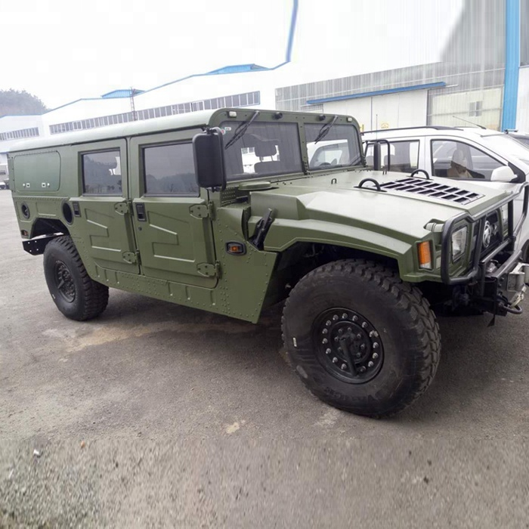

ADIEQ5058M 4X4 APC VEHICLE
Announcement model | ADIEQ5058M | Types | Motorhome
Curb weight / KG | 3850 | Total mass / KG | 4400
Emission standard | GB17691-2005 euro IV | Fuel type | Diesel
Rated passenger/person | 2— 4 | Number of axes | 2
Wheelbase / mm | 3300 | Axle load / KG | 2030/2370
Tire specifications | 37×12.5R16.5LT | Number of tires | 4
Front/rear hang / mm | 574/1137 | Approach/departure angle / ° | 45/40
Front track / MM | 1802 | Rear track / MM | 1806
Vehicle length / MM | 5011 | Vehicle width / MM | 2400
Vehicle height / MM | 1980/ 2150 | Maximum speed / KM / H | 135
Chassis 1 | EQ2040M, Complete vehicle, Dongfeng Motor Corporation | ABS model | YF8 (Wuhan Yuanfeng Automobile Electronic Control System)
Engine model | ISDe200 42 | Displacement | 4500
Engine trademark | Dongfeng Cummins Engine Co., Ltd. | power | 147 (power is 141kW)
Remarks | 1. Optional top skylight, overhead luggage rack, overhead air conditioner, overhead satellite antenna, top replacement air fan, overhead solar panel, the height of the top without optional parts is 1980mm;  2. The car can be customized according to user needs Optional optional DVD, car Bluetooth, folding table, car refrigerator, water dispenser, car navigation, satellite phone, satellite TV, locker, pull-out cooker, camping tent, folding seat (behind the bedding ) and other facilities;  3. Optional anti-collision bar at the front, optional window opening and no window at the rear, and sun visor on the right side.

