ADIEQ2050E 4x4 off road jeep double cabin
Payment terms: T/T,down payment 60%,the 40% balance cash before delivery.
Loading port: any port of China to XXX
FOB: US$130,000.00/Unit
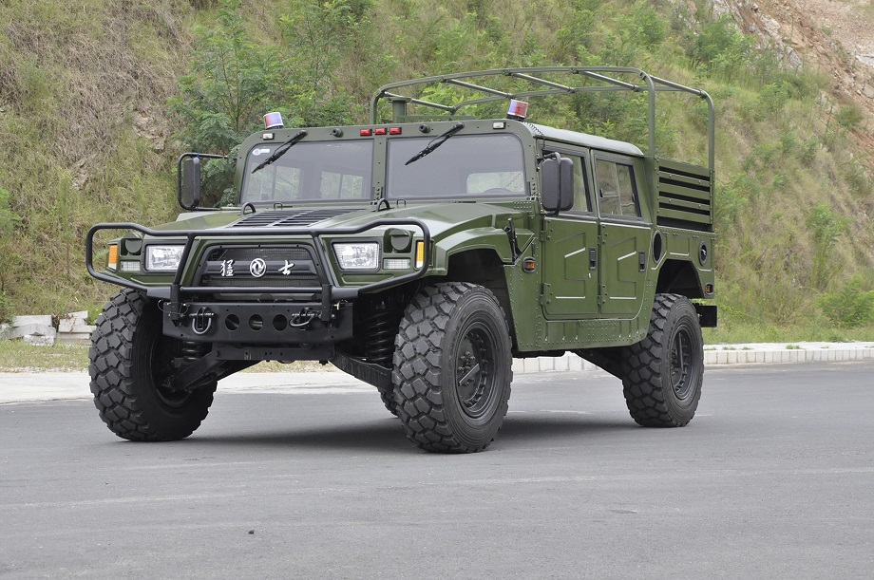
ADIEQ2050E 4X4 OFF ROAD JEEP specification
SPECIFICATION
Name vehicles | EQ2050E 4X4 OFF ROAD VEHCIEL
Vehicles brands | Dongfeng | Types of vehicles |  | OFF ROAD VEHICLE
Chassis Model | EQ2050E | Standard chassis |  | Euro II
Parameters
Product Type | EQ2050E
Curb mass(mm) | 3150 |  | Total mass(mm) |  | 5000
Engine Model | EQB150-20 |  | Fuel type |  | DIESEL
Displacement(ml) | 3920 |  | Engine Power(kw) |  | 112
Shaft number | 2 |  | Wheelbase(mm) |  | 3300
Axle-load | - |  | Spring few films |  | -
Tyre number | 4 |  | Tire specifications |  | 37×12.5R16.5
Departure angle | 72/34 |  | Suspension  front/rear (mm) |  | 562/1008
front Tread(mm) | 1820 |  | Rear tread(mm) |  | 1820
Vin | LGHH5D2D, |  | Max speed(km/h) |  | 115
overall Dimensions size (mm) | 4717×2210×1930 |  | Cargo compartment(mm) |  | 1150×1320×340
Number of passengers | - |  | Cab passengers |  | 2+2
 | - |  | Chassis Model |  | EQ2050MRJ
Other description | -

