ADIEQ2250F 6x6 Bulletproof truck
Payment terms: T/T
Loading port/destination port: any port of China to XXX
FOB: US$82,500.00/Unit
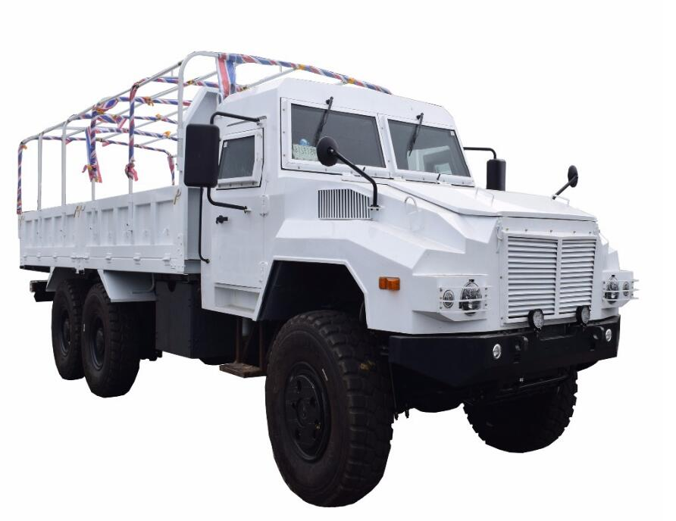
ADIEQ2250F Diesel 6x6 Off-road Truck
Model | ADIEQ2250F 6X6 Off-road army Truck
Weight | Load weight(kg) |  | 21000-30000
Weight | Curb weight(kg) |  | 11300
Weight | G.V.W(kg |  | 29000
axle | Front/rear axle load weight(kg) |  | 9T/ 10Tx2
Performance  parameter | Engine model |  | C260-30 Cummins  diesel engine
Performance  parameter | Engine type |  | Four-stroke, water-cooled, inline 6-cylinder, supercharged, diesel engines
Performance  parameter | Engine power |  | 191kw 260 horse power
Performance  parameter | Gearbox |  | Manual 9 speed
Performance  parameter | Top speed (km/h) |  | 85
Performance  parameter | Minimum turnning diameter (m) |  | 18.6
Performance  parameter | (%)  Max gradeability (load 3500kg、no traction) |  | 60
Performance  parameter | Per 100km fuel consumption (L) |  | 30
Performance  parameter | Brake distance (full load 30km/h) (m) |  | ≯9
Performance  parameter | Manual brake performance (%) |  | 40
（mm）  Dimension  parameter  (mm) | Total length |  | 9400
（mm）  Dimension  parameter  (mm) | Total width |  | 2590
（mm）  Dimension  parameter  (mm) | Height (empty load by calash) |  | 3250, 3302
（mm）  Dimension  parameter  (mm) | Wheelbase | Front axle to the center of the rear suspension | 4500 4500+1400 mm
（mm）  Dimension  parameter  (mm) | Wheelbase | Between middle rear alxe | 1400
（mm）  Dimension  parameter  (mm) | Wheel tread | Front axle | 1876
（mm）  Dimension  parameter  (mm) | Wheel tread | Middle、rear axle | 1870
（mm）  Dimension  parameter  (mm) | Sidewall inner dimension | Length | 6200
（mm）  Dimension  parameter  (mm) | Sidewall inner dimension | Width | 2500
（mm）  Dimension  parameter  (mm) | Sidewall inner dimension | Height | 800
（mm）  Dimension  parameter  (mm) | Angle of trim | Approach angle | 34°
（mm）  Dimension  parameter  (mm) | Angle of trim | Departure angle | 45°
（mm）  Dimension  parameter  (mm) | Max wading depth |  | 900
（mm）  Dimension  parameter  (mm) | Minimum clearance distance between ground |  | 305
（mm）  Dimension  parameter  (mm) | REAR the trailer hook from the pitch (full load) |  | 857
（mm）  Dimension  parameter  (mm) | Truck floor height (empty load) |  | 1400
tire | 14.00-20 14.00R20

