ADIEQ5010E 4X4 high mobility armored vehicle
Payment terms: T/T 40% deposit,the 60% balance L/C at sight can be accepted with 5% on order to USA escrow account
Loading port/destination port: any port of China to
FOB: US$360,800.00/Unit
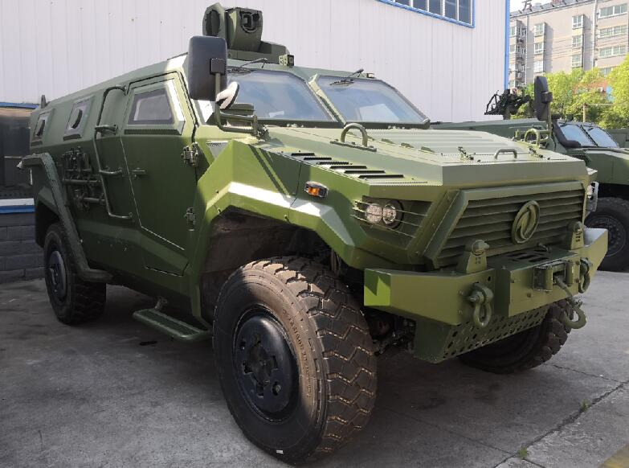
ADIEQ5010E 4X4 High mobility armored vehicle specification
Model |  | ADIEQ5010E 4X4 high mobility armored vehicle
Overall dimension (mm) |  | 5100X2350X1860
Wheelbase(mm) |  | 3650
Wheel Tread front/rear (mm) |  | 1820/1820
Approach angle(°) |  | 47
Departure angle(°) |  | 40
Min. ground clearence(mm) |  | 406
Curb weight(kg) |  | 3250
GVW (kg) |  | 6300
Max. speed(km/h) |  | 120
Max. climbing grade(%) |  | more than 60%
Max. driving side slope(%) |  | 60%
Portrait transit angle(°) |  | 32
Min. swerve diameter(m) |  | no more than 15
Tire specification |  | 37x12.5R16.5
Engine | Model | Cummins ISDe300-40 300hp
Engine | Emission standard | Euro 4
Engine | Engine type | Water-cooled six-cylinder,4 stroke turbocharged and intercooled diesel
Engine | Displacement | 6.7L
Engine | Max. output | 221kw/2700r/min
Engine | Max. torque | 1100N.m/2500r/min
Clutch |  | Single, dry disc, φ395 spring,hydraulic booster, far-distance control
Transmission |  | Manual, six D drive with Synchronizer, one R drive
Divided-moved Ware |  | manual, two position,higher gear ratio1.08,lower gear ratio 1.35
Drive axle |  | Split Type cast-iron Axle Housing, steel tube semi-axle bushing,universal-joint cross couping with front/rear axle.
Frame |  | Run-in frame with two slot side carling
Suspension |  | Independent suspension of Front/Rear axle
Brake system |  | Driving arrester:  four wheel double-loop air brake, drum arrester, two brake shoes in front, double-loop pump in series, air-pressure control, two air bag brake in front and rear, front dual disc and  Parking arrestor  rear wheel brake, drum arrester, air-pressure control
Steering system |  | Front wheel turning, gear wheel and hydraulic power assisted steering system
The trench width (mm) |  | 850
Wading depth (mm) |  | 760
Vertical obstacle height (mm) |  | 440
Protection performance |  | 100 meters from the front windshield glass can withstand 7.62 mm rifle design, the body can withstand 7.62 mm armor-piercing shot. 100 meters from the side of the body can fully withstand 7.62 mm rifle shooting, which can effectively protect explosive shock wave. After the installation of V underbody armor protection to enhance the level of protection type.
Vehicle function |  | Fully meet the forces of the siege of the border areas, low-intensity conflict in the border plateau, rapid deployment, within the scope of the technical and tactical indicators city theater of battle.
Strike capability |  | The roof has a 360-degree full - to - general weapon seat, Can carry a 04 - type 35mm grenade launcher.89 type 12.7mm Heavy machine guns
Driving type |  | 4x4 off road Left hand driving
Passenger capacity |  | 10
Air conditioner |  | option

