ADIEQ5050F 6x6 high mobility armored vehicle
Payment terms: T/T 40% deposit,the 60% balance L/C at sight can be accepted after 5% on order into USA Escrow
Loading port/destination port: any port of China to
FOB: US$354,770.00/Unit
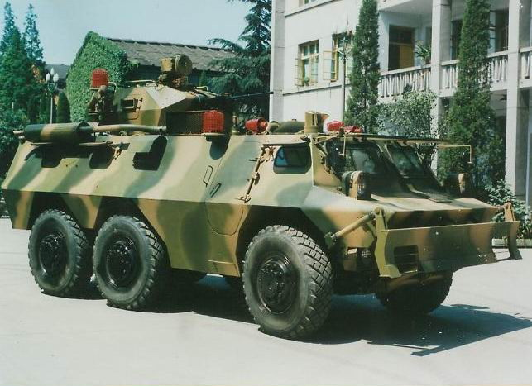

The ADIEQ5050F 6×6 wheeled armored vehicle is mainly composed of an integrated powertrain unit, transmission system, steering system, steering system, braking system, auxiliary gas system, mobile system, protection system, electronic and electrical information system, weapon system, (Oil) cooling system, water propulsion system and other components. It is mainly deployed in mechanized units, special operations units and internal defense units. It is used as an operational platform for infantry, to cooperate with main combat equipment, and to perform independent combat missions. As a mobile platform, it can be equipped with different equipment and converted into a variety of armored vehicles (anti-storm guns, personnel transport vehicles, rescue vehicles, command vehicles, ambulances, fire trucks and assault vehicles, etc.) to meet various tasks and demand.
：main feature
The integrated powertrain unit greatly improves vehicle maintainability and independent suspension systems.
The driving window observation method with the same protective performance as the vehicle body takes into consideration the requirements of the driver's field of vision for high-speed driving safety and the protection of the occupants during wartime.
Modular design, high degree of generalization, enhanced vehicle modification and modification, easy to form a car.
It has the capability of urban street fighting or flexible maneuvering in the forest zone, and has the ability to run at high speed (maximum road speed is not less than 100km/h) and long distance (running mileage is not less than 800km).

EQ5050F wheeled armored vehicle main tactical technical indicators (basic configuration)
item |  | data
parameter | driving type | 6×6
parameter | )people capacity | 2+6
parameter | ）door number | 3
weight | (kg)total weight | 16500
weight | （kg）curb weight | 15500
dimension | （mm）  Overall dimension: L*H*W | 5700x2490x1940 mm  7225×2914×2160mm  High for the ground to the top
dimension | （mm）  Clearance from ground | 430
dimension | Approach/departure angle | 40/33
Driving performance | （km/h）  Road top speed | 100
Driving performance | （km）  Maximum mileage | 800
Driving performance | （%）  Maximum grade | 60
Driving performance | （mm）  Vertical height | 550
Driving performance | （mm）  Wading depth | 1200
Protective performance | Type of protection | Armor plate + bulletproof glass
Protective performance | Protective performance | 100 meters on the front, 200 meters on the side, anti-7.62mm × 39 armor-piercing projectile. The rear deck and top deck are protected against 7.62mm ordinary bullets and shrapnel.
engine | Maximum rated power | 275kw@2100r
engine | fuel sort | diesel
transmission | type | Electronically controlled automatic gearbox
transmission |  | 6 forward/1 reverse
Braking System |  | drum
Suspension system |  | Double wishbone independent suspension, coil spring
Driving system |  | Hydraulic overall power steering
Air Conditioning System |  | 12kwSingle cold, 12kw
Off-road tire |  | 12.00R20 14.00R20-18PR(FD)
chair |  | leather
radio |  | Ultrashort wave radio
Fire extinguishing system |  | Automatic fire extinguishing in the power cabin, manual fire extinguishing in the passenger compartment
Windshield and window glass type |  | bullet-proof glass

