ADIEQ5090F 4X4 off road wheeled armored anti-riot vehicle
Payment terms: T/T,down payment 60%,the 40% balance cash before delivery.
Loading port: any port of China to XXX
FOB: US$226,000.00/Unit RHD
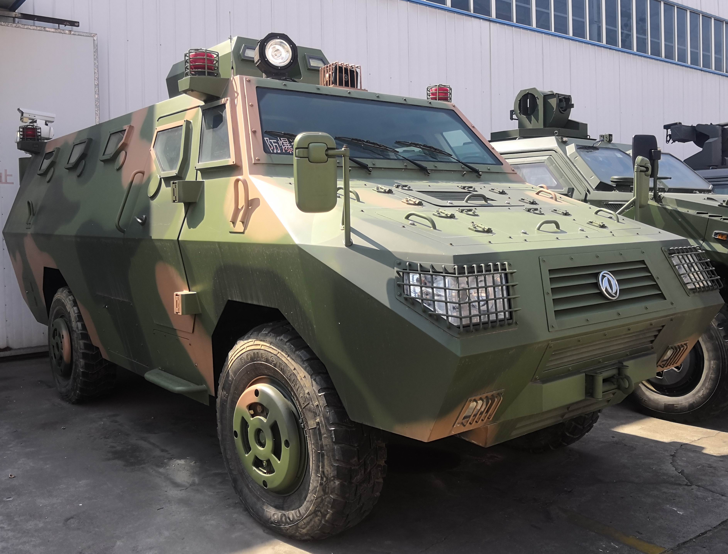
ADIEQ5090F 4X4 off road wheeled armored anti-riot vehicle

Model |  | 4X4 off road wheeled amored anti-riot vehicle
Overall dimension L*W*H |  | 6570x2490x3050 mm
Wheelbase(mm) |  | 3200
Tread (mm) |  | 1970
Approach angle(°) |  | 40
Departure angle(°) |  | 35
Min. ground clearence(mm) |  | 300
Curb weight(kg) |  | 4500
GVW (kg) |  | 9000
Max. speed(km/h) |  | 120
Max. climbing grade(%) |  | more than 60%
Max. driving side slope(%) |  | 40%
Portrait transit angle(°) |  | 32
Min. swerve diameter(m) |  | no more than 15
Engine | Model | Cummins ISDe180-30 180hp
Engine | Emission standard | Euro III
Engine | Engine type | Water-cooled six-cylinder,4 stroke turbocharged and intercooled diesel
Engine | Displacement | 4.5L
Engine | Max. output | 136kw/2500r/min
Engine | Max. torque | 650N.m/1200~1700r/min
Clutch |  | Single, dry disc, φ395 spring,hydraulic booster, far-distance control
Transmission |  | Manual, six D drive with Synchronizer, one R drive
Divided-moved Ware |  | manual, two position,higher gear ratio1.08,lower gear ratio 1.35
Drive bridge |  | Split Type cast-iron Axle Housing, steel tube semi-axle bushing,universal-joint cross couping with front/rear axle, Differential Lock on front/rear axle
Frame |  | Run-in frame with two slot side carling
Suspension |  | Independent suspension of Front/Rear axle
Brake system |  | Driving arrester:  four wheel double-loop air brake, drum arrester, two brake shoes in front, double-loop pump in series, air-pressure control, two air bag brake in front and rear, front dual disc and  Parking arrestor  rear wheel brake, drum arrester, air-pressure control
Steering system |  | Front wheel turning, gear wheel and hydraulic power assisted steering system
Tyre |  | 295/60R22.5 Meridian tyre without inner tube
Protection performance |  | Vehicle Resistance Level: Four sides of this vehicle can resist 56 type submachine gun, 7.62mm steel cored warhead shooting. The top and bottom of vehicle can resist 56 type submachine gun with steel cored warhead shooting. The whole vehicle can resist demolition by explosion device on the side and bottom.
Driving type |  | 4x4 off road Left hand driving or right hand driving
Air conditioner |  | option
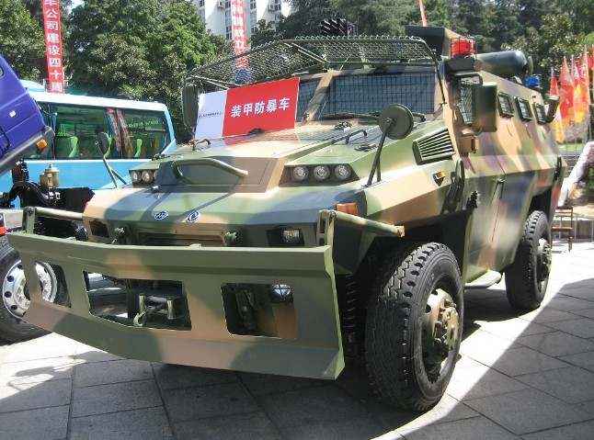
Note: price is not include Weapon .

