ADIEQ5120G 6x6 off-road mobile workshop truck
Payment terms: T/T 40% deposit,the 60% balance L/C at sight can be accepted after 5% into USA escrow on order
Loading port/destination port: any port of China to
FOB: US$57,250.00/Unit
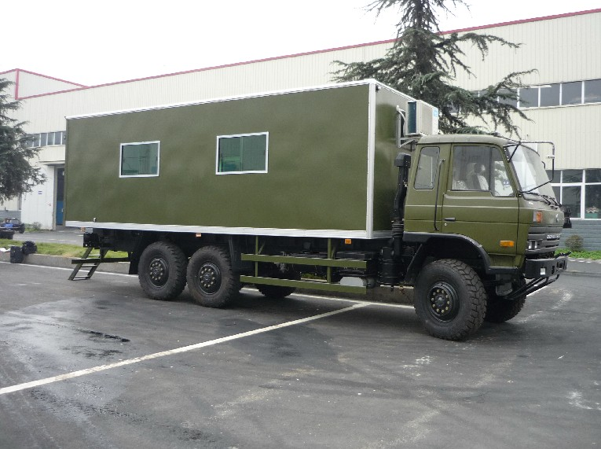
the new 6X6 off road workshop technical parameters
vehicle name | ADIEQ5102G 6X6 Off-road mobile workshop truck
overall dimension L*W*H | 9630*2470*3780
fuel sort | diesel
Emission standard | Euro 3
（ml）/（kw）displacement/power | 5900/ 140
steering type | steering wheel, left hand driving
box inner size L*W*H(mm) | 7200*2300*2200
Axle number | 3
wheelbase (mm) | 4350+1300
spring leaf | 10/12
tire specification | 11．00R20
wheel numeral | 6
（mm）wheel span front/rear | 1876 / 1870
（kg）total weight | 16050,
（kg）specified load weight | 7900
（kg）curb weight | 7955
cab passengers | 3
（°）approach/departure angle | 35/34
（kg）front/rear suspension | 1385/1515
（km/h）top speed | 90
（kg）：axle load | 4020/12030(double axle),3410/8240 double axle
chassis model/manufacturer | EQ2162GJ Dongfeng vehicle co
engine model/manufacturer | C260-33 260hp 191KW  Dongfeng Cummins diesel engine co.,ltd
Vehicle Colour | Colour according to customer’s request but must inform us in advance.
Air conditioner | With A/C

