Steyr 6x6 off road special vehicle
Payment terms: T/T,down payment 40% arrange for manufacturing,the 60% cash before delivery(or 70% balance L/C at sight can be accepted)
Delivey time: depends on customer order quantity.
Loading port/destination port: Any port of China to XXXX
FOB: US$47,760.00/Unit
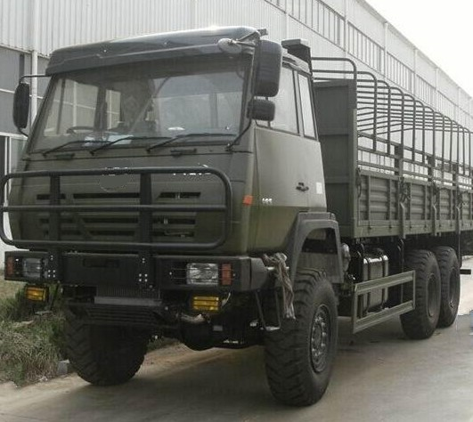

Steyr 6x6 off road special vehicle specification
Steyr 6x6 off road special vehicle (long cargo box)
Driving type |  | 6x6 off road for military
Overall Dimension (L*W*H) mm |  | 9915x2480x3350
Cargo box Dimension (L*W*H) mm |  | 7220x2368x620(long cargo box)
Wheelbase (mm) |  | 4325+1350
Curb weight (kg) |  | 11650
Front overhang/Rear overhang (mm) |  | 1576/3030
Front /Rear track (mm) |  | 1939/1800
Approach angle/Departure angle |  | 21/17
Max speed (km/h) |  | 80
Cab | Hydraulic shock absorb adjustable seat, adjustable steering. Safety belt, cabin front protection, cooler protection, light protection, upward exhaust pipe.
Engine | Model |  | WD615.50 WEICHAI DIESEL ENGINE
Engine | Feature |  | MAN EVB tech. Diesel, 4-stroke direct injection, 6 cylinder in line, radiator, turbo-charging.
Engine | Bore /stroke (mm) |  | 126x130
Engine | Displacement (L) |  | 9.726
Engine | Power |  | 290hp/213kw
Engine | Rated speed (r/min) |  | 2000
Engine | Torque (N.m) |  | 1160
Engine | Emission |  | EuroII
transmission | Model |  | FAST gearbox
transmission | Shift mode |  | Manual 9 forward 1 reverse
transmission | Torque (N.m) |  | 1350
transmission | First shift ratio |  | 7.285
Electrical | Battery |  | 12V/135Ah
Electrical | Generator |  | 28V-35A
Electrical | Starter |  | 5.4Kw/24V
Spring leaf | Type |  | Spring leaf
Spring leaf | Front |  | 9
Spring leaf | Rear |  | 9+6
Axle load weight(T) | Front |  | 6.5t Steering axle
Axle load weight(T) | Rear |  | 13t Double reduction, hub redactor driving
Steering | Left hand drive Power steering
Tire | 14.00-20 military tyre 6+1 spare
Clutch | 430 Diaphragm type, single dry frictional disc, hydralic boosting
Fuel tank | 380L steel tank
Air conditioner |  |  | With A/C

