ADIEQ2100E6D 6x6 off road truck
Payment terms: T/T
Loading port: Shanghai port of China
FOB: US$32,000.00/Unit
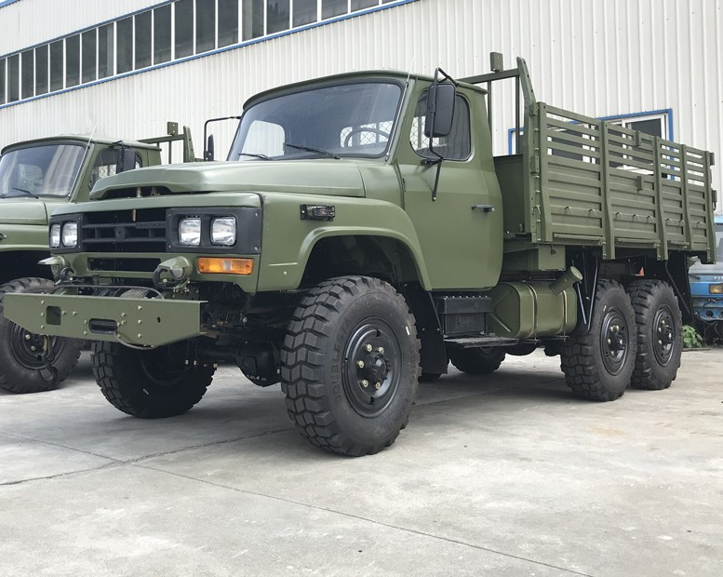
ADIEQ2100E6D Diesel 6x6 Off-road Truck
Model | ADIEQ2100E6D Off-road army Truck
（kg）  Weight  Parameter  (kg) | Load weight | Off-road travel |  | 3500
（kg）  Weight  Parameter  (kg) | Load weight | Highway travel |  | 5000
（kg）  Weight  Parameter  (kg) | Max gross weight of traction |  |  | 4500
（kg）  Weight  Parameter  (kg) | Empty load |  | Front axle load | 2850
（kg）  Weight  Parameter  (kg) |  |  | Middle、Rear axle load | 3440
（kg）  Weight  Parameter  (kg) |  |  | Max gross weight | 6290
（kg）  Weight  Parameter  (kg) | Load weight |  | Front ax;e load | 3265
（kg）  Weight  Parameter  (kg) |  |  | Middle、Rear axle load | 6725
（kg）  Weight  Parameter  (kg) |  |  | Max gross weight | 9990
Performance  parameter | Engine model |  |  | 6BT5.9 /EQB160-20 diesel engine
Performance  parameter | Engine type |  |  | Four-stroke, water-cooled, inline 6-cylinder, supercharged, diesel engines
Performance  parameter | Engine power |  |  | 118kw 160 horse power
Performance  parameter | Gearbox |  |  | Manual 5 speed
Performance  parameter | Top speed (km/h) |  |  | 85
Performance  parameter | Minimum turnning diameter (m) |  |  | 18.6
Performance  parameter | (%)  Max gradeability (load 3500kg、no traction) |  |  | 60
Performance  parameter | Per 100km fuel consumption (L) |  |  | 30
Performance  parameter | Brake distance (full load 30km/h) (m) |  |  | ≯9
Performance  parameter | Manual brake performance (%) |  |  | 40
（mm）  Dimension  parameter  (mm) | Total length |  |  | 6996
（mm）  Dimension  parameter  (mm) | Total width |  |  | 2400
（mm）  Dimension  parameter  (mm) | Height (empty load by calash) |  |  | 3302
（mm）  Dimension  parameter  (mm) | Wheelbase |  | Front axle to the center of the rear suspension | 4025
（mm）  Dimension  parameter  (mm) |  |  | Between middle to rear alxe | 1250
（mm）  Dimension  parameter  (mm) | Wheel tread |  | Front axle | 1876
（mm）  Dimension  parameter  (mm) |  |  | Middle、rear axle | 1870
（mm）  Dimension  parameter  (mm) | Sidewall inner dimension |  | Length | 4000
（mm）  Dimension  parameter  (mm) |  |  | Width | 2180
（mm）  Dimension  parameter  (mm) |  |  | Height | 900
（mm）  Dimension  parameter  (mm) | Angle of trim |  | Approach angle | 34°
（mm）  Dimension  parameter  (mm) |  |  | Departure angle | 45°
（mm）  Dimension  parameter  (mm) | Max wading depth |  |  | 900
（mm）  Dimension  parameter  (mm) | Minimum clearance distance between ground |  |  | 305
（mm）  Dimension  parameter  (mm) | After the trailer hook from the pitch (full load) |  |  | 857
（mm）  Dimension  parameter  (mm) | Truck floor height (empty load) |  |  | 1400

