ADIEQ2100B 4X4 off road military truck
Payment terms: T/T,down payment 40% arrange for manufacturing, the 60% cash before delivery.
Loading port/destination port: Any port of China to
FOB: US$31,230.00/Unit
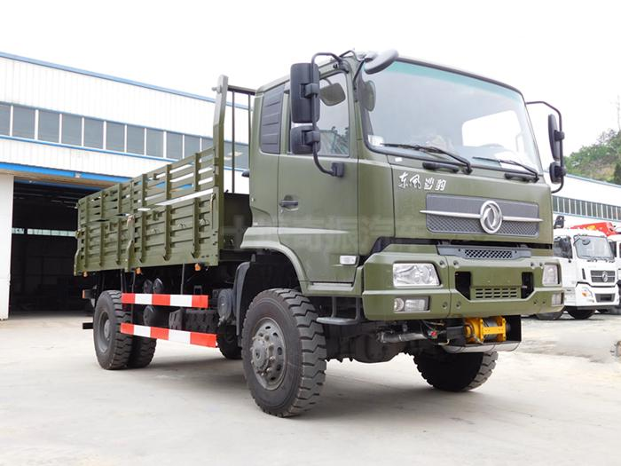
ADIEQ2100B 4X4 off road military truck specification
Specification | Model |  | ADIEQ2100B 4x4 military truck
Specification | model |  | ADIEQ2100BJ
Specification | Overall dimension(mm) |  | 7700,7900×2500×2870,3490
Specification | cargo box size(mm) |  | 4270×2294×550
Specification | G.V.W(KG) |  | 16000
Specification | Curb Weight(kg) |  | 10700
Specification | Load weight(kg) |  | 5300
Specification | Specified pessanger(contain driver) |  | 2
Specification | Driving type |  | 4×4
Chassis | Chassis model |  | EQ2100BJ
Chassis | Front/rear axle load weight |  | 3.3T/8T  4.5T/9T option
Chassis | Axle number |  | 2
Chassis | Wheelbase(mm) |  | 4200/4500
Chassis | tire number |  | 6
Chassis | tire specification |  | 9.00R20,
Chassis | Gearbox manual |  | 6 Speed
Chassis | Top speed(kw/h) |  | 76
Engine | Engine model | Displacement  (ml) | Power(kw)
Engine | B190-33 190hp  Dongfeng cummins | 5900L | 140
Engine | Emission standard | Euro 3
Air conditioner | With A/C

