ADIEQ2102N 6x6 double cabin cargo truck
Payment terms: T/T
Delivery time: depends on buyer’s order quantity
Loading port/destination port: any port of China to XXX
FOB: US$39,700.00/Unit
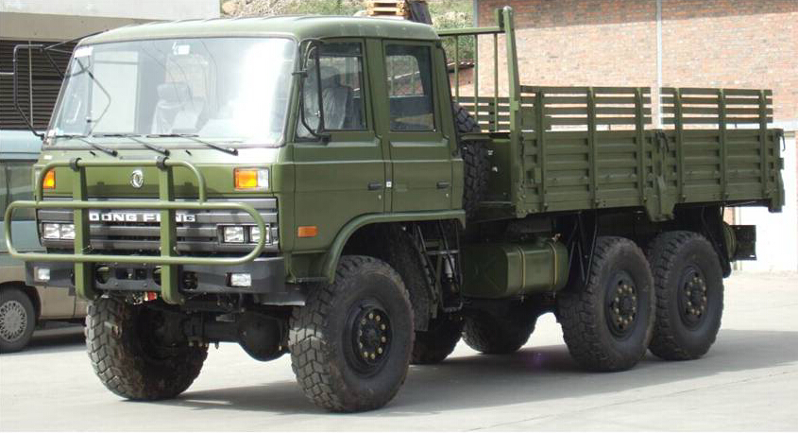
the new vehicle technical parameters
vehicle name | ADIEQ2102N 6x6 Off-road Truck double cabin
overall dimension L*W*H mm | 7650,7760 * 2470 * 2893,2740
fuel sort | diesel
exhaust standard | Euro 3
ml/kwdisplacement | 5900/ 140
steering type | steering wheel
Cargo box inner size L*W*H mm | 4800 * 2294 * 550,800
Axle number | 3
Wheelbase(mm) | 3500+1250
spring leaf | 10/12
tire specification | 12.5R20
tire numbers | 6
wheel track front/rear mm | 1876 / 1870
max gross weight(kg) | 16050
Rated load weight(kg) | 8045
curb weight (kg) | 7955
max load weight allowed(kg) | 6000
cab passengers | 3
°approach/departure angle | 35/34
front/rear suspension(kg) | 1385/1515
top speed(km/h) | 90
axle load(kg) | 4020/12030,3410/8240
chassis model/manufacturer | EQ2162NJ  Dongfeng vehicle co
engine model/manufacturer | EQB190-33  Dongfeng Cummins diesel engine co.,ltd
Air conditioner | With A/C

