ADIEQ5090G 4x4 military off road truck
Payment terms: T/T,down payment 40% arrange for manufacturing,the 60% cash before delivery.
Delivery time: depends on customer’s order quantity
Loading port/destination port: Any port of China to XXX
FOB: US$29,700.00/Unit
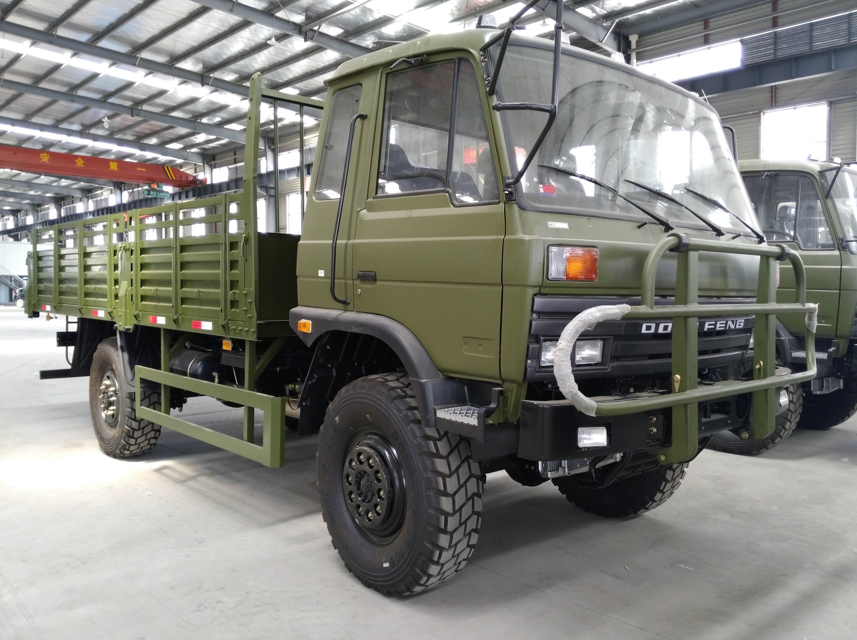
the new vehicle technical parameters
vehicle name | ADIEQ5090G 4x4 Military truck
overall dimension L*W*H (mm) | 7760 * 2470 * 2825
fuel sort | diesel
emission standard | EURO 3
displacement（ml）/power（kw） | 5880/ 125
steering wheel | steering wheel，with power steering
Cargo box dimension L*W*H（mm） | 5100 * 2294 * 550
axle numeral | 2
wheelbase（mm） | 3950
Leaf spring | 9/11
tire specification | 12.5R20
wheel numeral | 4
wheel tread front/rear（mm） | 1876 / 1870
max gross weight（kg） | 8510
specified load weight（kg） | 2500
Curb weight（kg） | 5815
cab passengers | 3
approach/departure angle（°） | 35/33
front/rear suspension（kg） | 1408/1492
top speed（km/h） | 91
axle load weight（kg）： | 3860/4650
chassis model/manufacturer | EQ2090GJ / Dongfeng co
engine model/manufacturer | B170-33/Dongfeng Cummins engine co,.ltd
Air conditioner | With A/C

