ADIEQ2162G 6x6 Off road truck
Payment terms:T/T
Loading port/destination port: any port of China to XXX
FOB: US$39,700.00/Unit
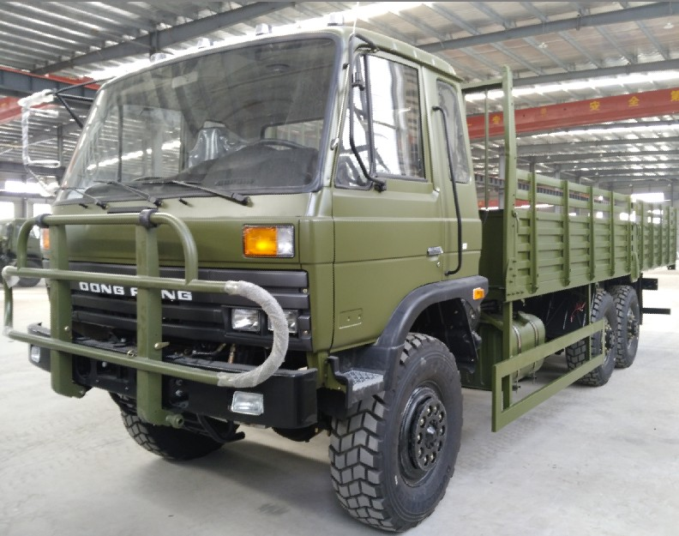
ADIEQ2162G 6X6 Off road truck technical parameters
vehicle name | ADIEQ2162G 6x6 Off-road Truck
overall dimension L*W*H mm | 9830 * 2480 * 2880
fuel sort | diesel
emission standard | Euro 3
ml/kw displacement | 5900/ 155
steering type | Power steering
Cargo box inner size L*W*H mm | 7200 * 2300 * 550/800  Long cargo box
Axle numbers | 3
Wheelbase mm | 4350+1300
spring leaf | 10/12
Tire specification | 12.5R20
wheel numeral | 6
wheel tread front/rear mm | 1876 / 1870
max gross weight kg | 17955
specified load weight kg | 10000
curb weight kg | 7955
max load weight allowed kg | 10000-15000
cab passengers | 3
/°approach/departure angle | 35/34
front/rear suspension | 1385/1515
top speed km | 90
Axle load weight kg | 4020/12030(double axle),  3410/8240(double axle)
chassis model/manufacturer | EQ2162GJ  Dongfeng vehicle co
engine model/manufacturer | B210-33  Dongfeng Cummins diesel engine co.,ltd
Transmission | 5 speed manual  6 wheel drive
Brakes | Air brake drum type
Ground clearance mm | 305
Colour | Can be chosen by customers
Air-conditioner | With A/C
Tire | Mud & sand type

