Shiyan Qianfeng Industry & Trade Co.,Ltd
Add:No.208#,Autoparts Plaza,Zhenya Area,Bailang Middle Road,Shiyan ,Hubei ,China
Tel:0086-719-8318338 Fax: 0086-719-8365165 E-mail:charley222@126.com
Dongfeng EQ5160G 6x6 off road military special truck
Payment terms: T/T,down payment 30% arrange for manufacturing,the 70% cash before delivery.
Loading port/destination port: Any port of China to
FOB: US$47,100.00/Unit
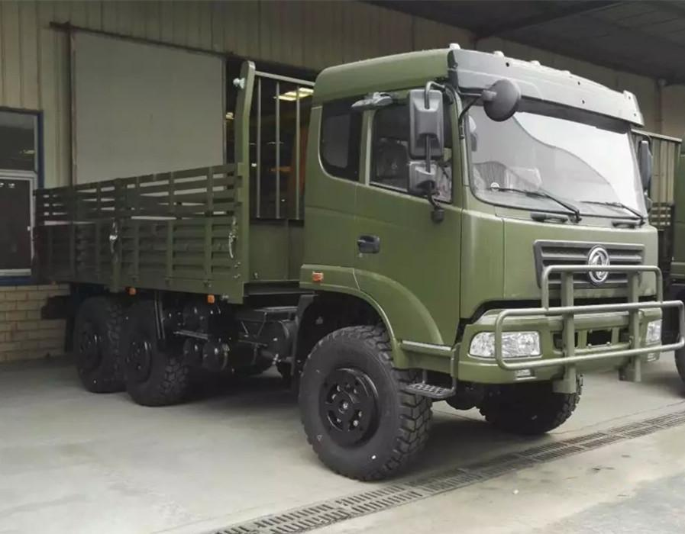
Dongfeng EQ5160G 6x6 off road military special truck specification
Brand | Dongfeng | Drive type | 6x6 latest new design militery truck
Product name | Off-road military cargo truck | G.V.W (kg) | 16050
Curb weight  (kg) | 7955 | Overall dimension L*W*H(mm) | 9630*2470/2480*3350  9915*2470*3350
Load weight  (kg) | 8095 | Cargo Box  Dimension  L*W*H(mm) | 7200*2300*620  7200*2368*620
Wheel base  (mm) | 4350+1350  4650+1350 | F/R axle load weight(kg) | 6.5t Steering axle /13t Double reduction, hub redactor driving
Quantity of leaf spring | 9/12 | Quantity of tires | 6 + 1 spare
Tyre type | 14.00-20  12.5R20 | Approach/  Departure angle | 35/34°
F/R suspension (mm) | 1110/1585 | Front track (mm) | 1876
Rear track  (mm) | 1870,1870 | Max.vehicle speed | 90km/h
Passengers in cab | 3 | Chassis model | EQ2102GJ
Engine | Model | WD615.50 WEICHAI DIESEL ENGINE
Engine | feature | MAN EVB tech. Diesel, 4-stroke direct injection, 6 cylinder in line, radiator, turbo-charging.
Engine | Bore /stroke (mm) | 126x130
Engine | Displacement (L) | 9.726
Engine | Power | 290hp/213kw
Engine | Rated speed (r/min) | 2000
Engine | Torque (N.m) | 1160
Engine | Emission level | Euro 2
Gearbox | Model | FAST gearbox
Gearbox | Shift mode | Manual 9 forward 1 reverse
Gearbox | Torque (N.m) | 1350
Gearbox | First shift ratio | 7.285
Electrical | Battery | 12V/135Ah
Electrical | Generator | 28V-35A
Electrical | Starter | 5.4Kw/24V
Fuel tank | 380L steel tank
Vehicle color | According to customer request but need to inform us in advance
Brake  system | Service brake | Double circuit pneumatic (air) brake
Brake  system | Parking brake | Spring-Power drum brake
Cabin | Description | One and half row, standard configuration,power steering, with Air conditioner
Performance | Max.grade ability | 60%
Performance | Braking distance | 8m
Performance | Minimum turning diameter | 18.8m
Company name: Shiyan Qianfeng Industry & Trade Co.,Ltd
Add:No.208#,Zhenya Area, Autoparts Plaza,Bailang Middle Road,Shiyan,Hubei,P.R.China
E-mail: charley222@126.com
Tel:0086-719-8318338
Fax: 0086-719-8365165
Mobile/Whatsapp: 0086-13972506691
Skype: Charlie3378
Http//：www.qftruck.en.alibaba.com

Note: Photo for reference only,subject to manufacture’s real object
