ADIEQ5102G 6x6 water tank truck 8000L
Payment terms: T/T
Loading port/destination port: any port of China to XXXX
FOB: US$37,380.00/Unit
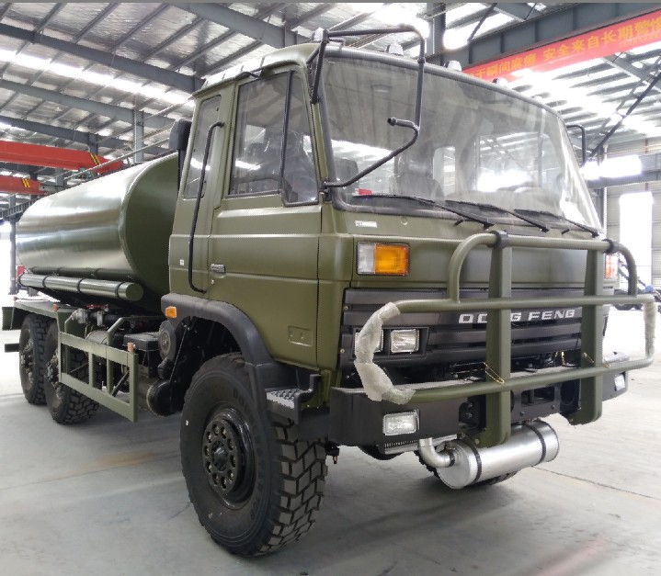
ADIEQ5102G 6x6 water tank truck 8000L specification
the new water vehicle 8000L technical parameters
vehicle name | ADIEQ5102G 6x6 Off-road water tank truck  LHD or RHD driving
overall dimension L*W*H(mm) | 7760 * 2470 * 2820
Tank size L*W*H(mm) | 4380*2000*1150
fuel sort | diesel
exhaust standard | Euro III
Displacement(ml)/power(kw) | 5900/ 140
steering type | steering wheel
axle number | 3
Wheelbase(mm) | 3500+1250
spring leaf | 10/12
wheel specification | 12.5R20
wheel number | 6
wheel tread front/rear(mm) | 1876 / 1870
max gross weight(kg) | 15955
specified load weight(kg) | 8000-10000L
curb weight(kg) | 7955
cab passengers | 3
approach/departure angle | 35/34
front/rear suspension(mm) | 1385/1515
top speed(km/h) | 90
axle load weight(kg) | 4020/12030(double axle),3410/8240(double axle)
chassis model/manufacturer | EQ2102GJ Dongfeng vehicle co.,ltd
Engine model/manufacturer | EQB190-33 Dongfeng Cummins diesel engine co.,ltd
Air conditioner | With air conditioner
Tank material | Carbon steel

