EQ5162N Dongfeng 6x6 ambulance truck
Payment terms: T/T
Loading port/destination port: any port of China to
FOB: US$46,880.00/Unit
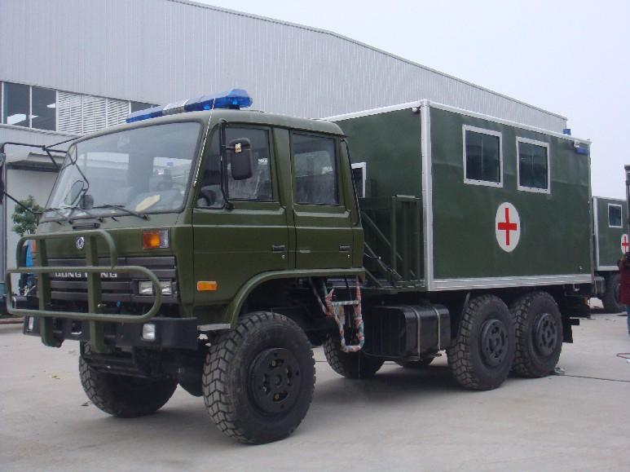

the new vehicle technical parameters
vehicle name | ADIEQ5162N Off-road truck ambulance（double cabin）
（mm）  overall dimension L*W*H | 7600 * 2550 * 3550
fuel sort | diesel
emission standard | Euro III
displacement（ml）/power（kw）displacement | 5900/ 140
steering type | steering wheel
（mm）  box inner size L*W*H | 4800 * 2250 * 2480
axle | 3
wheelbase | 3500+1250
spring leaf | 10/12
wheel specification | 12.5R20
wheel numeral | 6
（mm）wheel span front/rear | 1876 / 1870
（kg）max gross weight | 16050,11650
（kg）specified load weight | 7900,3500
（kg）curb weight | 7955
cab passengers | 3
approach/departure angle | 35/34
（kg）front/rear suspension | 1385/1515
（km/h）top speed | 90
（kg）：axle load | 4020/12030(double axle),3410/8240
chassis model/manufacturer | EQ2162GJ Dongfeng vehicle co
：engine model/manufacturer | EQB190-33  Dongfeng Cummins diesel engine co.,ltd
2、医medical cabin arrangement schematic diagram
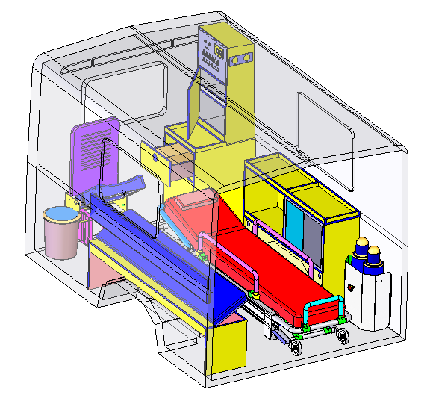
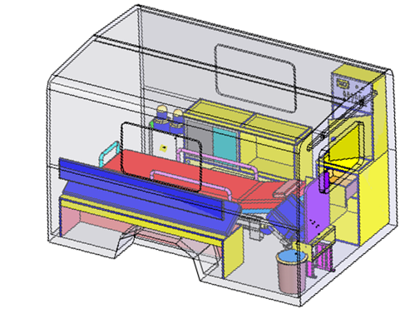

3、医疗舱布置平面示意图:medical cabin plane diagram
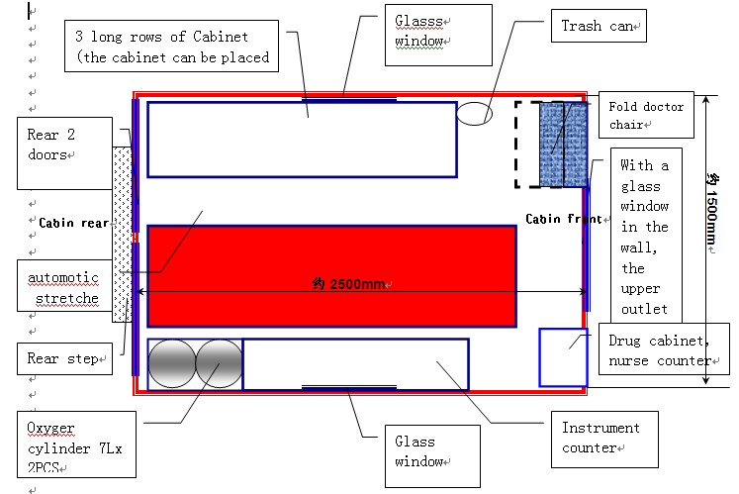

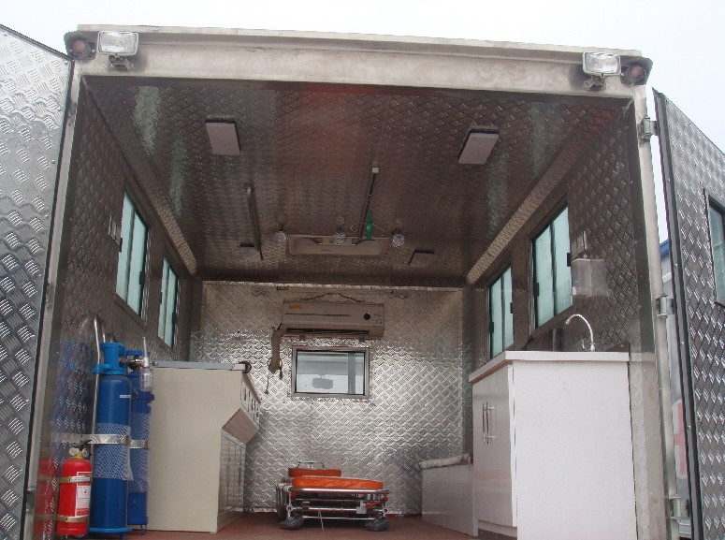
Modification Items

1 | Medical cabin air conditioning (Originalair-conditioning system )
2 | Medical cabin with ventilation system installed
3 | Medical cabin with heater system installed
4 | Field ambulance with lights installed on the left and right sides of roof and rear roof
5 | Medical cabin fluorescent lighting
6 | Three rotatable searchlights
7 | one UV disinfection ultraviolet light
8 | Intelligent power management system, equipped with electricity equipment battery, 220 V power inverter, charger
9 | 10 m mobile cables, connecting external power supply
10 | Right side of the vehicle body with 220V/15A waterproof, protective cover, with an external power supply socket installed
11 | two 220V socket in the medical cabin
12 | two 12V socket in the medical cabin
13 | Driving cab with alarm lamp and alarm lamp controller
14 | double-row Superintendent blue flashing lights installed on the front of the roof
15 | 100w vehicle loudspeakers inside the superintendent flashing lights
16 | square Superintendent blue Strobe installed on the left and right sides of the outer roof and rear roof
17 | Pillar Superintendent blue Strobe installed on the tail of the roof
18 | Complete separated Separation wall installed between the driving cab and medical cabin, sliding window installed on the separation wall.
19 | install equipment counter on which can lay defibrillator, ventilator, aspirator inside the left side of the medical cabin.(or designed to counter Block + single small equipment cabinet according to customer requirements)
20 | On the right side in the medical cabin,install Long rows of seats with three seats, fitted with the two-point seat belts in a drawer, under the seat can be placed spade stretcher and debris
21 | two 10 litres’ oxygen cylinders
22 | Oxygen valve, supply of oxygen, attract private-interface connector (one oxygen interface, one air interface )
23 | Medical bulkheads with corrosion resistance, impact resistance, flame retardant, anti-ultraviolet, adopt special engineering materials processing and installation.
24 | Acid and alkali, fire prevention, anti-skid \ anti-static floor of the medical cabin, the four neighboring arch-bound to prevent the accumulation of dust and anti-skid for the rinse water
25 | Install a set of medicine cabinets, instruments counters and other equipment cabinets.
26 | Install Nurses console in the medical cabin
27 | Install trash bin on the left inside the cabin
28 | Folding up suspention device for the infusion bottle and safety handrails intalled on the top of the cabin.
29 | fire extinguisher(1 kg) and stent
30 | On both sides of the medical cabin, window, door, the back door windows were pasted by 2 / 3 special opaque film for car.
31 | Automatic vehicle stretcher
32 | front and rear interphones
34 | Visualization reversing surveillance system
35 | wash basin

