ADISX2110 4X4 military truck
Payment terms: T/T
Loading port: any port of China
FOB: US$37,500.00/Unit
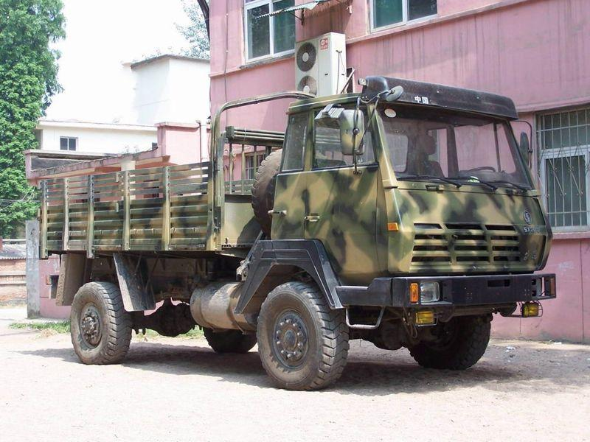
4WD Military Truck 4x4 Military truck specification
Model | ADISX2110
Driving | 4×4
Max. speed(Km/h) | 98
Min. turning radius(m) | ≤17
Max. slope(%) | 60
Fuel consumption(L/100km) | 28
Tanker volume(L) | 200
Approach angle/departure angle | 35°/36°
Total weight(Kg) | 10695
Self-weight(kg) | 7195
Off road pay load(kg) | 3900
Max. pay load(kg) | 5000
Trailer weight(kg) | 4400
Driving cab seat | 2
L×W×H(mm) | 6706×2500×2930
Wheelbase(mm) | 3500
Front suspension/rear suspension(mm) | 1506/1300
Engine model(STEYR) | WD415.21
Max. power(Kw) | 155(2200r/min)
Max. torque(N.m) | 820(1600r/min)
Transmission box model | 7DS908 mechanical type
Transfer case | ZQC800
Steering type | Total recirculation ball-type steering gear
Tire | 12.50-20 low pressure off-road tire 18layers
Driving axle | Steel tube inserting casting shell driving axle
Fording depth(mm) | 1100

