This Sales and Purchase Agreement (the “Agreement”) is entered into as of this ….. of June 2020 BY AND BETWEEN:
The Seller of BTC

Company Name | WIDE SEA SHIPPING SERVICES LLC
Address | NO 1119 AL SALEMITAH TOWER, DUBAI UAE
Represented By | MAYRA DOS SANTOS BARBOSA
Registration | L/N865915
Passport no. | GA435519
Issue Date | 23 SEPTEMBER 2019
Expire date | 22 SEPTEMBER 2029
Seller Rep | Daniel
Telephone | TBA
Location | Los Angeles California

Party One, AND
The Buyer of BTC
Company Name
Address
Represented By
Position
Passport no.
Issue Date
Expire date
Email
Telephone

Herein after termed as Party Two.
Each of Party One and Party Two is a “Party” and collectively they are the “Parties” to this Agreement.

INSTRUMENT | BITCOIN (BTC) ₿
TYPE OF ASSET | DIGITAL CRYPTO CURRENCY
RECEIVING MODE | BITCOIN WALLETS
CONTRACT QUANTITY | 35,000 BTC WITH ROLLS & EXTENSIONS IN WRITING TO POINT OF (BTC) EXHAUSTION
BTC DISCOUNT | 5% GROSS, 3% NET TO BUYER
FIRST TRANCHE | 5000 BTC-(MINIMUM TRANCHE).
SUBSEQUENT TRANCHES | 3,000 BTC NEXT DAY, 30,000 BTC – UNTIL CONTRACT EXHAUSTED.
PRICE PER 1 BTC | TO BE CONFIRMED FROM THE DAILY EXCHANGE RATE VIA www.coinmarketcap.com /bitcoin.com
CONSULTANT FEES | 1% TO SELL SIDE . 1% TO BUY SIDE OPEN. BUYER SHALL ELECT TO PAY CONSULTANTS FEES DIRECTLY. IF INVOICE ONLY STATED PAYMENT TO SELLER, THEN BUYER MUST PAY CONSULTANTS FEES SIMULTENOUSLY WHEN PAYING THE SELLER. .2% COMM EACH FOR 5000 BTC PURCHASE AND ABOVE
PAYMENT MODE | BANK TRANSFER VIA DIRECT PAYMENT TO SELLER’S DESIGNATED ACCOUNT LISTED IN THE INVOICE TO THE BUYER.
DELIVERY MODE | TO BUYER’S BTC WALLET ADDRESS AFTER BUYER REQUESTS INVOICE, MAKES PAYMENT AND FUNDS TRANSFER IS CLEARED.

F2F B2B-CASH TO CASH PROCEDURE

1. BUYER AND SELLER SIGN THE AGREEMENT (BUYER PROVIDE CURRENT STATEMENT ACCOUNT, SELLER PROVIDER WALLET SCREEN SHOT)
2. SELLER AGENT AND BUYER MEET IN THE SELLER AGENT OFFICE IN CALIFORNIA
3. BUYER TRANSFER THE FIRST TRANCHE 5000 BTC TO SELLER GIVEN ACCOUNT OR HAND OVER CASH TO SELLER AGENT.
4. UPON THE RECEIPT/CONFIRMATION OF PAYMENT, SELLER TRANSFER THE 5000 BITCOINS FROM HIS WALLET TO THE BUYER’S WALLET AND PROVIDE THE SCREENSHOT TO THE BUYER
5. SELLER PAY ALL BROKERS AND DISCOUNT TO BUYER BY BTC
6. BOTH PARTIES DEPARTS FROM THE MEETING VENUE –SELLER AGENT OFFICE IN CALIFORNIA
7. BUYER CONFIRM THE BITCOINS AND PREPARE FOR THE NEXT TRANCHE OF 32,000 BITCOINS
WEEKLY.
8. NOTE: NO SATOSHI, NO COIN MOVEMENT FROM WALLET A TO WALLET B PROCEDURE IS NOT NEGOTIABLE.

SELLER BANK DETAILS PAYMENT

BANK NAME: xxx
BANK ADDRESS: xxx
ACCOUNT NAME: WIDE SEA SHIPPING SERVICES LLC
ACCOUNT NO: xxx
IBAN NO: xxx
SWIFT CODE: xxx
OFFICE ADDRESS: xxx
PURPOSE OF PAYMENT: PURCHASE OF PROPERTY

PLEASE. NO ACH. NO CARD LAUDING. NO CHEQUES. (ONLY WIRE OR DIRECT TRASNFER, LEDGER TO LEGDER TRANSFER)

SELLER WALLET ADDRESS: XXXXX
SELLER HAS THE RIGHT TO CHANGE THE RECEIVING BANK COORDINATES LATER WITH WRITING NOTIFICATION TO THE PAYER BEFORE THE PAYMENT IS MADE-NOTE MULTIPLE ACCOUNT MAY APPLY
BUYER BANK DETAILS
BANK NAME: XXXX
BANK ADDRESSXXXX
SWIFT CODE: XXX
ACCOUNT NO: XXX
ACC No : X

IMFPA
SELLER CONSULTANT BANK DETAILS FOR 1% PER BTC @5000 BTC AND 1% PER BTC @33000 BTC AND ABOVE
ACCOUNT HOLDER: | CLOSED…..
BANK NAME:
BANK ADDRESS: | TBA
SWIFT WIRING CODE:
US DOLLAR BANK ACCNT NO: | TBA
BANK TEL:
BANK FAX: | TBA
PASSPORT:
Required Message: | ALL TRANSFER INSTRUCTIONS SHALL STATE: “FUNDS ARE CLEAN AND CLEAR, OF NON-CRIMINAL ORIGIN AND ARE PAYABLE IN CASH IMMEDIATELY UPON RECEIPT BY BENEFICIARY’S BANK.”
SPECIAL INSTRUCTIONS: | PLEASE PROVIDE THE COURTESY COPY OF THE SWIFT WIRE CONFIRMATION RECEIPT TO MY EMAIL ADDRESS :
THE ABOVE MENTIONED BENEFICIARY RESERVES THE RIGHT TO CHANGE THE BANK COORDINATES STATED HEREIN AT ANY TIME BY PROVIDING WRITTEN REQUEST TO THE UNDERSIGNED.
Special Instructions: SAME DAY TRANSFER AND IMMEDIATE CREDIT Required Message: “The Remitter is known to us. This is done with Full Banking Responsibility and we are satisfied as to the Source of Funds sent to us.”

BUYER CONSULTANT BANK DETAILS FOR 1% PER BTC @5000 BTC AND 1% PER BTC @33000 BTC AND ABOVE
GROUP 1A OF BYER SIDE……34% OF 1% CLOSED FOR THE FACILITATOR GROUP….
ACCOUNT HOLDER: | CLOSED….. 34% OF 1%
BANK NAME:
BANK ADDRESS: | TBA
SWIFT WIRING CODE:
US DOLLAR BANK ACCNT NO: | TBA
BANK TEL:
BANK FAX: | TBA
PASSPORT:
Required Message: | ALL TRANSFER INSTRUCTIONS SHALL STATE: “FUNDS ARE CLEAN AND CLEAR, OF NON-CRIMINAL ORIGIN AND ARE PAYABLE IN CASH IMMEDIATELY UPON RECEIPT BY BENEFICIARY’S BANK.”
SPECIAL INSTRUCTIONS: | PLEASE PROVIDE THE COURTESY COPY OF THE SWIFT WIRE CONFIRMATION RECEIPT TO MY EMAIL ADDRESS :
Special Instructions: SAME DAY TRANSFER AND IMMEDIATE CREDIT Required Message: “The Remitter is known to us. This is done with Full Banking Responsibility and we are satisfied as to the Source of Funds sent to us.”

GROUP 2B OF BYER SIDE……66% OF 1% OPEN FOR THE INTERMEDIARIES AND BUYER MANDATE GROUP….

ACCOUNT HOLDER: | OPEN – 66% OF 1%
BANK NAME:
BANK ADDRESS:
SWIFT WIRING CODE:
US DOLLAR BANK ACCNT NO:
BANK TEL:
BANK FAX:
PASSPORT:
Required Message: | ALL TRANSFER INSTRUCTIONS SHALL STATE: “FUNDS ARE CLEAN AND CLEAR, OF NON-CRIMINAL ORIGIN AND ARE PAYABLE IN CASH IMMEDIATELY UPON RECEIPT BY BENEFICIARY’S BANK.”
SPECIAL INSTRUCTIONS: | PLEASE PROVIDE THE COURTESY COPY OF THE SWIFT WIRE CONFIRMATION RECEIPT TO MY EMAIL ADDRESS :

Special Instructions: SAME DAY TRANSFER AND IMMEDIATE CREDIT Required Message: “The Remitter is known to us. This is done with Full Banking Responsibility and we are satisfied as to the Source of Funds sent to us.”

BUYER PASSPORT COP

BUYER PASSPORT COPY

SELLER PASSPORT COPY

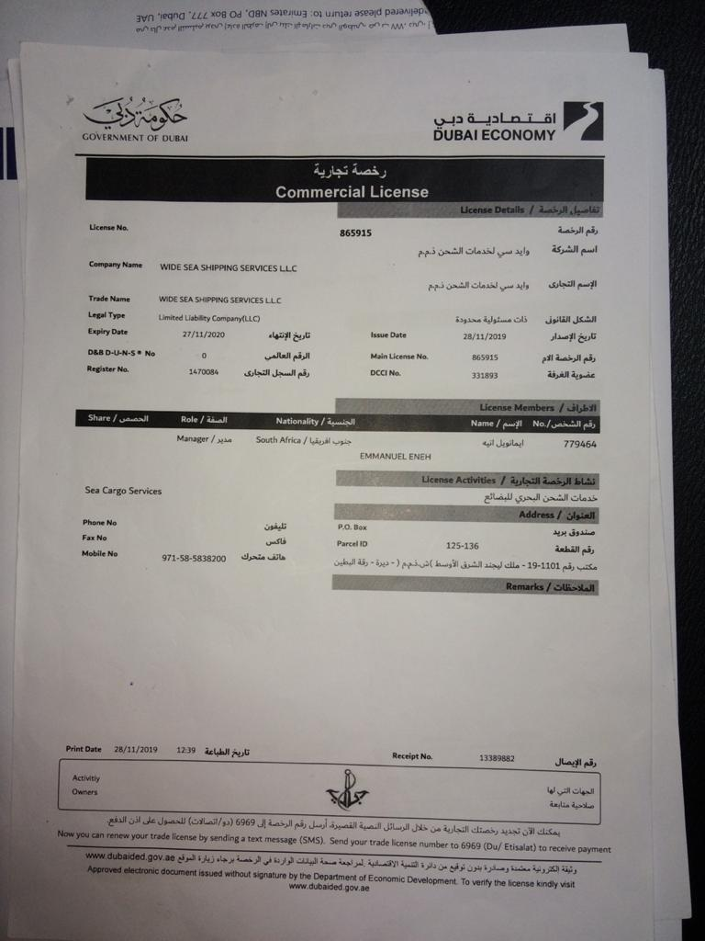

SELLER CERTIFICATE

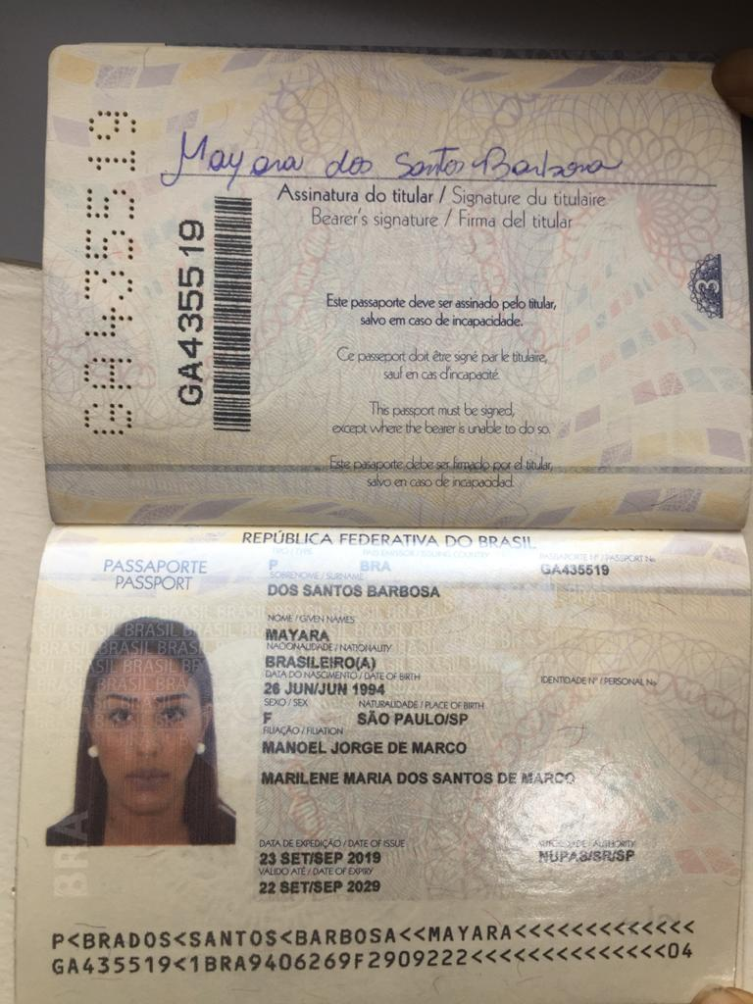

This Agreement is dated as of the date first above written and has been entered as of that date by the duly authorized representatives of the Parties as set forth below: Upon signing the agreement we shall commence the transaction within 72 hours otherwise the contract shall be null and void and the default party shall pay the penalty therein or face litigation.
Signed for and on behalf of (Party One) [Seller]
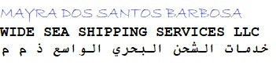
-------------------------------------------------------------------_
NAME/TITLE: MAYRA DOS SANTOS BARBOSA
COMPANY: WIDE SEA SHIPPING SERVICES LLC
PASSPORT NUMBER: GA435519
DATE OF ISSUE: 23 SEPTEMBER 2019
DATE OF EXPIRY: 22 SEPTEMBER 2029
COUNTRY OF ISSUANCE: BRASIL

Signed for and on behalf of (Party two) [Buyer]

Name :
Designation :
Passport # :
Issue date :
Expiry date :
Place of Issue:
Wallet address:

(ELECTRONIC DOCUMENT TRANSMISSIONS)

EDT (Electronic document transmissions) shall be deemed valid and enforceable in respect of any provisions of this Contract. As applicable, this agreement shall be:-

- Incorporate U.S. Public Law 106-229, ‘‘Electronic Signatures in Global & National Commerce Act'' or such other applicable law conforming to the UNCITRAL Model Law on Electronic Signatures (2001) and

- ELECTRONIC COMMERCE AGREEMENT (ECE/TRADE/257, Geneva, May 2000) adopted by the United Nations Centre for Trade Facilitation and Electronic Business (UN/CEFACT).

- EDT documents shall be subject to European Community Directive No. 95/46/EEC, as applicable. Either Party may request hard copy of any document that has been previously transmitted by electronic means provided however, that any such request shall in no manner delay the parties from performing their respective obligations and duties under EDT instruments

