# October 15th, 2024

COMMERCIAL OFFER

# No: A-124538PG

**2012 Solar Titan 130-20502 Turbine Compressor Packages**

**4 x 2012 Solar Titan 130-20502 Turbines with Dresser-Rand Compressors D10R7S**

**Unit A - Total Starts 10 / Total Hours 3 Unit B - Total Starts 81 / Total Hours 6,659 Unit C - Total Starts 59 / Total Hours 7,783 Unit D - Total Starts 27 / Total Hours 60**

Proprietary & Confidential

# List of Equipment Attached in Appendix I

Proprietary & Confidential

### The subject equipment is listed for sale with all OEM technical specifications, the OEM and original owner’s commercial terms and all preservation/maintenance storage records.

Equipment is in storage and preservation under supervision. Equipment comes with owner warranty valid one year.



Equipment is available for immediate delivery (5 days) after signing contract and with payment terms



Transportation and Shipping will be an additional cost and a separate contract if requested.

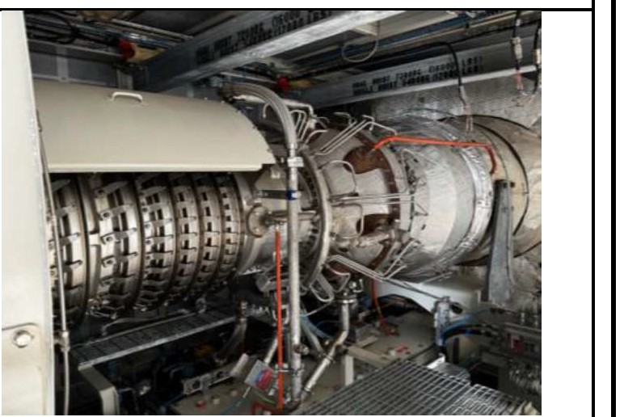

### Appendix 1- List of Equipment

|  |  |  |  |  |  |
| --- | --- | --- | --- | --- | --- |
| No | Equipment  Name | Specification | Quantity | Photo | |
| Main Gas Turbine and Compressor Package (GTCP) | | | | | |
| 1.0 | Gas Turbine Package KT-2401, KT-2501, KT-22 | | | | 1, KT-2301 |
| 1.1 | Turbine Engine | Manufacturer: Solar Model: Titan 130-20502  Two-shaft, axial-flow design  Air Inlet Assembly Compressor Case Assembly Compressor Rotor Assembly Fuel Manifold  Compressor Diffuser Bleed Valve Assembly  Combustor Liner Assembly Torch Igniter Assembly  First-Stage Diaphragm Assembly  Gas Producer Rotor Assembly Third-Stage Nozzle Assembly Power Turbine Bearing  Support Housing  Power Turbine Rotor Assembly Fourth- Stage Nozzle  Assembly  Turbine Exhaust Diffuser Exhaust Collector Forward Support  Engine Rear Mount Assembly | 4 units |  |  |

#### 0

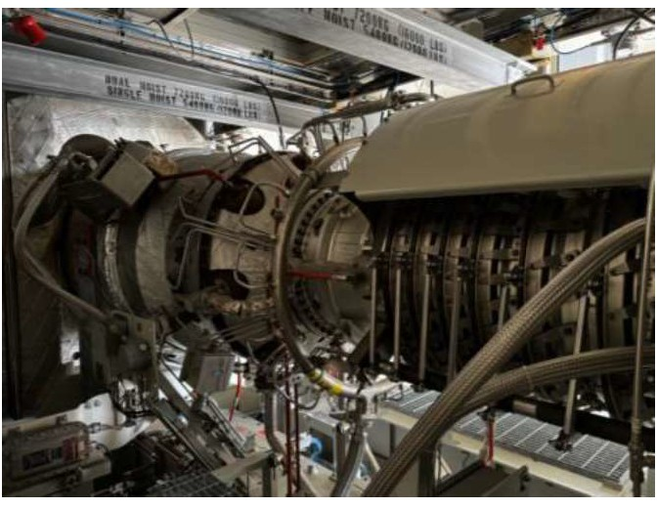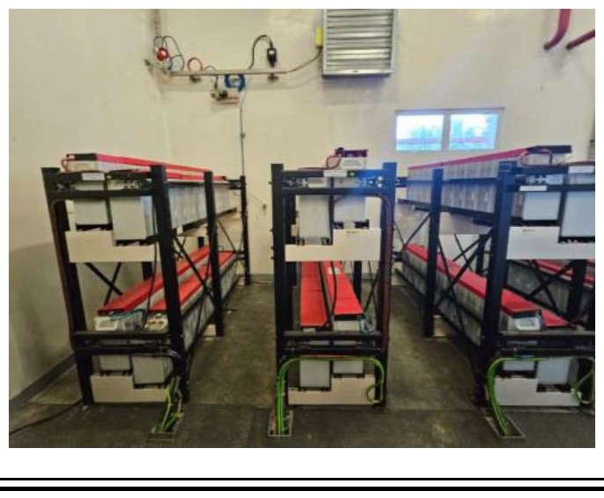

* 1. Pneumatic Actuated 4 units Check Valves

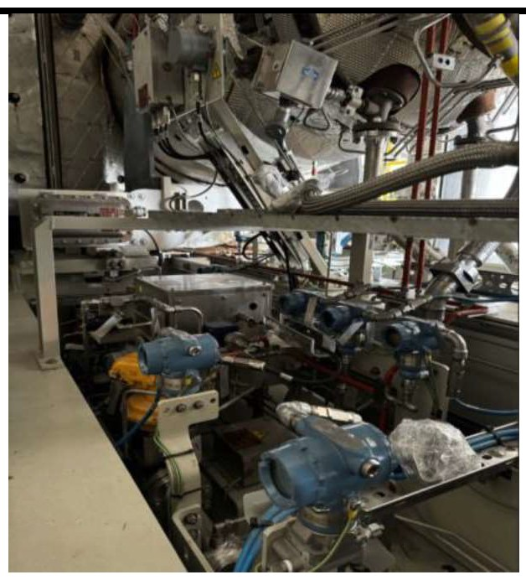

Electric Actuators

Electric Fuel Control Valves Fuel Flow Meter Filters/Strainers

Fixed Orifices

Gas Fuel Flow Transmitter Pneumatically Actuated Valves Hand Valves

Pressure Control Valves Pressure Differential Switch

Pressure Differential Transmitters

Pressure Safety Valves Pressure Transmitters Speed Element Solenoid Valves

Engine Cleaning Tank Temperature Elements Thermowell Displacement Probes

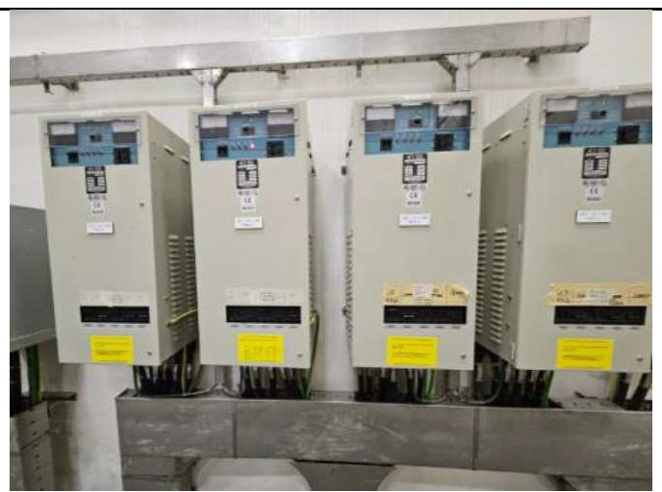

* 1. Unit Control Power Supply Module 4 units

System Power

Battery Charger

Battery Banks

#### 1.4

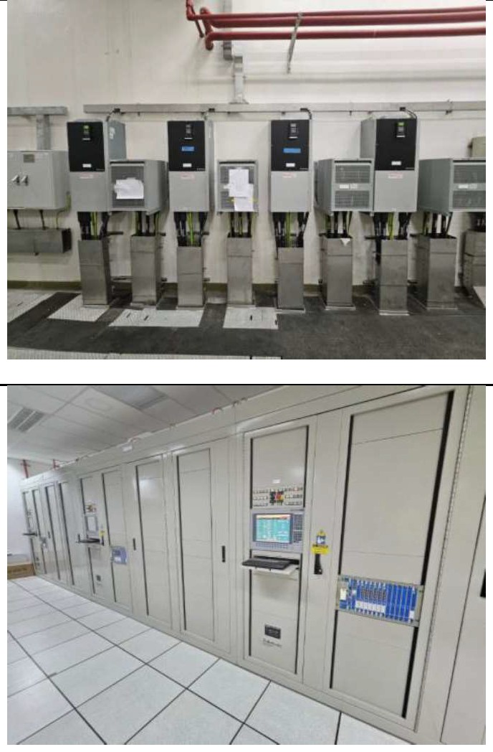

* 1. Unit Control System

Line Reactors Motors

Variable Frequency Drives (VFD)

Controllogix™ Controller Assembly

Controllogix Chassis

In-Chassis Power Supply Controllogix Processor

Module

ControiNet Interface Module Modbus Module

Ethernet Communications Module

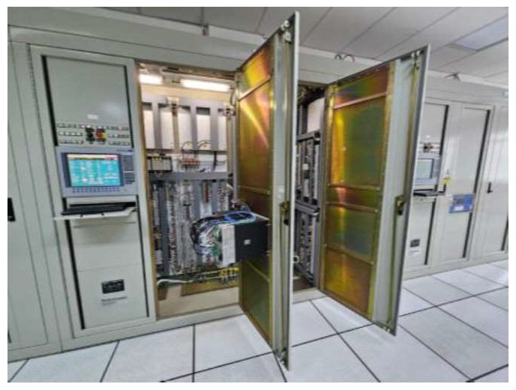

Flex Input/Output (110) System Flex 1/0 Redundant ControiNet

Adapter Module

Flex 1/0 Terminal Base

Flex 1/0 16-Channel Discrete Input Module

Flex 1/0 2/2-Channel Analog 1/0 Module

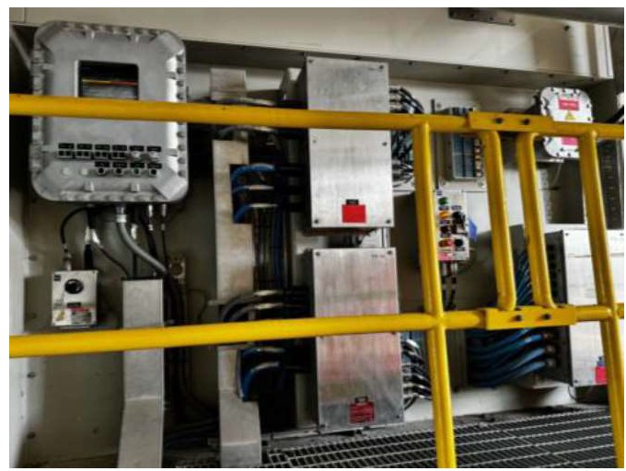

Flex 1/0 4-Channel Analog Output Module

Flex 1/0 Fast-Speed Input Module

Flex 1/0 8-Channel Discrete Output Module

Flex 1/0 10/6-Channel Discrete 1/0 Module

Flex 1/0 16-Channel Discrete Output Module

Flex 1/0 8-Channel Thermocouple/RTD Input Module

Turbine Control and Interface

4 units

4 units

Turbine

Digital Display Terminal Display Computer

Programming Computer

Vibration Monitoring System Power Supply

Rack Interface Module

Keyphasor Interface Module

4-Channel Relay Module

Proximitor/Seismic Monitor Module

TDXNET Communication Processor

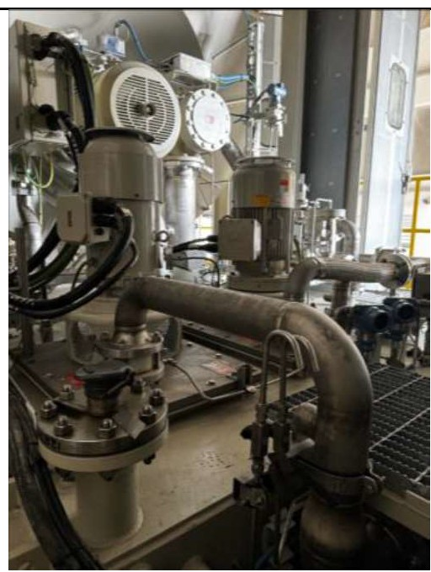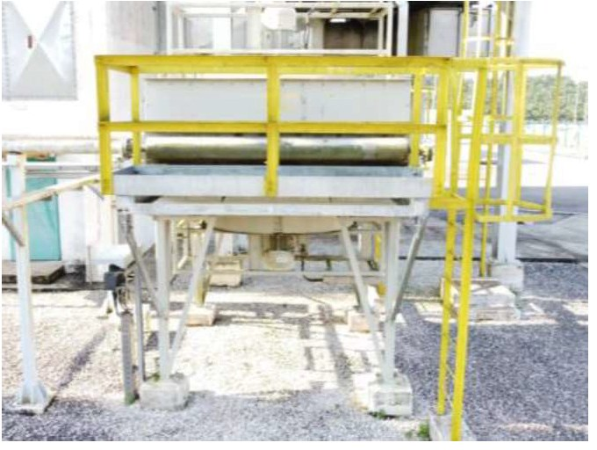

* 1. Lube Oil

System

Main Lube Oil Filter Check Valves Filters/Strainers Air/Oil Separator Flow Sight Glasses Fixed Orifices Transfer Hand Valve Lube Oil Heater Lube Oil Cooler Hand Valves

Level Indicators Level Transmitter Motors

Pumps

Pressure Control Valve Pressure Differential

Transmitter

Pressure Switches Pressure Safety Valves Pressure Transmitters Lube Oil Tank

Temperature Control Valve Temperature Element

4 units

Vibration Switch Flame Arrestor

* 1. Fire & Gas Local Operating Network 4 units

System

Controller

Enhanced Digital Input/Output (EDIO) Module

Flame Detectors Thermal Detector Thermal Sensor Gas Detector

Primary, Extended, and Subsequent Release Solenoid Valves

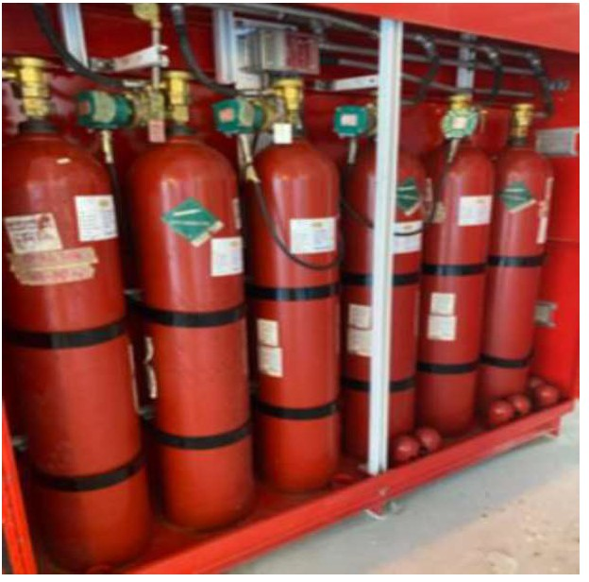

C02 Fire Cylinder Cabinet C02 Nozzles

Release Confirm Pressure Switch

Audile Alarms/Strobe Light Strobe Light

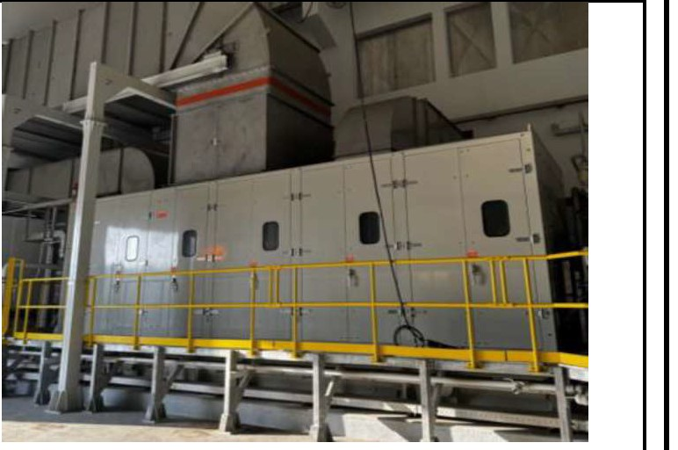

### 1.8

Enclosure and Enclosure 4 units Air Inlet System

Doors

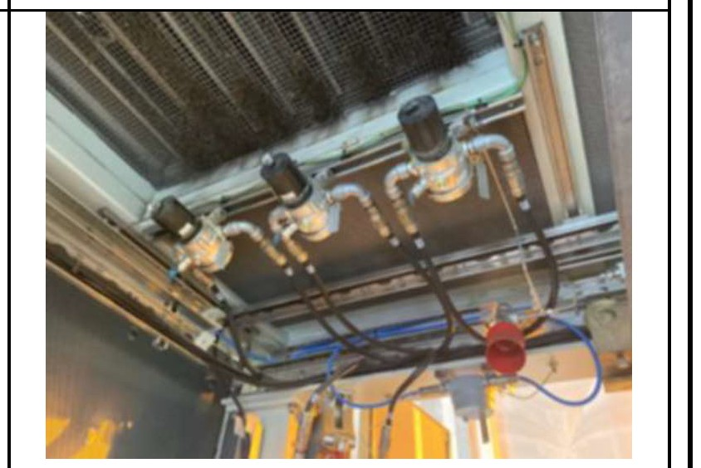

Door Position Alarm

Enclosure Ventilation Silencers Ventilation Fan

Dust Protection Filters Differential Pressure Switch Backdraft Dampers

Fire Dampers Pressurization Lighting System Trolley Beam

Air Inlet System Air Cleaner

Air Inlet Filter Differential Pressure Transmitter

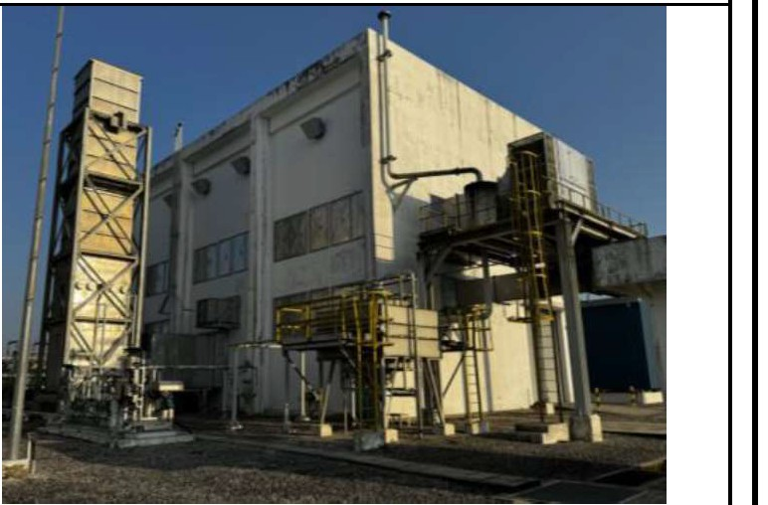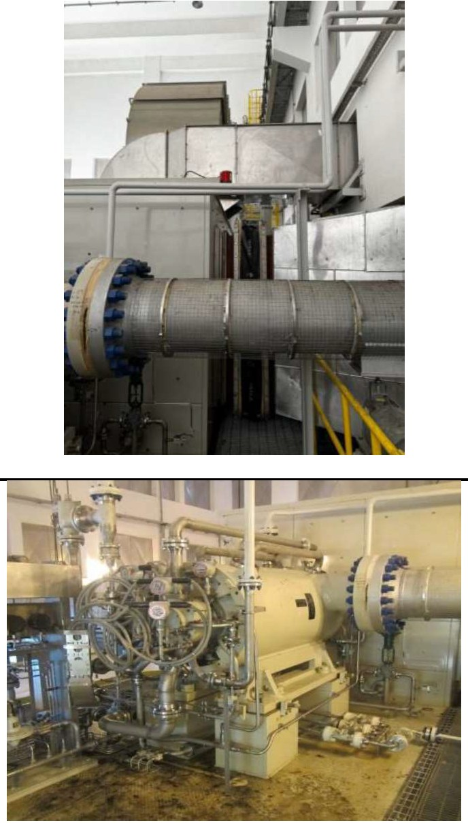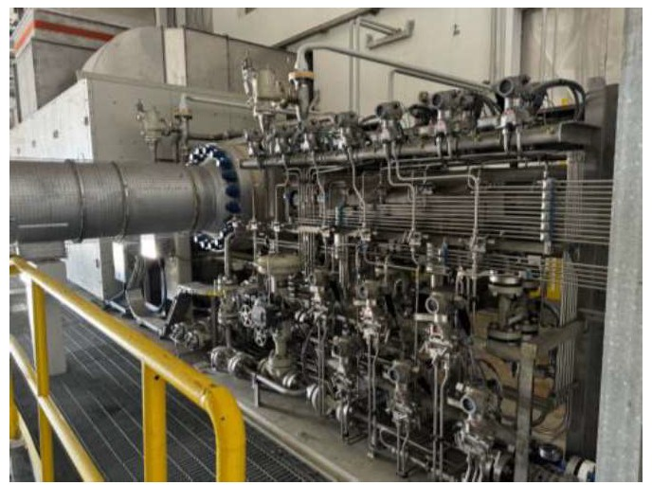

|  |  |  |  |  |  |  |
| --- | --- | --- | --- | --- | --- | --- |
|  |  | Air Air | Inlet Dueling |  |  |  |
| 1.9 | Exhaust Stack | Exhaust System Exhaust Bellows Exhaust Silencer Exhaust Drain | | 4 units |  |
| 2.0 | Gas Compressor | Tag Number: BUA-K-2401, BUA-K-2501, BUA-K-2201, BUA-K-2301  Design Pressure: 96 barg Design Temperature:  117°C/0°C  Design Flow Rate: 270 MMSCFD  Manufacturer Dresser-Rand Model: D107RS  Rated Capacity Inlet: 3,688.5 ACFM  Rated Power: 9,308 kw  MAOP: 106.5 barg  Allowable Working Temperature: 193.3°C/- 28.890C  Minimum Operating Speed: 5060 rpm  Max Continuous Speed: 8,856 rpm | | 4 units |  |

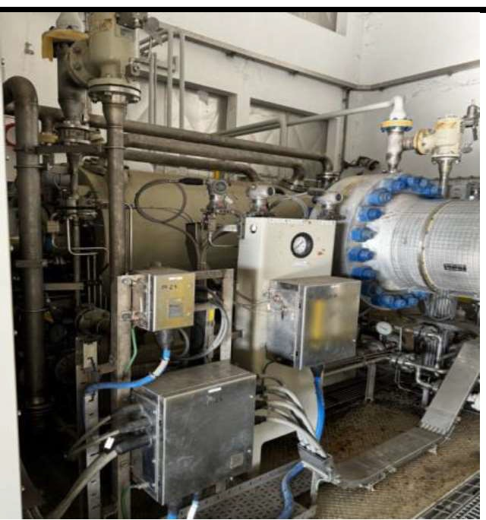

|  |  |  |  |  |  |  |
| --- | --- | --- | --- | --- | --- | --- |
|  |  | Trip :9,289 **RPM**  Driver type : Gas Turbine Compressor Type : Centrifugal Compressor Stage : 7 stages |  |  |  |  |
|  | | | | | | |

**APPENDIX - I**

#### Main Gas Turbine and Compressor Package (GTCP)

|  |  |  |  |  |
| --- | --- | --- | --- | --- |
| No | Equipment Name | Specification | Quantity | Offer Price (RM) |
| 1.0 | Gas Turbine Package KT-2401, KT-2501, KT-2201, KT-2301 | | | |
| 1.1 | Turbine Engine | Manufacturer: Solar Model: Titan 130-20502  Two-shaft, axial-flow design  Air Inlet Assembly Compressor Case Assembly Compressor Rotor Assembly Fuel Manifold  Compressor Diffuser Bleed Valve Assembly  Combustor Liner Assembly Torch Igniter Assembly  First-Stage Diaphragm Assembly Gas Producer Rotor Assembly Third-Stage Nozzle Assembly Power Turbine Bearing Support Housing  Power Turbine Rotor Assembly  Fourth- Stage Nozzle Assembly Turbine Exhaust Diffuser Exhaust Collector  Forward Support  Engine Rear Mount Assembly | 4 units |  |
| 1.2 | Fuel System | Pneumatic Actuated Valves  Check Valves Electric Actuators  Electric Fuel Control Valves Fuel Flow Meter Filters/Strainers  Fixed Orifices  Gas Fuel Flow Transmitter Pneumatically Actuated Valves Hand Valves  Pressure Control Valves Pressure Differential Switch  Pressure Differential Transmitters Pressure Safety Valves  Pressure Transmitters  Speed Element Solenoid Valves Engine Cleaning Tank Temperature Elements Thermowell Displacement Probes | 4 units |  |

|  |  |  |  |  |  |  |
| --- | --- | --- | --- | --- | --- | --- |
|  | 1.3 | Unit Control System Power | Power Supply Module Battery Charger  Battery Banks | 4 units |  |  |
| 1.4 | Start System | Line Reactors Motors  Variable Frequency Drives (VFD) | 4 units |  |
| 1.5 | Unit Control  System | ControlLogix Controller Assembly  ControlLogix Chassis  In-Chassis Power Supply ControlLogix Processor Module ControlNet Interface Module Modbus Module  Ethernet Communications Module  Flex Input/Output (I/O) System Flex I/O Redundant ControlNet Adapter Module  Flex I/O Terminal Base  Flex I/O 16-Channel Discrete Input Module  Flex I/O 2/2-Channel Analog I/O  Module  Flex I/O 4-Channel Analog Output  Module  Flex I/O Fast-Speed Input Module Flex I/O 8-Channel Discrete Output Module  Flex I/O 10/6-Channel Discrete I/O Module  Flex I/O 16-Channel Discrete Output Module  Flex I/O 8-Channel Thermocouple/RTD Input Module  Turbine Control and Interface Turbine Control Panel  Digital Display Terminal Display Computer Programming Computer  Vibration Monitoring System Power Supply  Rack Interface Module  Keyphasor Interface Module 4-Channel Relay Module  Proximitor/Seismic Monitor Module TDXNET Communication Processor | 4 units |  |
|  | | | | | | |

|  |  |  |  |  |  |  |
| --- | --- | --- | --- | --- | --- | --- |
|  | 1.6 | Lube Oil System | Main Lube Oil Filter Check Valves  Filters/Strainers Air/Oil Separator Flow Sight Glasses Fixed Orifices Transfer Hand Valve Lube Oil Heater  Lube Oil Cooler Hand Valves Level Indicators Level Transmitter Motors  Pumps  Pressure Control Valve  Pressure Differential Transmitter Pressure Switches  Pressure Safety Valves  Pressure Transmitters Lube Oil Tank  Temperature Control Valve Temperature Element  Thermowells Vibration Switch Flame Arrestor | 4 units |  |  |
| 1.7 | Fire & Gas System | Local Operating Network Controller  Enhanced Digital Input/Output (EDIO) Module  Flame Detectors Thermal Detector Thermal Sensor Gas Detector  Primary, Extended, and Subsequent Release Solenoid Valves  CO2 Fire Cylinder Cabinet CO2 Nozzles  Release Confirm Pressure Switch Audile Alarms/Strobe Light  Strobe Light | 4 units |  |
|  | | | | | | |

|  |  |  |  |  |  |  |
| --- | --- | --- | --- | --- | --- | --- |
|  | 1.8 | Enclosure and Air Inlet System | Enclosure Doors  Door Position Alarm  Enclosure Ventilation Silencers  Ventilation Fan  Dust Protection Filters Differential Pressure Switch Backdraft Dampers  Fire Dampers Pressurization Lighting System Trolley Beam  Air Inlet System Air Cleaner  Air Inlet Filter Differential Pressure  Transmitter  Air Inlet Silencer  Air Inlet Ducting | 4 units |  |  |
| 1.9 | Exhaust Stack | Exhaust System Exhaust Bellows Exhaust Silencer  Exhaust Drain | 4 units |  |
| 2.0 | Gas Compressor | Tag Number: BUA-K-2401, BUA-K-  2501, BUA-K-2201, BUA-K-2301  Design Pressure: 96 barg Design Temperature: 117°C/0°C  Design Flow Rate: 270 MMSCFD Manufacturer Dresser-Rand Model: D107RS  Rated Capacity Inlet: 3,688.5 ACFM Rated Power: 9,308 kw  MAOP: 106.5 barg  Allowable Working Temperature: 193.3°C/-28.89°C  Minimum Operating Speed: 5060 rpm Max Continuous Speed: 8,856 rpm  Trip Speed : 9,289 RPM Driver type : Gas Turbine  Compressor Type : Centrifugal Compressor Stage : 7 stages | 4 units |  |
|  | | | | | | |