**1 Unit Cummins C1100 D5B**

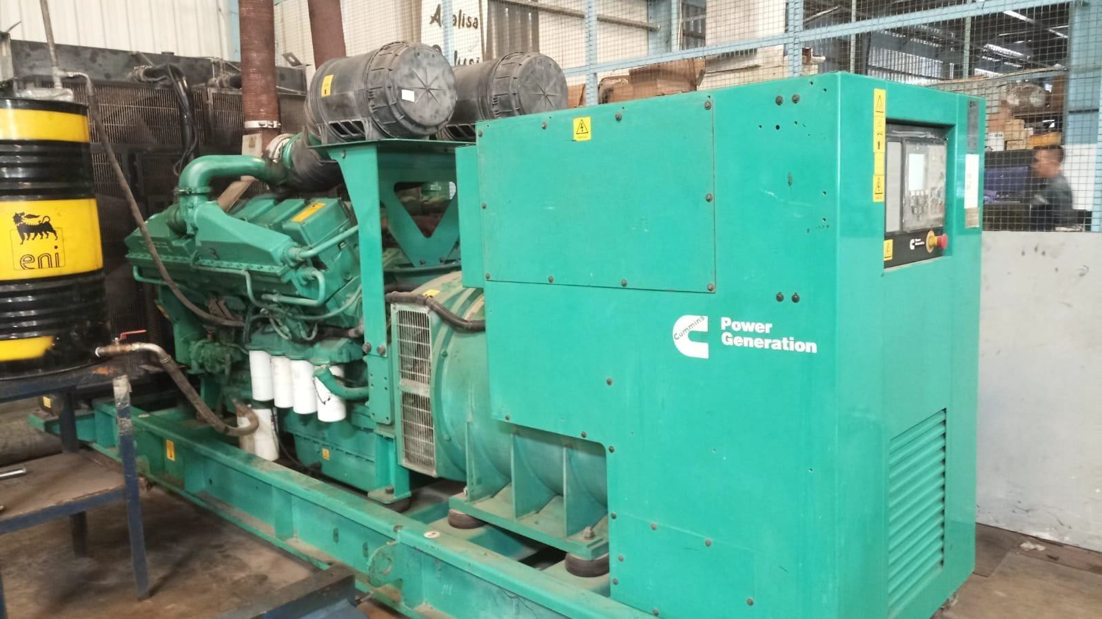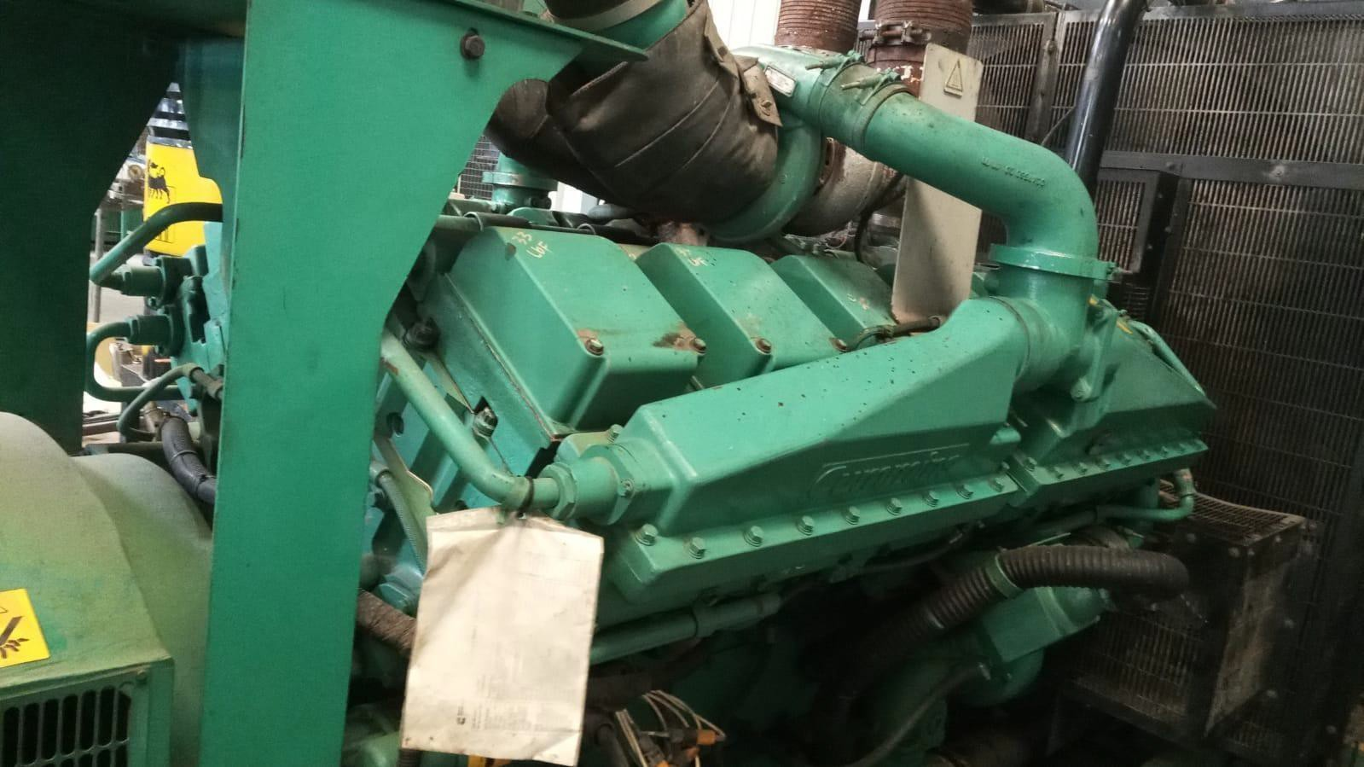

|  |  |  |  |  |  |  |  |  |  |
| --- | --- | --- | --- | --- | --- | --- | --- | --- | --- |
| **No** | **Manufacturer** | **Serial No.** | **Year of Manufacturer** | **Running Hours** |  | **HZ** | **Rated Voltage** | **KVA** | **KW** |
| 1 | Cummins | A15K465307 | 2015 | 617 | 50 |  | 380 | 1110 | 888 |

Price Quotation :

Price/Unit USD $160.000 (one hundred sixty thousand Us Dollars)

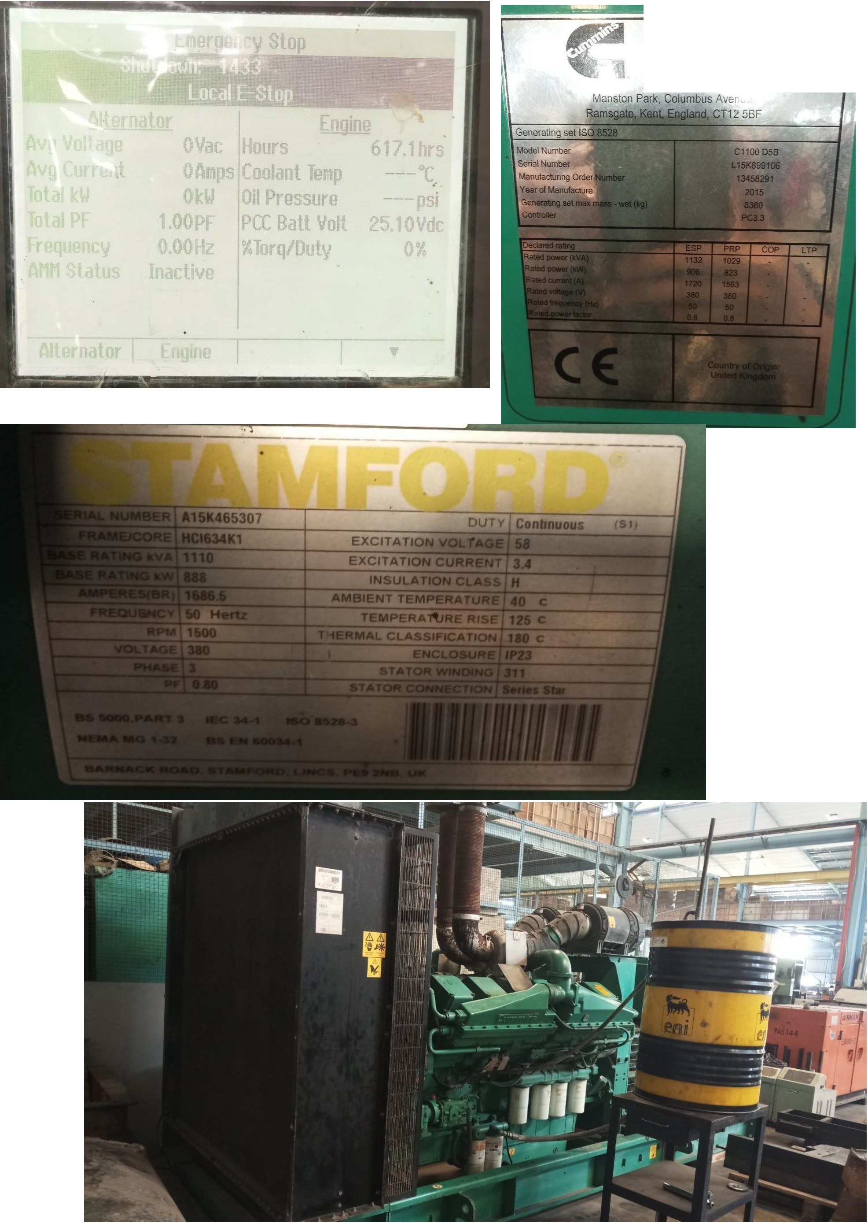

GQ...., 2re *-="' "*

**Power**