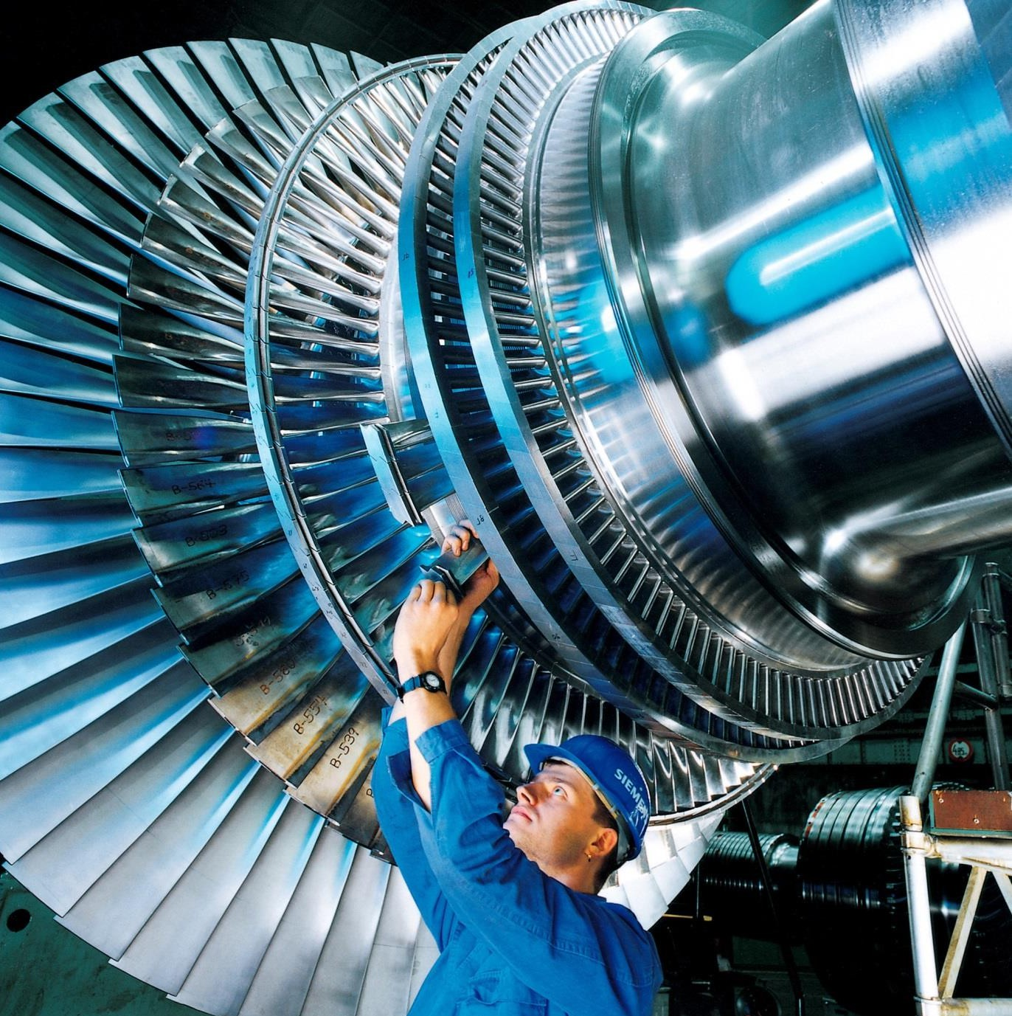

PLC EQUIPMENT FOR SALE

**Two (2) Siemens TG50D5/W701DS**

**127.8 MW Gas Turbine Generator Packages**

**Contents**

1. EXECUTIVE SUMMARY 3
2. WARRANTIES 3
3. MAIN EQUIPMENT DESCRIPTION 3
4. EQUIPMENT LIST 5
5. GENERAL REMARKS FOR RELOCATION 7
6. MAINTENANCE PROGRAM 8
7. DISMANTLING AND PACKING 8
8. CONCLUSION 8
9. LAYOUT OF THE GT POWER ISLAND 9
10. PICTURES 10

# EXECUTIVE SUMMARY

Owners is offering two (2) Siemens Westinghouse TG50D5/W701DS 127.8 MW gas turbine generator packages for sale. The turbine packages together offer 255 MW ready to ship equipment. This technology is one of the most widespread middle size engines (100-104 MW) for power generation and the only turbine of its size that can operate on heavy fuel oil (HFO).

The units are offered with some of the required balance of plant by separate negotiation

These units were installed and operated at the former Turin Turbigo Power Station from 1996 until the end of 2004, when they were dismantled as the result of a plant upgrade. The units were purchased and upgraded by Turbocare SpA (now known as EthosEnergy Italia S.p.A. (“Ethos”) to 127.8 MW nominal capacity each. Ethos also fully refurbished the units to zero hours. The turbines have the capability of being able to switch between natural gas and liquid fuel while still operating under load.

# WARRANTIES

The units have been carefully stored in Italy since the time of the major overhaul the gas turbine and of generator assemblies including stator and rotor overhauls which completed in 2010. Ethos also upgraded the gas turbine longitudinal sections to 127.8 MW ISO condition according to the OEM technical specification.

Warranties at a cost will be available from Ethos subject to their inspection and some minor servicing (seal replacements etc) of the machines which have been stored for in excess of 10 years

Full overhaul reports are available.

# MAIN EQUIPMENT DESCRIPTION

## Equivalent Operating Hours

|  |  |  |
| --- | --- | --- |
|  | **Unit 1 “TG E”** | **Unit 2 “TG C”** |
| In-service year | 1995 | 1995 |
| Equivalent Hours | 40,113 | 49,064 |

It should be noted that both units were refurbished to zero hours for routine overhaul periods.

## ISO Performance

|  |  |
| --- | --- |
| Net Electric Output | 127.8 MW |
| Heat Rate OCGT | 11,149 kj/kWh |
| Efficiency OCGT | 32% |
| Efficiency CCGT | 52% |

# EQUIPMENT LIST

Each of the two (2) gas turbine operating islands comprises:

## Gas Turbines W701DS

Module for outdoor installation and suitable for distillate, HFO and natural gas operations.

## ABB 50 Hz Synchronous Generator

Module, hydrogen cooling type,

## Balance of Plant

Available by separate negotiation and confirmation by purchaser of condition and location at Fagioli, Turin.

## Electrical Package

* + - Generator Circuit Breaker;
    - Starting System Board and Transformer (1 packages for 2 power islands).
    - Static frequency controller
    - Barring gear

## Mechanical Package

* + - Common Lube Oil System for the Gas Turbine and Generator
    - Gas Fuel System Skid
    - Liquid Fuel System Skid
    - Cooling Water Skid
    - Water Injection Skid
    - Liquid Fuel Forwarding Skid
* Rotor jacking oil system and hydrogen oil system.

## BOP Required

Much of the necessary BOP required to operate the Gas Turbines has been scrapped as unserviceable or because of storage constraints. This includes major items such as:

* + Air filters
  + Exhaust stacks and silencers
  + Controls and Instrumentation
  + Water and Air coolers
  + GSU and Auxiliary Transformers
  + Equipment housings, access ladders and walkways, pipe racks etc

## The purchaser will need to have an examination, inventory and valuation (by Ethos or others) of the above remaining BOP to enable them to make an offer.

# GENERAL REMARKS FOR RELOCATION

## NOx Abatement.

A water demineralised system for NOx abatement will be required if the country of destination has stringent anti-pollution rules. If they are less stringent, it is possible to run the units without water demineralisation system but with a 250ppm Nox emission.

With water injection benefits are (at ISO conditions and base load): Natural gas fuel emissions below 35 ppmv Nox corrected to 15% O2. o #2 distillate fuel emissions below 140 ppmv Nox corrected to 15% O2

# MAINTENANCE PROGRAM

The W701DS maintenance program provides for four types of inspections differing in scope and interval:

|  |  |
| --- | --- |
| Combustion System Inspection (ISC) | 1 week, 6 men per 8 hrs/day |
| Reduced Hot Part Inspection (RPCr) | 3 weeks, 6 men per 8 hrs/day |
| Hot Gas Path Inspection (RPC) | 7 weeks, 6 men per 8 hrs/day |
| General Revision (RGTG) | 11 weeks, 6 men per 8 hrs/day |

The maintenance interval on the basis of the equivalent hours (EH) are:

|  |  |
| --- | --- |
| ISC | 8,000 EH |
| RPCr | 16,000 EH |
| RPC | 24,000 EH |

# DISMANTLING AND PACKING

Dismantling and packing was performed by the OEM with maximum care and according to accepted standards which preserve all the equipment, machinery and parts, and will allow the re-erection work in the new site of destination without any disturbance. The dismantling and packing works were performed in the following order:

* + Removal of any kind of oils, grease, chemicals, water, etc. contained in the equipment at the start of the dismantling works.
  + Disconnection of joints, gears, etc. Between machinery with maximum care in order to avoid damage between the parts.
  + Disconnection of anchor bolts.
  + Dismantling of equipment and machinery
  + Protective packing arrangements to secure the dismantled component for transportation and storage and to preserve them from humidity.

# CONCLUSION

The W701DS technology is designed for dual fuel use with capability of switching between natural gas and distillate /HFO while still operating under load. HFO is often used as a backup fuel for peaking power plants in case the supply of natural gas is not sufficient. In other cases when natural gas may be threatened or interrupted HFO is used as the substitute fuel for power plants.

1. **LAYOUT OF THE GT POWER ISLAND (Turbigo P.S.)**

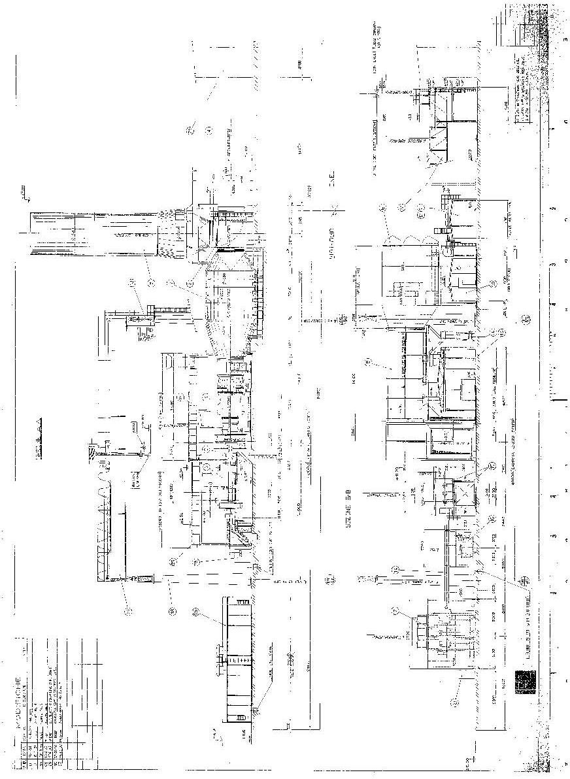

# PICTURES

[For illustration purposes only – virtually all the Balance of Plant has been scrapped]

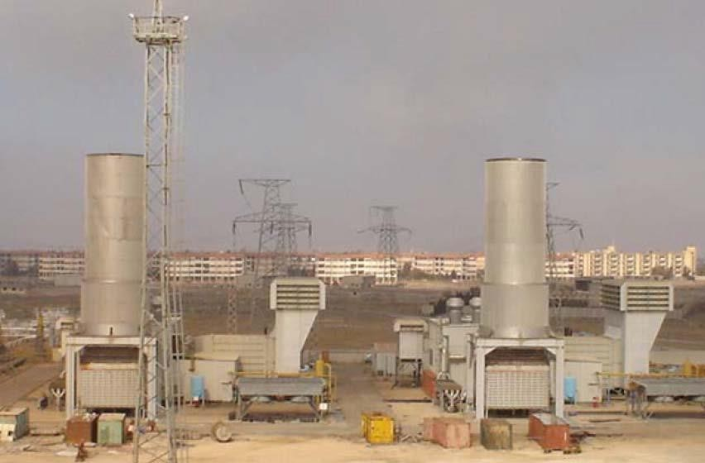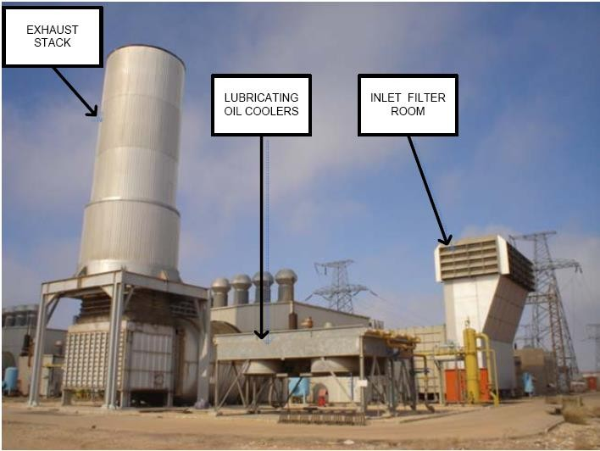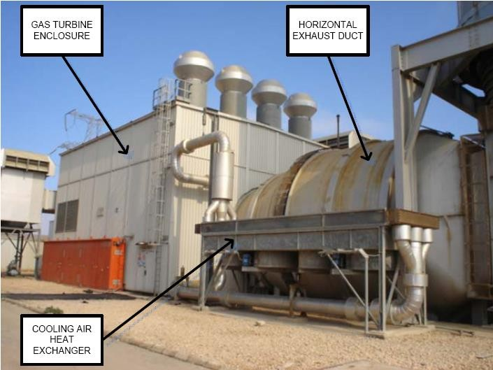

**OWNERS PLC**

5 St. John’s Lane

London EC1M 4BH

United Kingdom

Telephone: +44 20 7549 2839 [www.Owners.com](http://www.rurelec.com/)

Main Contact Person: Andy Coveney +44 7710 836312 [andy.coveney@coveneyassociates.com](mailto:andy.coveney@coveneyassociates.com) Contact (Legal matters): Maria Bravo (Company Secretary) [mbravo@Owners.com](mailto:mbravo@rurelec.com)

Contact (Technical Matters): Gerry Blake (Consultant Engineer)