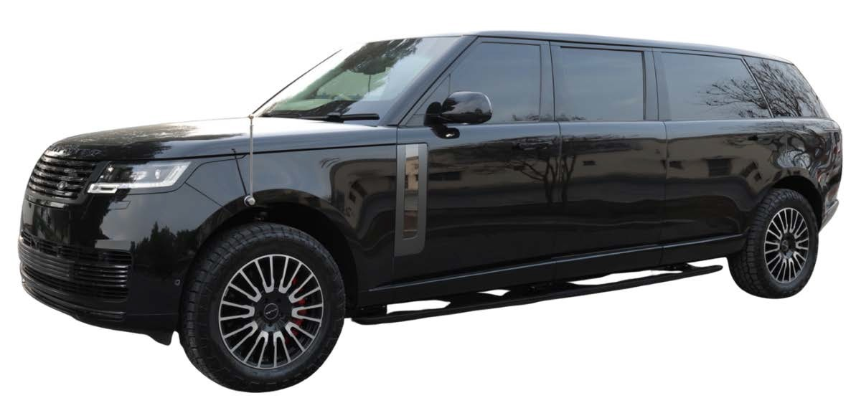

**1** | P a g e



### BR6 level is armored using materials, both opaque and transparent, that meet or exceed the requirements of the European CEN 1522/23 and CEN 1063 / NIJ IV standards to the level FBR6 for opaque areas and BR6 for transparent areas.



e



### All the armoring works are performed at our fully-equipped manufacturing facility, where we have a team of experienced and certified engineers and technicians on hand. To ensure we deliver quality armoring solutions, HS adheres to international ballistic standards (CEN, NIJ, VPAM, STANAG). Our in-house quality management system is ISO 9001:2008 certified, and we have achieved third- party ballistic certifications for our materials and processes

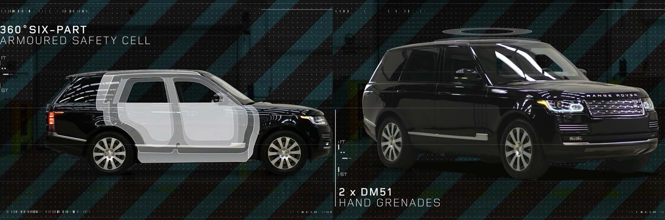

**2** | P a g

LAND ROVER RANGE ROVER 2025MY BR6 LEVEL ARMORED



1

2 4 5

3

6

7

9

8 10

#### ARMORING DESIGN

1. Cabin: The armoring is integrated inside the vehicle’s cab and forms a complete self-supporting structure to avoid excessive stress on the vehicle’s original structure, made of special steel comprising doors, a body firewall, a roof and others.
2. Bullet Proof Window Glasses and Wind Shield for protection against bullets and blast.
3. The battery and control module of the engine are protected to the same level as the opaque areas.
4. The interior armor-frame provides overlap for the large-surface armor components such as the door armor-plates and the windows.
5. Bulk Head : An ***Armored bulkhead*** is installed behind.
6. Upgraded suspension to cope with the additional weight due to armouring
7. Heavy-duty hinges with in-built door-stop. Hinge mounting points are reinforced both in the pillars and in the doors in a way that the armoring of the door is supported by the armoring of the pillar
8. The floor of the vehicle is designed to defeat DM 51 Grenade. Explosion proof blanket made of ballistic steel.



1. Armoring of Fuel Tanks.

**3** | P a g e

1. Hutchinson Run-Flat devices have been installed on all wheels. Forced drive running can be maintained even if a tire goes flat.

LAND ROVER RANGE ROVER 2025MY BR6 LEVEL ARMORED



Vehicles offers a specialized line of armored SUVs for those who value peace of mind over everything else. We have

35,000 square-foot production facility, which enables us to accomplish the most detailed and extensive of contracts quickly and cost-effectively.

1. *Batteries and computer are stored in a bullet-proof case.*
2. *Bullet-proof window glass is designed and processed to fit to the overlapping mounted to pillars.*
3. *First Class Finishing of Bullet-Proof glass and ceiling trim.*
4. *Armored/Bullet-proof rear bulkhead.*
5. *Armored/Bullet-proof glass and doors fit to the vehicle body snugly with any positional displacement or deformation.*
6. *The fuel tank is protected with an armored explosion-proof cover.*

*The whole underfloor function as a*

*protector by preventing invasion of fragments and blast caused by explosions of DM51 NATO grenades.*

1. *Firewall: Armored/Bullet-proof Partition*
2. *Heavy-Duty suspension to handle the extra weight added due to armoring.*

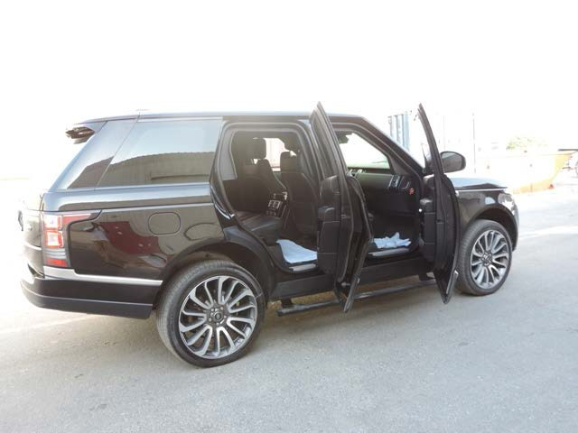

**BULLET PROOF WINDOW GLASS IS DESIGNED AND PROCESSED TO FIT THE OVERLAPPING MOUNTED TO PILLARS**

**4** | P a g e

LAND ROVER RANGE ROVER 2025MY BR6 LEVEL ARMORED

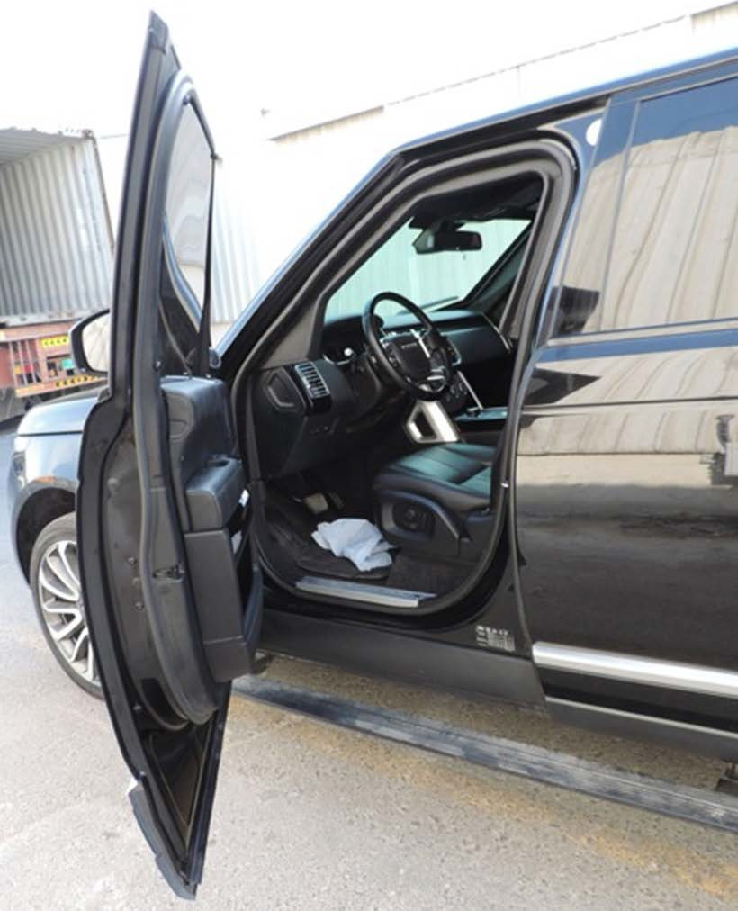

#### Armored Bulk Head with Gun Port

The Armored Bulkhead with Gun Port feature is part of our 360 degree bulletproof protection. In case of rear attack, the bulkhead has a gun port on it that can allow you to counter the attack



**5** | P a g e

## PASSENGER CABIN PROTECTION

The passenger cabin will be well protected according to minimum protection level BR6 including all sidewalls, doors, pillars, roof, ﬂoor, front, bulkhead, and rear door.

Edges and seams are armored by utilizing an overlap design system which minimizes gaps and preventing penetration.

The ballistic steel panels are covered with cathodic dip painting before installation.

The vehicle resembles a normal civilian low proﬁle vehicle – meaning that the vehicle is nearly visually identical to a standard vehicle. Therefore, unwanted attention while travelling is avoided.

## ENGINE BAY PROTECTION

Batteries are to be protected within steel armored boxes within the engine compartment against projectiles and splinters. Armored boxes can be easily removed for maintenance or transportation.

The vehicle management system, including fuse boxes, which controls essential electrical vehicle functions, to be protected with armored steel to level BR6 protect it against splinters and fragmentation.

Full length armored steel to the level of BR6 ballistic certiﬁcation is to be mounted on both sides of the engine compartment behind the vehicle wings protecting the engine compartment.

## FUEL TANK PROTECTION

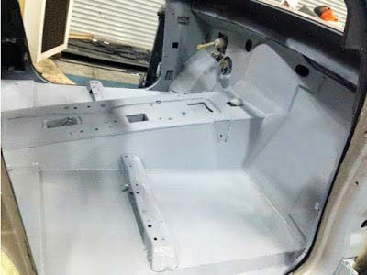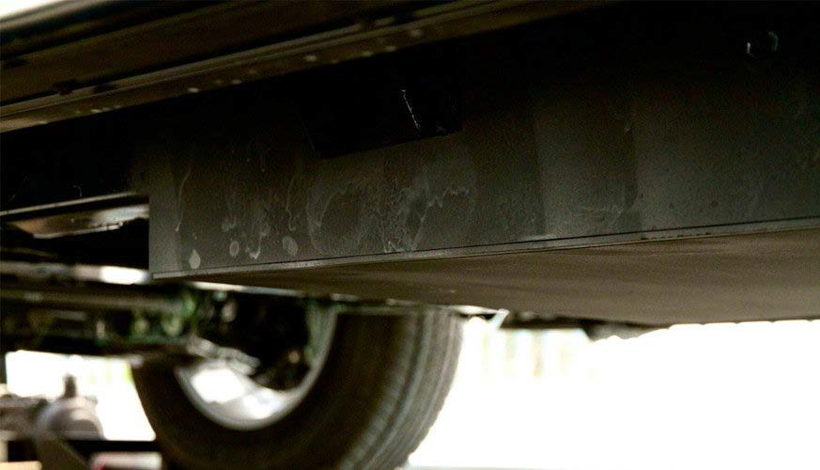

All fuel tanks and fuel pipes will be armored using blast steel to combat ballistic and fragmentation attacks. Fuel line hoses will also be protected against blast and projectiles.

## HEAVY DUTY SUSPENSION SYSTEM

The standard original suspension system will be completely replaced with an engineered-for-purpose high performance suspension system providing constant loading. Off-the-shelf suspension system

components providing temporary loading, such as those manufactured for Armoring applications.



**6** | P a g e

## FIREWALL – ARMORED PARTITION

#### THE WHOLE FLOOR FUNCTIONS AS A PROTECTOR AGAINST INVASION OF FRAGMENTS CAUSED BY EXPLOSIONS

**RUN FLAT DEVICES – HUTCHINSON USA**

**ALL FIVE WHEELS WILL BE FITTED WITH RUN-FLAT SYSTEMS RATED AT 50KM AT A SPEED OF 80 KM/H RUN-FLAT CAPABILITY SUPPLIED BY HUTCHINSON INTERNATIONAL**

**CEN 1063 BALLISTIC RESISTANCE LEVEL 6 - SPECIFICATIONS BR6**

## OPAQUE AREAS

PASSENGER COMPARTMENT REAR BULKHEAD

* Calibre 7.62 x 39 mm, FMJ/PB/HCI, AK 47 Kalashnikov
* Calibre 5.56 x 45 mm, FJ/PB/SCP, M16 Colt **(FB5-FB6)**
* Calibre 7.62 x 51 mm, FJ/PB/SC, FN “FAL/LAR” NATO rifle **(FB6-NIJ III)**

## TRANSPARENT AREAS

* Calibre 7.62 x 39 mm, FJ/PB/FeC, AK 47 Kalashnikov
* Calibre 5.56 x 45 mm, FJ/PB/SCP, M16 Colt (BR5-BR6)
* Calibre 7.62 x 51 mm, FJ/PB/SC, FN “FAL/LAR” NATO rifle (BR6-NIJ III)

**FLOOR** The floor of the vehicle is designed to defeat the following:

* + Two DM 51 hand grenade (German Norm) detonated simultaneously

#### ENHANCED FLOOR PROTECTION

* 1x HG85 (equivalent to M67 Grenade) under vehicle

**FIREWALL & ROOF** The Roof of the vehicle is designed to defeat the following:

* + 2x DM51 Hand Grenade Placed directly on the roof

#### ENHANCED ROOF PROTECTION

**7** | P a g e

* 1x HG85 Hand Grenade (Equiv. to M67 Grenade) Placed directly on the roof

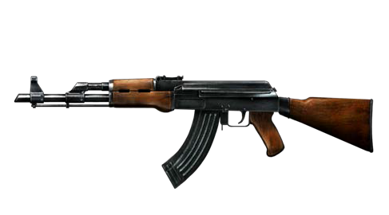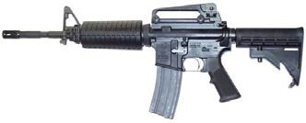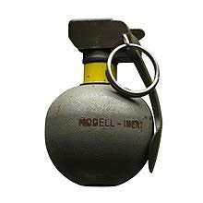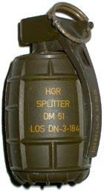

**LEVELS OF CAR ARMOUR**

**BALLISTIC PROTECTION BULLET TYPE THICKNESS ESPESOR**

**84**

Handguns and

Shotguns

# 85

Riffle protection -

AK 47

**86**

High Power Rifle

Protection

# 87

Armour Piercing

Rif le Protection



**-**I **ii**- '



* 9mm
* .38 Secial
* .357 Magnum
* .44 Magnum
* 7.6X33/.30 CAL Carbbine

• 62X39/ AK -47

• 7.62X51 mm/M-80

* .380 Winchester FMJ

• 5.56X45mm/M-l6/l93

* 30.06 AP (Armor Piercing)
  + 32 mm
  + 41 mm
  + 78 mm



#### B6 BALLISTIC SPECIFICATIONS

**9** | P a g e

HS Vehicles in BR6 level are armored using materials that meet or exceed the requirements of the European CEN 1522/23 standard - level FB6 for the vehicle’s sides and rear and level FB6 for the firewall and the roof, and meet or exceed the requirements of US NIJ level IV or CEN 1063 – level BR6 for transparent areas, see details below.

#### ARMORING

All four sides of the passenger compartment and the roof of the vehicle are protected using 8mm high-quality armor steel and 39mm glass defeating 7.62x51mm P80 Nato Ball ammunition (U.S. NIJ level IV, CEN level FB6/BR6) at 0° incidence (90° to the surface) and 10m range according to CEN1063 and CEN1522.

#### OPAQUE AREAS

Both sides of the passenger compartment and the rear bulkhead of the vehicle are protected using 8mm high-quality armour steel defeating the following ammunitions up to the 7.62x51mm P80 Nato Ball (U.S. NIJ level IV, CEN level FB6) at 0° incidence (90° to the surface) and 10m range according to CEN1522.

* Calibre 7.62 x 39 mm, FMJ/PB/HCI, AK 47 Kalashnikov
* Calibre 5.56 x 45 mm, FJ/PB/SCP, M16 Colt (FB5-FB6)
* Calibre 7.62 x 51 mm, FJ/PB/SC, FN “FAL/LAR” NATO rifle (FB6-NIJ III)

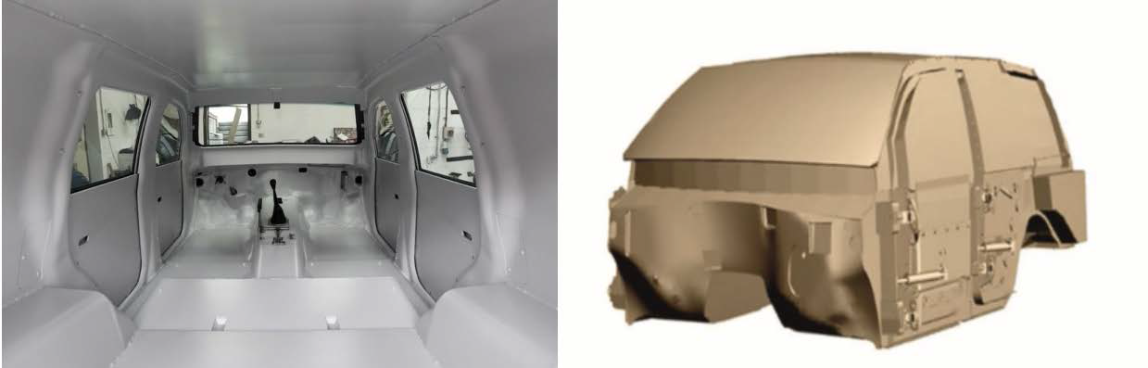

#### TRANSPARENT AREAS

All transparent areas are multi-layer and polycarbonate coated Glass with 39 mm thickness, to protect against the following and lesser weapons/ ammunitions up to the 7.62x51mm P80 Nato Ball (U.S. NIJ level IV, CEN level FB6) at 0° incidence (90° to the surface) and 10m range according to CEN1063.

* Calibre 7.62 x 39 mm, FJ/PB/FeC, AK 47 Kalashnikov
* Calibre 5.56 x 45 mm, FJ/PB/SCP, M16 Colt (BR5-BR6)
* Calibre 7.62 x 51 mm, FJ/PB/SC, FN “FAL/LAR” NATO rifle (BR6-NIJ III)

#### FLOOR (Enhanced Floor Protection)

The floor of the vehicle is designed to defeat the following:

* Two DM 51 hand grenade (German Norm) detonated simultaneously
* Two HG85 (equivalent to M67 Grenade) under vehicle .
* Two DM31 API Landmines.

In addition, the floor also offers protection against anti-personnel mines.

* + Upgraded suspension to cope with the additional weight due to armouring. Homologated heavy-duty suspension, tested and proven for the increased weight
  + Hinges milled from a single piece of steel tested to hold the doors even during the blasts. No sagging guaranteed

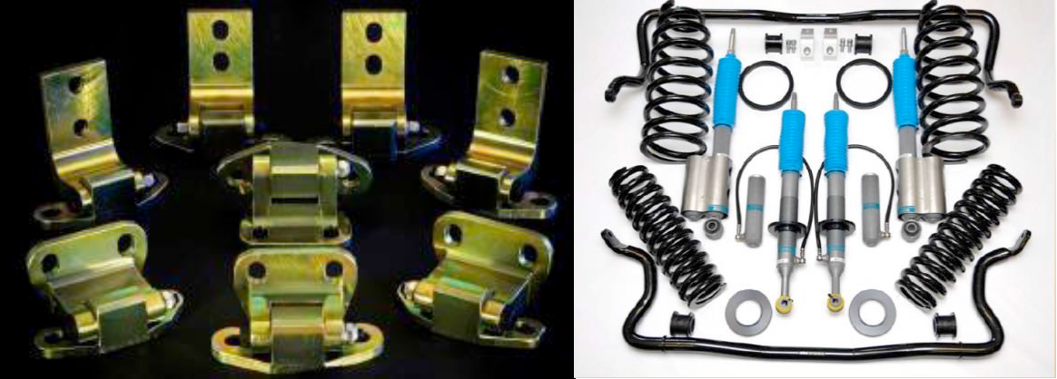

#### Pictures for reference purpose only

**10** | P a g e

**FIREWALL & ROOF (Enhanced Roof Protection)**

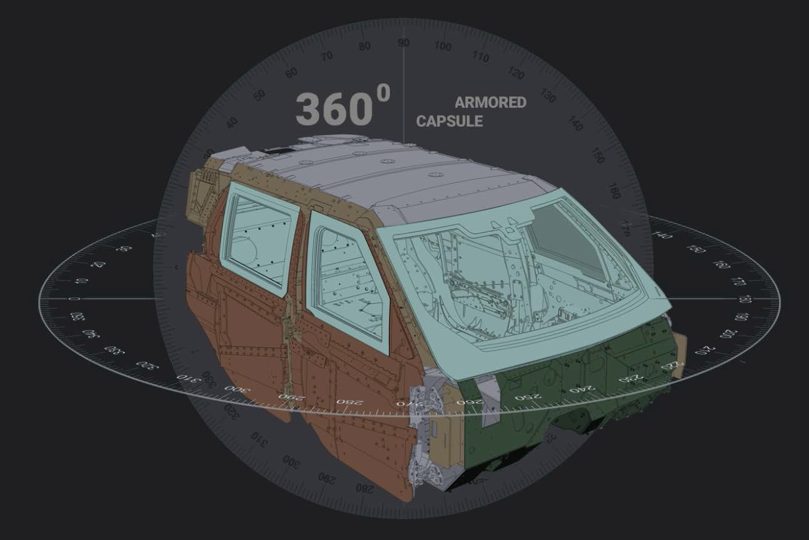

The firewall and the roof are protected using 6.5mm high-quality armour steel defeating the following ammunitions up to the 7.62x51mm M80 Nato Ball

(U.S. NIJ level III, CEN level FB6) at 0° incidence (90° to the surface) and 10m range according to CEN1522.

* Calibre 7.62 x 39 mm, FJ/PB/FeC, AK 47 Kalashnikov
* Calibre 5.56 x 45 mm, FJ/PB/SCP, M16 Colt (FB5-FB6)
* Calibre 7.62 x 51 mm, FJ/PB/SC, FN “FAL/LAR” NATO rifle (FB6-NIJ III)
* 2x DM51 Hand Grenade Placed directly on the roof
* 1x HG85 Hand Grenade (Equiv. to M67 Grenade) Placed directly on the roof
* 2x HG85 Hand Grenades (Equiv. to 2xM67 grenades) placed directly on the roof

#### BGP armored glass ensures maximum security against threats with firearms while maintaining and ensuring the aesthetic and functional performance of the



**11** | P a g e

**original glass. 360 Degree complete body armouring.**

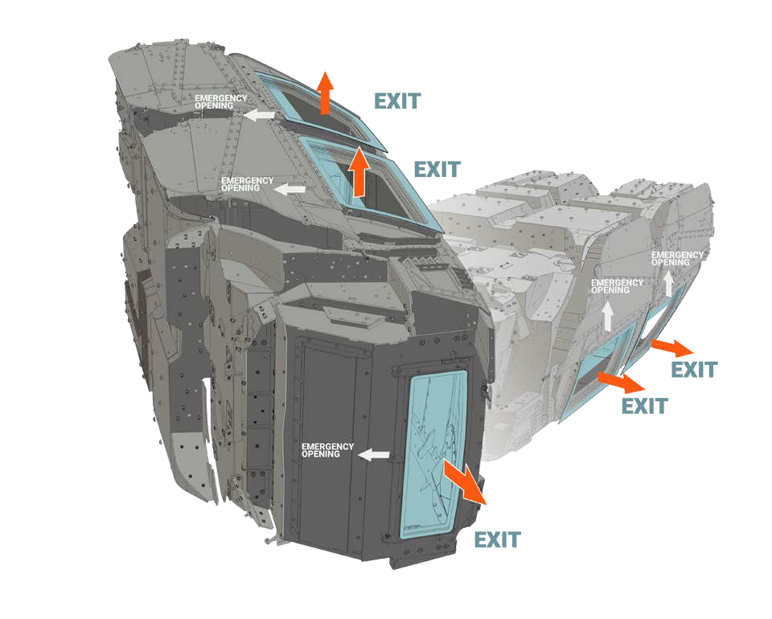

**BATTERY & ECM PROTECTION**

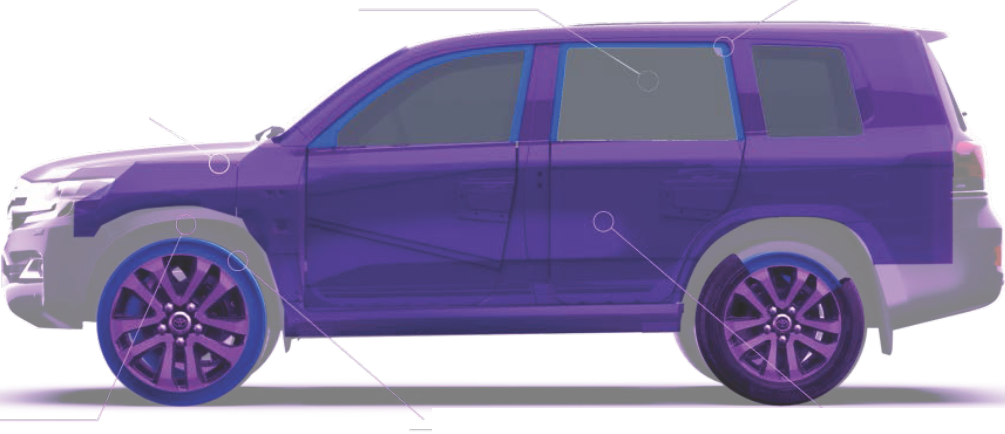

Protects the battery & ECM from blast or fire penetration.

**BALLISTIC GLASS**

High opticalc larity with

ballistic protection.

## OVERLAP SYSTEM

A ll door openings overlapped

with ballistic stee l.

## REINFORCED SUSPENSION

Mainta ins optimalride comfort on any terra1n.

## RUNFLAT DEVICES

Enables operation of vehicle

with punctured tires.

## 360° PERIMETER PROTECTION

Full 360-degree protection of vehic le capsule.



## OEM SPECIFICATIONS:

Range Rover P530 SWB (390kW) Engine Specifications

Type **TWIN TURBO DIR F/INJ**

Size **4395cc, 4.4L**

Power @ RPM **390kW @ 5500rpm (523.0 hp)**

Torque @ RPM **750Nm @ 1800rpm (553.1 lb-ft)**

Cylinders **turbocharged eight-cylinder**

Number of Valves **32**

Valves **VARIABLE DOUBLE OVERHEAD CAM**

Euro Rating **-**

Compression ratio **10.5**

Power/weight ratio **154.9kw/tonne**

Bore/stroke **89mm × 88.3mm (3.5in × 3.5in)**

**13** | P a g e



## TEST REPORTS/ PRODUCT LIABILITY

All materials used in the production of the cabin were successfully tested against projectiles and explosives by independent laboratories. Test reports can be presented upon request or during a factory visit. The armoring of the vehicle provides protection against a wide range of projectiles and explosives. However, complete protection is not possible for reasons of design and modern military weapon technology.



## WARRANTY AND AFTER SALES

HS Vehicles warrants any armor related items installed, and conversion related custom workmanship, including transparent armor*, for the period of 1 year or 20,000km, whichever comes first. Any suspected warranty related work must first be confirmed as being necessary by means of technical consultation with a representative of HS Vehicles.

Warranty work authorized to be directly covered by HS Vehicles shall be performed locally at the nearest authorized facility**, and billing forwarded directly to HS Vehicles. After careful assessment of said invoice, HS Vehicles shall, upon consultation and approval, make payment for any/all repairs deemed to be of a reasonable nature*** by our Warranty Service and Engineering Departments.



**14** | P a g e

**15** | P a g e

|  |  |  |  |  |  |  |
| --- | --- | --- | --- | --- | --- | --- |
| **COMMERCIAL OFFER – BR6 ARMORING FOR Range Rover P530 Autobiography Stretched Version – 2025YM** | | | | | | |
| **ITEM**  **No.** | **ITEM DESCRIPTION** | **COO** | **QTY** | **UNIT** | **ExW RATE** | **ExW TOTAL** |
| 1 | BR6 Level of Armoring USING High Brinel Light Weight Steel - According to CEN 1063, Range Rover P530, 4.4 Ltr V8 Autobiography Long Wheelbase Stretched Version 2025YM | UAE | 1 | UNIT | $ 435,000.00 | $ 435,000.00 |
| 2 | Run Flat Devices on all wheels. | USA | 1 | SET | *STANDARD* | *STANDARD* |
| 3 | Bullet Catcher | SWEDEN | 1 | SET | *STANDARD* | *STANDARD* |
| 4 | ECM, Fuse Box & Battery Protection. | SWEDEN | 1 | SET | *STANDARD* | *STANDARD* |
| 5 | Fender & Fuel Tank Protection | SWEDEN | 1 | SET | *STANDARD* | *STANDARD* |
| 6 | Heavy Duty Suspension System with HD Sway Bar | GERMANY | 1 | SET | *STANDARD* | *STANDARD* |
| 7 | HD Brake Upgrade | UK | 1 | SET | *STANDARD* | *STANDARD* |
| 8 | 18” HD Full Wheel Assembly – Includes - All Terrain Tyres, Runflat, HD Wheels from Hutchinson USA | USA | 1 | SET | *STANDARD* | *STANDARD* |
| 9 | Chassis, with Axle extension of 950+mm | GERMANY | 1 | SET | *STANDARD* | *STANDARD* |
| 10 | Heavy Duty Door Hinges | SWEDEN | 01 | SET | STANDARD | STANDARD |
| 11 | VIP INTERIOR | UK | 01 | SET | STANDARD | STANDARD |
| ***SHIPPING:*** | | | | | | |
| 12 | Shipping Charges | *1 Unit* | | | | *TBD* |
| **TOTAL** | | | | | | **$ 455,000.00** |
| **USD Four Hundred and Fifty Five Thousand Only** | | | | | | |

**16** | P a g e

|  |  |
| --- | --- |
| **BUYER** | |
| **PROPOSAL REFERENCE** | 08-19-24-HSV-BR6 Range Rover P530 Autobiography Stretched Version 2025YM - VIP - RHD |
| **DATE** |  |

## PAYMENT AND DELIVERY TERMS

|  |  |  |  |
| --- | --- | --- | --- |
| **VEHICLE ORDER** | **MANUFACTURING LOCATION** | **MANUFACTURING DATE** | **COMPLETION DATE** |
| 1 | UAE | Upon Confirmation of Order and Advanced payment | EX-Works in 160 Days from the date of CHASSIS RECIEPT |

* 80% advance payment on price is due on order for new production vehicles.
* Full payment of price is required within 5 working days of Buyer receiving notice of completion of the vehicle and prior to shipping/releasing vehicles for shipping.

Please contact us if you require any further details or assistance from our side.

