**TWO (2) SIEMENS WESTINGHOUSE W701DS GAS TURBINE GENERATOR SETS SPEC**

# January 2025

# INTRODUCTION

Energy Experts Now (EEN) offers for sale two (2) Siemens Westinghouse W701DS Gas Turbine Generator Sets. These are the upgraded version of the W501D models which were manufactured by Fiat who designated them as TG50D5 units under a licence from Westinghouse, presently a Siemens Company.

The W501D gas turbines were initially installed and operated at the former Turin Power Station in Italy for three years before being dismantled. After that limited operation, these units were upgraded by Siemens to W701DS models with 127.8MW nominal capacity each. Siemens also fully refurbished the units to zero hours.

EEN is able to offer both units for sale at a competitive price to a buyer with a requirement for ready-to-ship equipment which can provide over 250 MW in modular units of 127.8 MW with 52% thermal efficiency if installed in combined cycle.

The units are packaged and stored ready to be shipped immediately. The units have been kept at an enclosed storage facility and have been inspected by o u r engineers periodically since the zero hour overhaul and upgrade by Siemens. The two units are stored in Italy..

# EQUIPMENT PRESENTATION

The gas turbines had been originally designed by Westinghouse as W501D and were upgraded by Turbocare, a Siemens-Westinghouse company, to the W701DS version with an increased output of 9% and higher efficiency of 1.4% over the previous versions.

The nominal net site output is 127.8 MW at ISO conditions, with 32% efficiency in open cycle and 52% efficiency in combined cycle.

The turbines are **dual fuel, operating both on natural gas and distillate oil** (also **heavy fuel oil – HFO** - following pre-treatment) and are equipped with by-pass stacks for simple cycle operation. This feature of the units, to be able to operate reliably on a variety of gas and liquid fuels, provides very important fuel security in a region where fuel supplies may be disrupted. Moreover, the Siemens-Westinghouse 701DS gas turbines can instantaneously respond to changes in fuel availability by switching fuels while operating under full load.

Each unit is located in a separate enclosure and is equipped with its own inlet filtration system, anti-icing system and water injection for NOx abatement.

A warranty for 8,000 hours, or 12 months from first fire, can be negotiated at extra cost if required.

# MAINTENANCE HISTORY AND CURRENT STATUS

The October 2007 maintenance records for the two (2) W701DS Gas Turbine Generator sets are provided by TurboCare SpA and are exhibited below:

# Unit 1 Unit 2

**In Service Year** 1995 1995

# Equivalent Hours

40,113 49,064

# Previous Maintenance

Hot Part July 03

Major Aug 03

**Stopped** May 06 May 06

# Last Maintenance

Major

To be scheduled

Hot Part Oct 06

# TurboCare Maintenance

Major Aug 07

Major Oct 07

In addition to this, TurboCare SpA conducted a major overhaul of all generator assemblies including stator and rotor overhauls at a cost of some euros €5 million. TurboCare SpA also upgraded all gas turbine longitudinal sections to 127.8MW according to the OEM technical specification. The overhaul and upgrade results, as well as the aftermath performance test results, may be made available upon request.

The standard overhaul warranty provided by TurboCare SpA at ISO conditions was:

* Net Power Output of 127,800 kW;
* Heat Rate of 2,664 kCal/kWh

The upgrading warranty provided by TurboCare SpA at ISO conditions guaranteed:

* Power increase of 4.2%;
* Heat Rate improvement of 0.6%;
* Exhaust Temperature increase of 12 0C.

All figures make reference to ISO conditions, base load, dry natural gas, open cycle and with GT auxiliaries only.

# POTENTIAL USE OF 701DS TECHNOLOGY

The 701DS technology is one of the most widespread middle size engines (100-140MW) for power generation.

These gas turbines are designed for dual fuel use with capability of switching between natural gas and HFO while still operating under load. HFO is often used as a backup fuel for[peaking](http://en.wikipedia.org/wiki/Peaking_power_plant) [power plants](http://en.wikipedia.org/wiki/Peaking_power_plant) in case the supply of natural gas is not sufficient. In other cases when natural gas supply may be threatened or interrupted, HFO is used as the substitute fuel for the power plants.

This flexibility to switch fuels is a very important advantage of the 701DS. In respect to fuel type, within reason any and all heavier grades of fuel can be used as these are less sensitive to fuel quality issues than the latest generation of H Class gas turbines.

The application of 701DS in power industry gives power producers an advantage of economic flexibility, switching to fuel oil when natural gas prices become expensive.

HFO can find a widespread application in developing economies where the thirst for energy is not met by existing capacity and where petroleum products remain key to satisfying that power demand. In such countries as United Arab Emirates, Bangladesh, Indonesia and countries across the Middle East that have limited or disrupted natural gas availability, the application of HFO can provide solution for power shortages in these regions.

# POSSIBLE CONFIGURATIONS OF 701’S

In simple cycle, the 701DS is a reliable machine with 127,800 kW net power output ISO conditions and 32% efficiency, which can serve as low cost machine for peaking services. In combined cycle it gives excellent fuel savings with 52% efficiency in base load operations.

For combined cycle applications, IPC can propose to either supply equipment only, or build and operate 1 x 400 MW power plant comprising of:

* Two (2) Siemens Westinghouse 701DS gas turbines,
* A 140MW steam turbine.
* Two (2) Nooter Erikson HRSGs.

A typical 400 MW combined cycle will look approximately as follows:

GTPRO19.0.1WXPP0105 1.01p

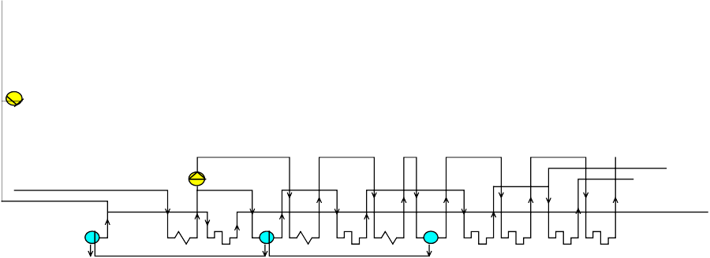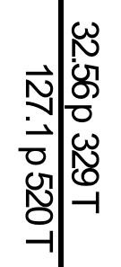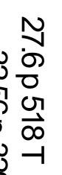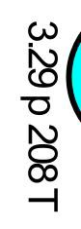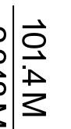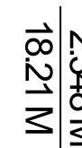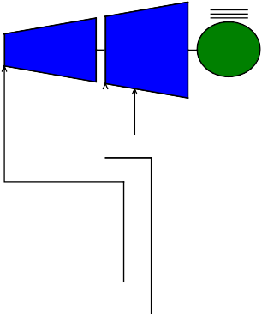

Assumed20CincreaseinFiringTemperatureand5%incrteaseinMass Flowfor 130MWe Net Power 388793kW

LHVHeat Rate6940 kJ/kWh

15T

60%RH

391.4m

1XSGT6-3000E

15.14p

14.54p

398.9m

130318kW

2XGT

1.04p

559T

74.72%N2

13.39%O2

3.356%CO2

7.63%H2O

0melev.

1p 15T

391.4m

406T

1211T

797.8M

0.8999%Ar

140924kW

39T

117.2M

CH47.487m LHV=374727kWth 25T

87T

124p

518T

79.52M

132T

3.8p

142T

0.07p

39T

117M

15.89M 0.05M

98.91M

2

. 3

4

8

M

77.25M

39T

FW

LTE LPB IPE2 LPS IPB HPE2 IPS1 HPE3 HPB1 IPS2 HPS0 RH1 HPS1

RH3 HPS3

98T

797.8M

1.07m^3/kg 853.6m^3/s

3.8p

132T

3.8p

142T

32.25p

233T

3.619p

210T

32.25p

238T

133.5p

295T

31.63p

310T

131.5p

327T

131.5p

332T

31.01p

400T

130.1p

420T

29.99p

460T

128.6p

480T

28.98p

520T

127.1p

520T

558T

797.8M

2.341m^3/kg

1867.6m^3/s

117.2M

18.24M

101.4M 15.89M

21.66M 80.31M

21.66M 80.31M

79.52M

21.66M 79.52M

98.91M 79.52M

* 1. M 79.52M

152 152 198 198 245 248 292 319 325 342 445 450 489 518 534 549 558

p[bar],T[C], M[kg/s],SteamProperties:Thermoflow- STQUIK

64106-24-200920:53:11 file=C:\TFLOW19\MYFILES\Independent PowerWECupgraded501D.gtp

# LIST OF INSTALLATIONS OF W701DS’S AND PHOTOS

Eight (8) W701DS’s have been installed in Syria (Nasserieh and Zayzoon) and equipped for residual oil (RO) operation in Simple Cycle. There is no drawback for the gas turbine to run in combined cycle with RO as compared with simple cycle other than scheduling of maintenance. The matter must be addressed in the design of the boiler and of the thermal cycle, depending on RO chemistry. Also, a fuel oil treatment plant should be designed to treat the residual oil before feeding to gas turbines.

Two (2) W701DS’s have been installed in Iraq and equipped for HFO operation when natural gas is not available. These units have been installed and currently operate absolutely remotely from offices located in Turin, Italy, using the Siemens state of the art remote control system, which can be offered as part of the package for these 701DS units if requested.

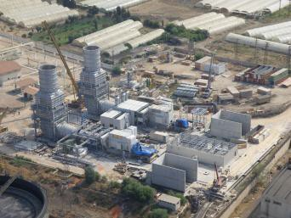

# SCOPE OF SUPPLY

The two (2) GTG sets are offered together with a package of balance of plant (BOP) which further enhances the ability to install and commission the units with minimum delay while waiting for BOP items to be ordered, where there can be long lead times on critical items which IPC is able to offer for immediate delivery. The gas turbines are delivered as nominal 127.8MW machines, each including the following scope of supply:

# Gas Turbine W701DS

* + - GT Engine;
    - GT Foundation Base Plates;
    - GT Exhaust Diverter Cone
    - Dual Fuel Std Combustion System;
    - Turbine Bearing Fire Fighting;
    - On Board I & C Devices;
    - On Board Air Cooling System;
    - On Board Bypass System;
    - GTLS Special Tools (one set for four GTLS).

# Generator

* + - Hydrogen Cooled Generator and Rotors (excitation system included);
    - Generator Stator Base Plates
    - Rotor Jacking Oil System;
    - Hydrogen Oil Sealing System;
    - Generator Assembly Special Tools (one set for four GTLS).

# Control Package

* + - Vibration Motion System (Bently Nevada);
    - Gas Detection System (MSA);
    - Fire Protection Board (Ciodue).

# Electrical Package

* + - Motor Control Centre;
    - 6kV Board;
    - Generator Protective Relay Panel;
    - Battery Charge with Batteries and Inverter;
    - Auxiliary Transformer;
    - Insulated Bus Bar Duct;
    - Generator Circuit Breaker;
    - Excitation Board;
    - Excitation transformer;
    - Lighting Board;
    - Starting System Board and Transformer (2 packages for 4 power islands).

# Starting Package

* + - SSS Clutch (SSS);
    - Barring Gear.

# Inlet Air System

* + - Filter Room;
    - Inlet Manifold;
    - Inlet Silencer.

# Exhaust System

* + - Horizontal Diffuser;
    - Silencer;
    - [Vertical Stack];
    - [Diverter Box].

# Mechanical Package

* + - Common Lube Oil System for the Gas Turbine and Generator;
    - Atomizing and Instrumental Air System;
    - Cooling Air System;
    - Gas Fuel System Skid;
    - Liquid Fuel System Skid;
    - Cooling Water Skid;
    - Water Injection Skid;
    - Liquid Fuel Forwarding Skid.

# Cooler Assemblies

* + - Air-to-Air Cooler for Rotor Cooling;
    - Oil-to-Water Cooler for Lube oil Cooling;
    - Water-to-Air Cooler for water Cooling System.

**Fire Fighting System** (CO2 deluge);

* + - GT Enclosure;
    - Turbine Bearing;
    - Mechanical Package Enclosure.

# Enclosures with Ventilation and Lighting System

* + - Gas Turbine Module;
    - Generator (only a shed);
    - Mechanical Package;
    - Electrical Package;
    - Control Room;
    - Battery ad DC Distribution Room.

Emergency Diesel Generators with Relevant Board (2 packages for 4 power islands) GT Pipe Rack Assemblies

# Documentation

* + - * Layouts, P&I drawings, Single Line Diagram (as available on site)
      * O&M manuals (as available on site)

# Terminal points

The used Gas Turbine Package is delimited by the following boundaries:

* + - Natural Gas: at inlet flange of the gas skid in the mechanical packages;
    - Diesel Fuel Oil: at inlet flange of the GT injection skid;
    - 15 kV: insulated bus bar duct terminals;
    - I&C Interconnection: at marshalling box at the supplied equipment;
    - Other Utilities (water, etc.): at inlet flange at the supplied equipment;
    - Pipe rack: at boundary of the power island.

# Exclusions

The following equipment, systems and connections, necessary in order to operate the power plant, are excluded from scope of supply:

* + - Generator step up transformers.
    - Consideration by purchaser to replace existing filter rooms with new pulse cleaning type if in desert area.
    - Pipes with diameters ≤2”
    - Cables, conduits and cableways
    - Control Systems
    - Battery
    - Pipework insulation
    - Valves, fittings, pipes, cables, structures and any other material of any kind outside terminal points;
    - Communication systems
    - Fire-fighting system(s) apart GT bearing, GT and mechanical enclosures
    - Gas reducing/Compression station
    - Tank and tank farm
    - Fuel oil transfer from tank to forwarding skid
    - Fuel oil treatment system
    - Fuel oil unloading bay system
    - Electrical substation
    - Ancillary buildings (e.g. warehouse, workshop etc.) with relevant equipment
    - Lighting system outside the existing GT power island boundary
    - Lightning system
    - Embedded systems and materials (e.g. oily and rainy water; raw, portable and demi water; sewage; cathodic protection; earthing grind etc.)
    - Water treatment plants (e.g. raw, potable, oily, demi etc.)
    - Hydrogen storage and/or production system
    - DCS for power plant control
    - Power plant electrical system supply
    - Black start system if required
    - HV and I&C interconnection to HV substation
* Any kind of modification request to comply with new site design conditions, norms, codes, local laws etc.



# PICTURES

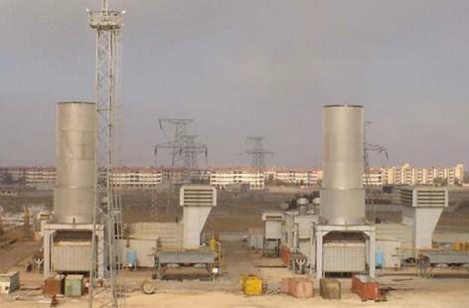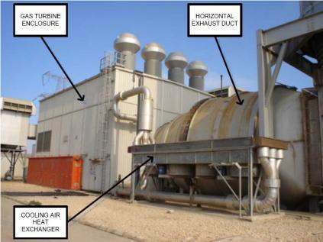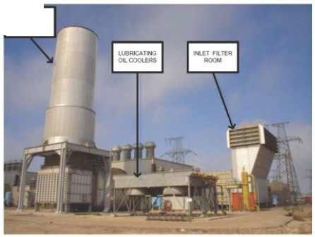

ElOWJSf

**SlACI<**

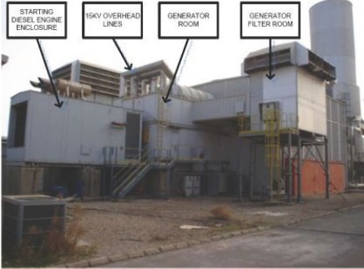

Left intentionally blank