B TYPE AMBULANCE QUOTATION

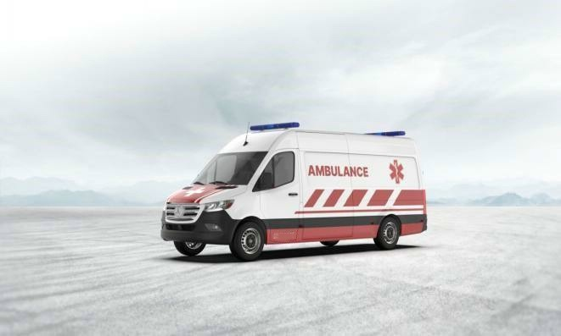AMBULANCE INTERIOR TECHNICAL SPECIFICATION

Seat of the Patient Cabin:

First seat is assembled in a way that the seated person will face towards the patient zone and is located within the cabinet system on the front side of the patient cabin and the seat should be inside the cabin. Seat part should be foldable into the back part and should be secured in that position while not used.

Second seat shall be located on the right side wall of the cabin from the rear view. This seat should be placed on a turntable; while the vehicle is cruising it should face forward and should be secured in this orientation by a locking mechanism .The seat part should be foldable into the back part and is secured on the wall in that position while not used.The seat shall also provide laid transportation of a secondary patient by lowering its back at least 160°. Both seats shall be equipped with upholstered back and head support made of non‐deforming material and seatbelts with automatic rewinding mechanism.

Door:

Patient cabin shall be accessible through a door on its right side and another two doors on the rear which allows loading and unloading the patient on the stretcher.

Right side door shall be sliding type with at least 100 cm width and the door shall be equipped with a sliding window with a locking mechanism which provides ventilation where necessary.

All of the vehicle doors should be controlled from a remote central locking system; furthermore, at least one of the doors at both driver’s and patient cabins shall be equipped with a mechanical locking mechanism manually controlled by a key when necessary.

Rear loading doors shall be able to be opened 180 degrees and allow easy access for loading and unloading the patient stretcher. Patient cabin door heights are at least 150 cm and the doors are be equipped with locking mechanisms which prevent accidental door opening in case they are not properly shut.

Each door shall be designed airtight.

Storage Parts and Design of the Cabinets:

Cabinet systems located at the front side of the patient cabin shall be made of compressed PVC coated foamed materials. Outside coating of the cabinet doors should be made of orange colored ABS materials.

At least 17 mm thickness foamed material composite materials are being used for building main frame and edges of the cabinet system. At least 10 mm. thick foamed material or composite material shall be used for drawers and the shelves.

Smooth surfaced, washable and plastic based ABS or composite material, the ﬁre‐resistance feature of which is in accordance with 95/28/EC regulation, shall be used for sidewalls and ceiling covering in the cabin. A single piece coating material, which has been produced by molding technique, should be used on each of right wall, left wall and ceiling surfaces and each surface coating should include cavities and partitions for the equipment mentioned below. Material density of this coating shall be at least 1.1 kg/m3. If composite materials are used, each side wall coating will consist of at most two separate parts. Parts should then be connected with smooth and leak tight joints using appropriate bonding materials suitable for using with the composite material.

Partition where the oxygen cylinders are placed are located next to the rear door entrance. Partition shall have doors; a plexiglas slide door located at the top of the partition will provide

access to the cylinder heads, and a grating of at least 60 cm2 area placed at the bottom side will provide ventilation.

Manometers and regulators of the oxygen cylinders shall be assembled on a separate panel on top of the oxygen cylinder partition for easy access and control.

A cabinet shall be placed on the left sidewall, which extends from ﬂoor to ceiling. Portable aspirator, ventilator and deﬁbrillator will be mounted inside this cabinet attached to the vehicle chassis. Area around the devices will be restrained by extensions having appropriate measures.

In the front part of the cabin partition, there shall be a cabinet system, in which, medical materials, drugs and other medical cases are stored.

Design of the cabinet system:The cabinet system shall consist of a single or two parts and it shall be placed at the leftmost side as viewed from the opposite side. Total dimensions of the cabinet system shall be min 140 cm in length, min 40 cm in depth and min 25 cm in width and it shall be equipped with sliding drawers. This special drawer cabinet shall be mounted by a rail system which allows easy opening of the entire cabinet by pulling it into the patient cabin and will be closed by pushing. A locking system shall keep it secure while it is in the closed position.

Next to the cabinet system, a locker with at least 4 sliding drawers with rail system shall be placed at the leftmost side, the ﬁrst aid personnel seat shall be placed in the middle and another partition where the resuscitation bag and basic medical supplies stored shall be placed at the right side; heights of these equipment shall not exceed the level of the window on the partition.

A locking system will secure the drawers when they are in the closed position to prevent accidental opening of the drawers or vibration and noise from the drawers while the vehicle is in motion.

Cabinet system shall be designed in a way that its top surface can be used as a workbench for preparation of the medical supplies such as medicines, injectors or IVs. Workbench surface shall be made of single piece leak tight material and workbench edges should be surrounded to prevent spilling or falling of the materials.

There shall be the second seat on the right cabin sidewall and behind the second seat there shall be a partition up to the level of the rear door, to allow placing a combination stretcher or a vacuum stretcher.

Patient cabin ceiling covering shall be coated with single piece ABS or composite material and shall have a special design that includes necessary holes at the level of main stretcher for IV hangings and

ceiling lighting instruments. Overhead grab handles are to be mounted strongly on the ceiling support belts on both sides.

There shall be a covering, which has been manufactured by molding technique, with special divisions in it for the purpose of installation of these instruments so that they shall not displace and fall from the ceiling.

A partitioned shelf or another apparatus that can hold three standard medical glove boxes and a soap dispenser apparatus suitable for standard soap bottle size are placed on the side wall of the patient cabin next to the partition which separates the driver’s cabin, either on the sidewall next to the patient cabin side door or at the opposite location on the other side door. Glove box holder and soap dispenser locations can be altered by the administration.

Related Administration shall be able to make alterations regarding the positions of the equipment.

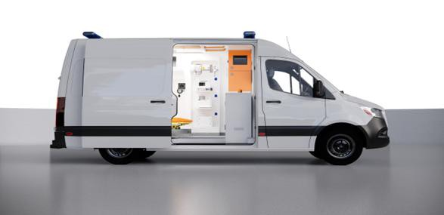

PROJECT PLAN

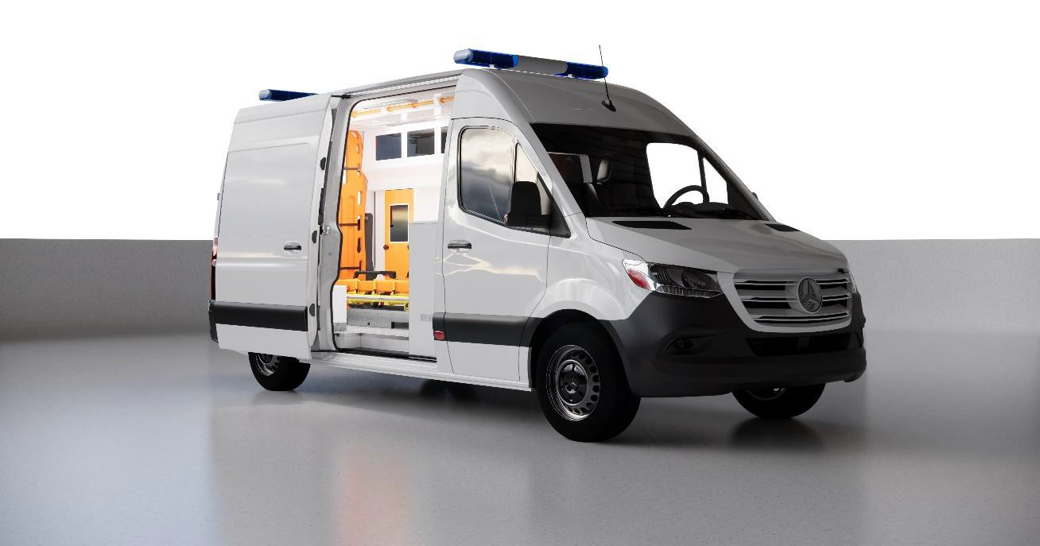

 | B Type Ambulance | Date: 20.10.2025 | Mercedes Sprinter

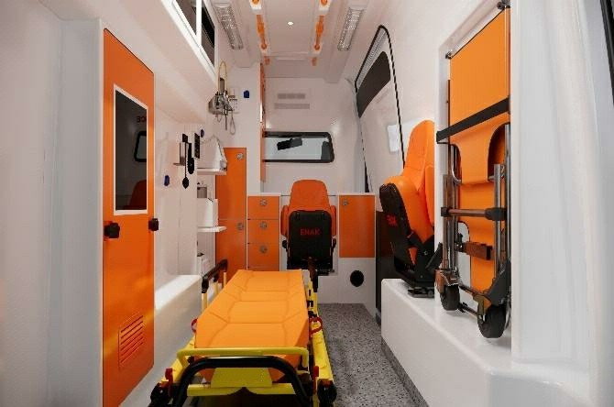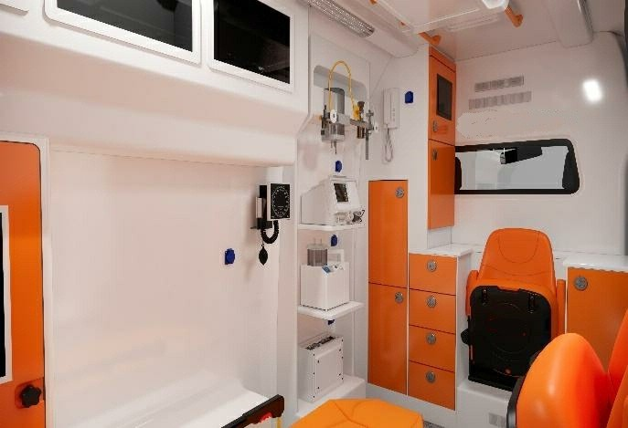

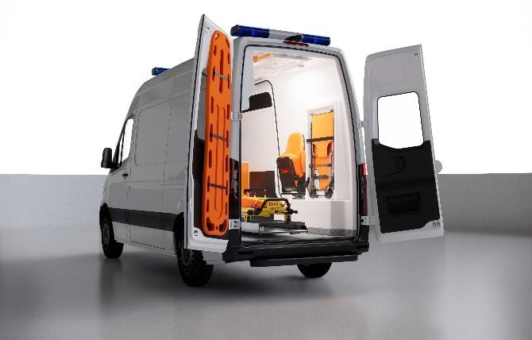PROJECT INTERIOR DESIGN

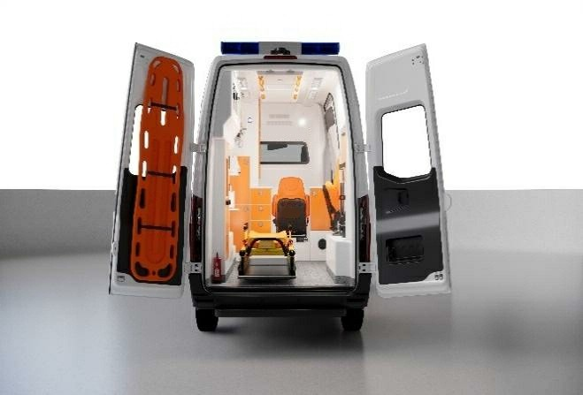

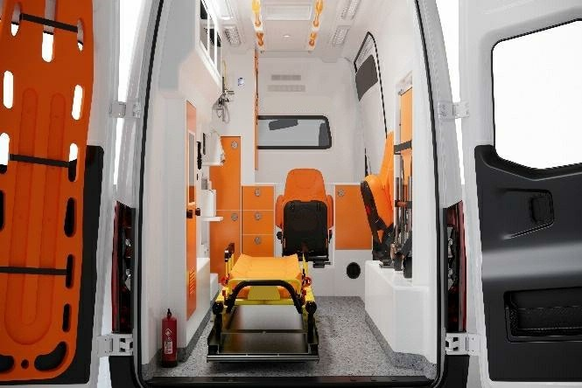

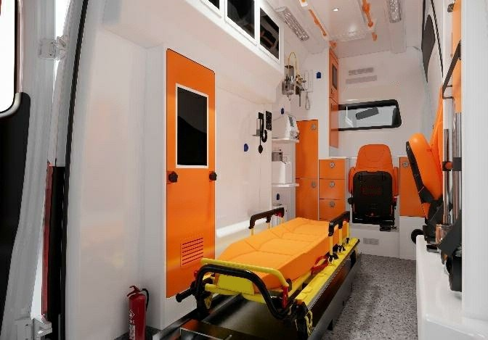

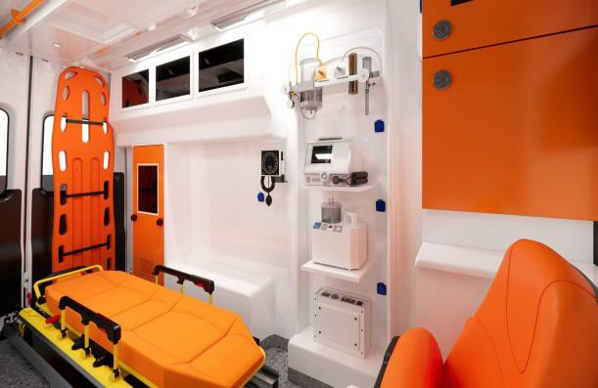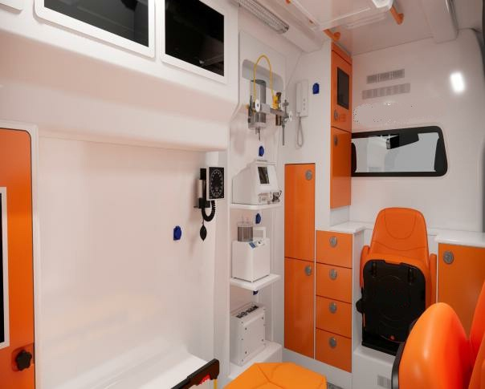

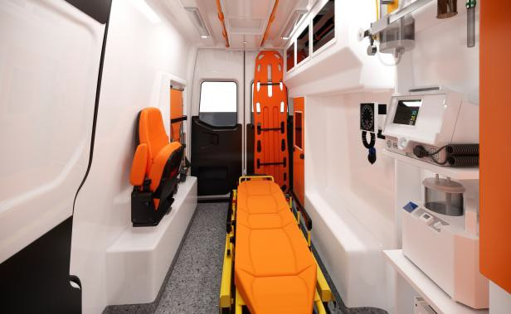PROJECT INTERIOR DESIGN

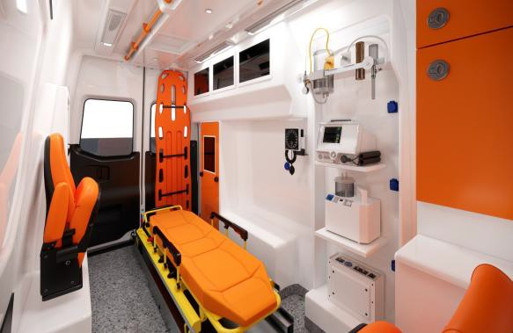

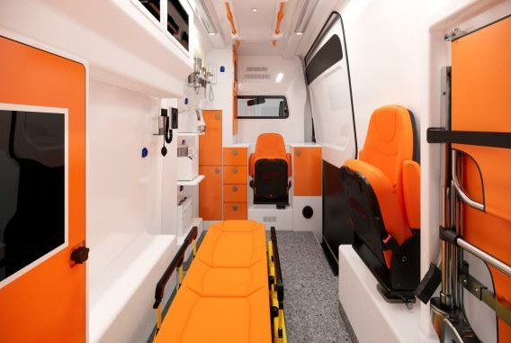

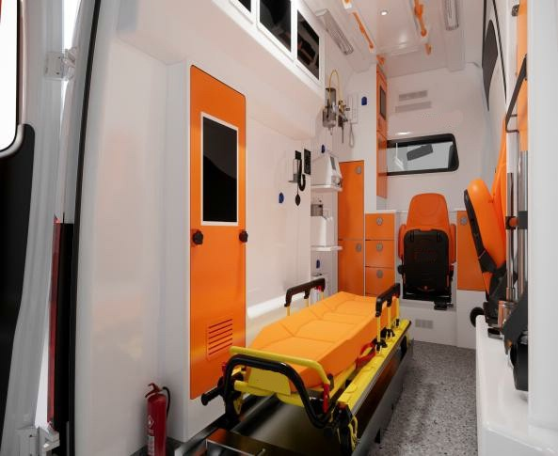

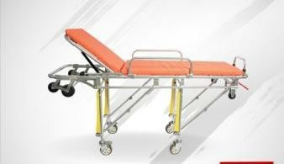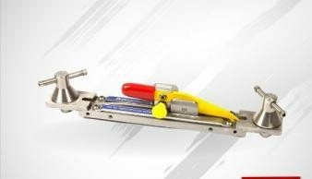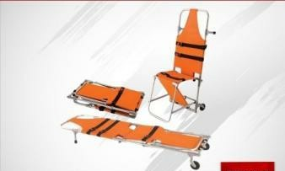

B TYPE AMBULANCE EQUIPMENT LIST

STRETCHERS GROUPS

  - MAIN STRETCHER 1 PCS

MAIN STRETCHER LOCK SYSTEM 1 PCS

  - CHAIR STRETCHER 1 PCS

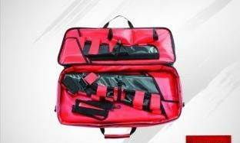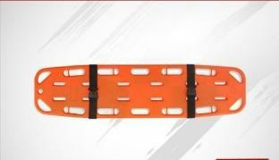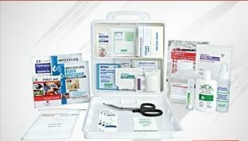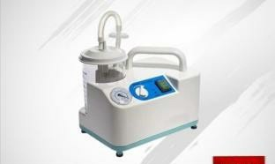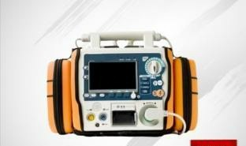

MEDICAL EQUIPMENTS

- 1 PCS

AIR SPLINT SET

- CERVICAL COLLARS 1 PCS

- SPINE BOARD 1 PCS

- BIRTH KIT 1 PCS

- BURN SET 1 PCS

PORTABLE SUCTION PUMP 1 PCS

6

- DEFIBRILLATOR 1 PCS

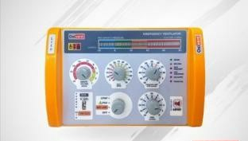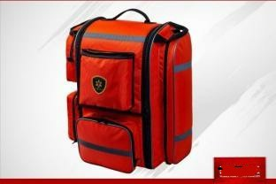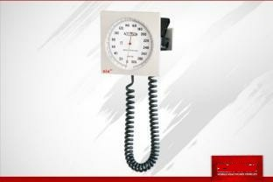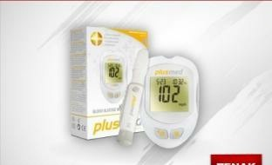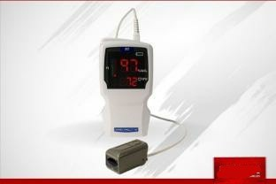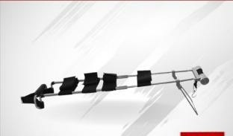

TRANSPORT VENTILATOR 1 PCS

FIRST AID BACK

9

1 PCS

- 1 PCS

FIXED SPYHG.

- STETHOSCOPE 1 PCS

- GLUCOMETER 1 PCS

- PULSEOXIMETER 1 PCS

TRACTION SPLINT SET 1 PCS

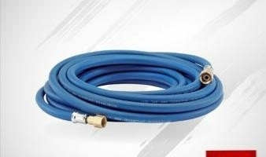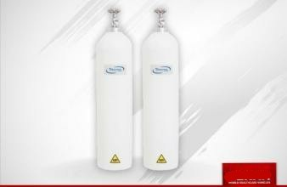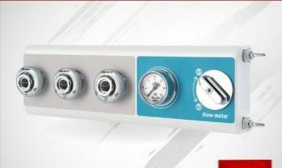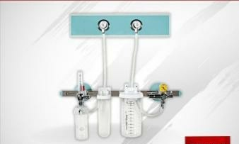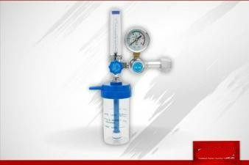

OXYGEN AND VACUUM SYSTEM

1 1 PCS

OXYGEN HOSE AND RECORDS

OXYGEN CYLINDER 2 x 10 LT

2

2 PCS

- OXYGEN OUTLET 1 PCS

- OXYGEN REGULATOR 1 PCS

- OXYGEN FLOWMETER 1 PCS

- SUCTION OUTLET 1 PCS

OTHER MATERIALS
1 PCS
DOOR INNER COVERS
1 PCS

INTERIOR FINISHES
1 | PARTITION COVER
2 | PARTITION GLASS | 1 PCS
3
4 | INSIDE CABIN MOUNTING BRACKETS | 1 PCS
INTERIOR
1 | LEFT SIDE CABINET / COVER ‐ ABS | 1 PCS
2 | RIGHT SIDE CABINET / COVER ‐ ABS | 1 PCS
3 | CEILING ‐ ABS | 1 PCS
PRE­MEDICINE CABINET
1 | PARTITION CABINET | 1 PCS
SITTING GROUPS
1 | SWIVEL & FOLDABLE SEAT | 1 PCS
2 | FOLDABLE SEAT | 1 PCS
FLOORING
1 | FLOOR INSULATION | 1 PCS
2 | FLOORING COVERING | 1 PCS
3 | ANTI BACTERIAL FLOORING | 7 m2
4 | WATER PROOFING | 1 PCS

ELECTRICAL SYSTEM
1 | ELECTRICAL SYSTEM | 1 SET
2 | DIGITAL CONTROL PANEL
3 | RECTIFIER‐battery charger‐ | 1 PCS
4 | RECTIFIER 220V ELECTRIC ENTRY AND CUTTING | 1 PCS
5 | ADDITIONAL GEL BATTERY (90A) | 1 PCS
6 | SOCKET ‐ 12V | 3 PCS
7 | INVERTOR ‐ 12V/220V/1000W | 1 PCS
8 | OUTLET 220V | 3 PCS
9 | FUSE CIRCUIT BREAKER | 1 PCS
10 | LED LIGHTING | 2 PCS
11 | STRETCHER SPOT LIGHT | 4 PCS
12 | INTERCOM | 1 PCS
13 | ELECTRONIC SIREN AND TOP LIGHTBAR | 1 PCS
14 | BACK TOP LIGHTBAR | 1 PCS
15 | SIDE WARNING LAMPS | 6 PCS

VEHICLE SPECIFICATIONS

Mercedes Sprinter Ambulance

Manufacturer Mercedes

Model

Model Production year
Sprinter 317 CDI

New

Type EUR 6

2024

1950cc

Displacement

Fuel Diesel 170 Hp

Weight 3.5 t

PRICING

B TYPE AMBULANCE UNIT PRICE TOTAL

MERCEDES SPRINTER B TYPE AMBULANCE

87.000 EUR X
60

5.220.000 EUR

NOTES

- Our prices do not include any taxes or custom charges or transportation charges.

- All prices are factory gate prices /EX Work

- Delivery time :150 DAYS after confirmation of the order.

- Payment terms: 60% on definite order/contract signing date,

- Remaining 40% on dispatch

- THE PRICES ABOVE ARE VALID FOR 10 DAYS.

