Technical specifications for the procurement and supply of blades (GT) for the Siemens SGT5-4000F gas turbine
1. General Provisions
1.1. Purpose of Purchase:
Supply of new rotor and guide vanes (a complete set for 4 stages) for the following work:
• Replacement of existing blades due to expiration of their service life.
*Note: Only original, new rotor and guide vanes manufactured by Original Equipment Manufacturers (OEMs): Siemens, Ansaldo, Medisky, or equivalent.
1.2. Installation Object:
Siemens SGT5-4000F Gas Turbine, 50 Hz.
Turbine Serial Number: U28008Z4
• Version/Modification: 4000F, Version 6

2. Scope of Delivery
2.1. Main Components
The supplier shall supply:
A. Siemens SGT5-4000F Gas Turbine Blades, Version 6.
• Siemens SGT5-4000F Gas Turbine Blades, Stage 1 (80 pcs.) Original Equipment Manufacturer (OEM): Siemens, Ansaldo, Medisky, or equivalent.
• Siemens SGT5-4000F Gas Turbine Blades, Stage 2 (75 pcs.) Original Equipment Manufacturer (OEM): Siemens, Ansaldo, Medisky, or equivalent.
• Siemens SGT5-4000F Gas Turbine Blades, Stage 3 (55 pcs.) Original Equipment Manufacturer (OEM): Siemens, Ansaldo, Medisky, or equivalent.
• Siemens SGT5-4000F 4-stage gas turbine blades (47 pcs.) Original Equipment Manufacturer (OEM): Siemens, Ansaldo, Medisky, or equivalent.
*See Appendix 1 for serial numbers of the blades actually installed.
B. Siemens SGT5-4000F Gas Turbine Guide Vanes
• Siemens SGT5-4000F 1-stage gas turbine guide vanes (78 pcs.). Original Equipment Manufacturer (OEM): Siemens, Ansaldo, Medisky, or equivalent.
• Siemens SGT5-4000F 2-stage gas turbine guide vanes (77 pcs.) Original Equipment Manufacturer (OEM): Siemens, Ansaldo, Medisky, or equivalent.
• Siemens SGT5-4000F 3-stage gas turbine guide vanes (67 pcs.). Original Equipment Manufacturer (OEM): Siemens, Ansaldo, Medisky, or equivalent.
• Siemens SGT5-4000F 4-stage gas turbine guide vanes (59 pcs.) Original Equipment Manufacturer (OEM): Siemens, Ansaldo, Medisky, or equivalent.
*See Appendix 1 for serial numbers of the actual blades installed.

2.2. Associated Elements
• Auxiliary systems, fasteners, and fixtures based on installation requirements.

2.3. Completeness
1000/0 kit for 1 Siemens SGT5-4000F gas turbine, including auxiliary systems, fasteners, and fixtures in accordance with the manufacturer's requirements.

3. Technical Requirements
3.1. General Requirements
• Full geometric and functional compatibility with the Siemens SGT5-4000F turbine (OEM blades only: Siemens, Ansaldo, Medisky, or equivalent.) Installation without modification: o rotor
o casing (including the installed original guide vane) o cooling system Compliance:
o Full compliance with the original blades.
• Overhaul interval: at least 33,000 hours
• Full service life: at least 66,000 hours *Note:
1. The overhaul interval and expected service life assume that the gas turbine is operated in accordance with the manufacturer's recommendations.
2. For stages 3 and 4, after inspection, depending on their condition, the service life may be extended for a third cycle.

4. Documentation
The supplier is obligated to provide the following documents for all new parts:
1. Material test certificates
2. Heat treatment reports
3. Coating application reports
4. Visual and non-destructive testing reports, including X-ray testing
5. Dimensional inspection report
6. Airflow inspection report
7. Moment load diagram

5. Delivery terms
• Delivery date: _______
• Packaging:
Factory packaging with:
corrosion protection
impact and weather protection

6. Warranty obligations
Warranty period: 8.00 operating hours or 18 months from the date of delivery to the Customer (whichever comes first)
7. Special conditions
• All data must be linked to:
turbine serial number
rotor configuration. The supplier is obligated to:
supply original Siemens blades

8. Delivery Terms
Delivery Terms
Transportation from the Supplier's warehouse to the destination is arranged by the Supplier at the Supplier's expense.
By agreement of the parties, delivery may be made by the Buyer's transport.

Appendix 1: Serial numbers of actually installed blades

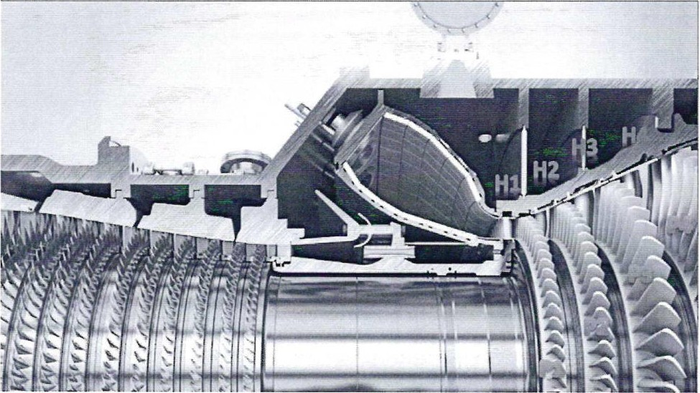

Siemens V94.3A / SGT5-4000F Turbine Blades

Technical Inventory / Registration Number List

A. Stationary Guide Vanes
Stage | Component | Designation | Stated Qty. | Leading Edge Length | Registration / Identification Numbers
1 | First-stage nozzle guide vanes | H1 | 78 pcs. | 15 cm | 30078943; 30078930; 30078889; 30078906; 30078960; 30112880; 30112884; 30112912; 30112856; 30078885; 30112910; 30078929; 30112878; 30112859; 30112844; 30078923; 30112872; 30112935; 30078904; 30078894; 30112916; 30112867; 30078886; 30112905; 30112911; 30078893; 30078922; 30112913; 30112882; 30078933; 30112908; 30078938; 30078881; 30078940; 30078911; 30112845; 30078936; 30112899; 30078920; 30012855; 30078900; 30112851; 30112885; 30078891; 30078951; 30078921; 30078934; 30078919; 30078941; 30112861; 30112837; 30112900; 30112847; 30112876; 30078927; 30112895; 30112891; 30078946; 30112890; 30112907; 30112875; 30078925; 30112889; 30078959; 30112852; 30112886; 30112869; 30112871; 30078908; 30112903; 30112893; 30112887; 30112860; 30112881; 30078909; 30078902; 30112883
2 | Second-stage guide vanes | H2 | 77 pcs. | 18 cm | 30104982; 30104978; 30104979; 30104980; 30125541; 30121148; 30121147; 30121075; BMA0470; 30100346; 30125555; 30104953; 30125594; 30121071; BG91976; 30117336; BG91990; BCA0358; BJA1039; BJA1034; BJA1045; BJA1083; BJA1067; BJAI046; BJAI056; BJA1038; BJA1079; BJA1041; BJA1036; BJA1053; BJA1068; 30002762; BJA1027; 30084988; 30100381; 30105028; 30100376; 30100383; BMA0443; 30117289; 30078826; 30084989; 30100365; 30100356; BDA0604; BG91988; BH82948; BGA1066; 30100385; 30078829; 30100386; BJA1051; 30100355; 30117344; 30117332; 30100379; 30100378; BCA0374; 300002761; 30100382; 30117288; 30121078; 30121088; BAA2173; 30121070; BMA0484; BH80400; 30117340; 30117370; 30121073; 30121079; 30121077; 30117343; 30121092; 30117333; 30125581; 30125519
3 | Third-stage guide vanes | H3 | 67 pcs. | 30 cm | 30085902; 30001024; 30099683; 30025526; 30096907; 30092152; 30001051; 30092156; 30099690; 30079210; 30099692; 30079216; 30079209; 30079196; 30079142; 30079138; 30079147; 30079193; 30079204; 30079205; 30079189; 30079191; 30099684; 30104861; 30085873; 30085874; 30104860; 30073514; 30085903; 30001024; 30000991; 30096906; 30042485; 30001020; 30092154; 30104858; 30079190; 30079154; 30079145; 30099689; 30073555; 30079207; 30099713; 30085905; 30001022; 30099699; 30085908; 30092170; 30081019; 30000989; 30085904; 30073529; 30073496; 30099696; 30079202; 30079206; 30031538; 30079143; 30092185; 30096902; 30001060; 30001018; 30001050; 30095159; 30001041; 30085907; 30092163
4 | Fourth-stage guide vanes | H4 | 59 pcs. | 50 cm | PCC40127K01809; PCC40127M018402; PCC40127M01881; PCC40127M01856; PCC40127M01866; PCC40127M01811; PCC40127K01806; PCC40127M01883; 475026-01; 474971-01; PCC40127M0836; PCC40127M01841; PCC40127M01851; 474994-01; PCC40127M01845; PCC40127M01830; 474988-01; PCC40127M01924; PCC40127M01863; PCC40127M01934; PCC40127M01947; PCC40127M01834; PCC40127M01952; PCC40127M01818; PCC40127M01860; PCC40127K01794; 466378-01; PCC40127M01847; PCC40127M01846; 463012-01; 463006-01; PCC40127M01878; PCC40127M01839; PCC40127K01793; PCC40127M01843; PCC40127M01906; PCC40127M01827; PCC40127K01800; PCC40127M01837; PCC40127K01797; PCC40127M01853; 466363-01; PCC40127M01832; PCC40127M01848; PCC40127M01867; 466374-01; PCC40127M01865; PCC40127M01872; PCC40127M01902; PCC40127M01861; PCC40127M01957; PCC40127M01876; PCC40127M01873; PCC40127K01804; PCC40127M01961; PCC40127K01792; PCC40127M01829; PCC40127K01795; PCC40127K01802

B. Rotor / Working Blades
Stage | Component | Designation | Stated Qty. | Leading Edge Length | Registration / Identification Numbers
1 | First-stage rotor blades | R1 | 80 pcs. | 15 cm | 30074875; 30074842; 30084095; 30084052; 30084127; 30084062; 30084098; 30084053; 30058324; BFA0827; 30084046; 30084082; 30084066; 30084088; 30084089; BFA0762; 30084085; 30084110; 30058358; 30074879; 30084130; BEA1069; 30084083; 30074834; 30084091; 30084078; 30044301; 30084087; 30084061; 30084068; 30084074; 30084047; 30084094; 30074818; 30084070; 30084064; 30084069; 30084073; 30074826; 30074846; 30084099; 30084063; 30084092; 30074859; 30084043; 30074844; 30084113; 30046002; 30074820; 30044323; 30074881; 30084044; 30045989; 30084042; 30074866; 30074816; 30074850; 30084102; 30044334; HNA0202; 30044303; BEA1068; 30074841; 30074830; 30084075; 30044330; 30084100; 30074827; 30044352; 30044342; 30084055; 30084077; 30084065; 30084084; 30084035; 30074852; HNA0196; HNA1177; 30074863; 30074837
2 | Second-stage rotor blades | R2 | 75 pcs. | 25 cm | 30102510; 30123399; 30123453; 30123451; 30099051; 30123408; 30123366; 30123432; 30123437; 30123418; 30123389; 30123367; 30123384; 30123419; 30123397; 30123436; 30123421; 30123404; 30123409; 30123372; 30123423; 30123401; 30123381; 30123402; 30123412; 30123403; 30123400; 30123386; 30123406; 30123439; 30123433; 30123411; 30123434; 30123415; 30123373; 30123405; 30123424; 30123455; 30123454; 30123393; 30123426; 30123427; 30123369; 30123420; 30123380; 30126500; 30123413; 30123430; 30098997; HKA0738; 30123410; 30123440; 30123370; 30123383; 30123379; 30098984; 30088984; 30099035; 30123388; 30123390; 30123395; 30123385; 30126436; 3012337; 3012392; 3012396; 30123429; 30123391; 30123435; 30123428; 30123378; 30123438; 30123375; 30123431; 30123376
3 | Third-stage rotor blades | R3 | 55 pcs. | 40 cm | 30114162; 30114130; 30114164; 30114147; 30114133; 30114139; 30114122; 30114110; 30114123; 30114154; 30114127; 30114138; 30114150; 30114119; 30114114; 30114126; 30114124; 30114142; 30114158; 30114121; 30114136; 30114160; 30114141; 30114152; 30114151; 30114137; 30114163; 30114109; 30114143; 30114125; 30114165; 30114149; 30114153; 30114108; 30114128; 30114129; 30114113; 30114146; 30114159; 30114116; 30114135; 30114155; 30114148; 30114174; 30114134; 30114132; 30114161; 30114120; 30114144; 30114115; 30114117; 30114112; 30114140; 30114111; 30114157
4 | Fourth-stage rotor blades | R4 | 47 pcs. | 64 cm | 30054794; 30054827; 30054823; 30054801; 30054790; 30054804; 30054802; 30054810; 30054831; 30054807; 30054818; 30054797; 30129987; 30054788; 30054816; 30054812; 30129985; 30129976; 30054815; 30129950; 30129945; 30129964; 30054830; 30129962; 30129942; 30054833; 30054811; 30054793; 30054820; 30054824; 30054785; 30054786; 30054817; 30054789; 30126650; 30054835; 30054822; 30054828; 30054809; 30126652; 30054800; 30129948; 30054796; 30054825; 30054783; 30054826; 30054792

Summary
Component Type | Stage 1 | Stage 2 | Stage 3 | Stage 4
Guide / nozzle guide vanes | 78 | 77 | 67 | 59
Rotor / working blades | 80 | 75 | 55 | 47

Important verification notes
- The stated quantities should be treated as the quantities declared in the source document, not yet as verified quantities.
- The number of registration numbers visible in the extracted text does not perfectly correspond to every stated quantity. This is particularly noticeable in the Stage 1 guide vanes and Stage 4 guide vanes.
- Several identification numbers contain apparent OCR ambiguities, especially where Cyrillic and Latin characters are visually similar. These should be checked against the original PDF/image before procurement.
- The source document uses the terms equivalent to guide vanes for stationary components and working blades for rotor components. For supplier communication, the preferred terminology is:
  - First-/second-/third-/fourth-stage nozzle guide vanes (NGV) for stationary turbine vanes;
  - First-/second-/third-/fourth-stage rotor blades for rotating blades.
- The values H1, H2, H3 and H4 have been retained as designations and should not be assumed to be Siemens Part Numbers without confirmation.
- The listed registration numbers should therefore be treated as identification/registration numbers from the supplied source document, pending confirmation of the corresponding Siemens drawing/reference numbers.

