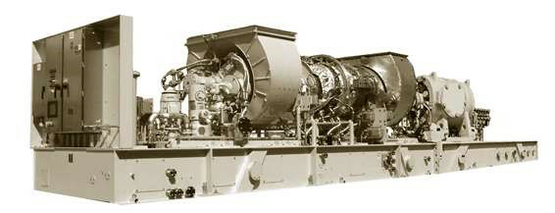

2 Units of SOLAR MARS 100 – SOLONOX VERSION 15000
For Sale

December 2025

Dear Sir,

Please find below our technical and commercial proposal as requested:

1. Scope of the technical proposal.

Supply Two Solar Brand Gas Turbines:

2 Units of Gas Turbine model MARS 100 SoLoNOx – Version 15000SAN, 14800 HP. These are used equipment, with zero hours, refurbished, and manufactured in 2011.

MAIN PLATES, ONE OF THEM

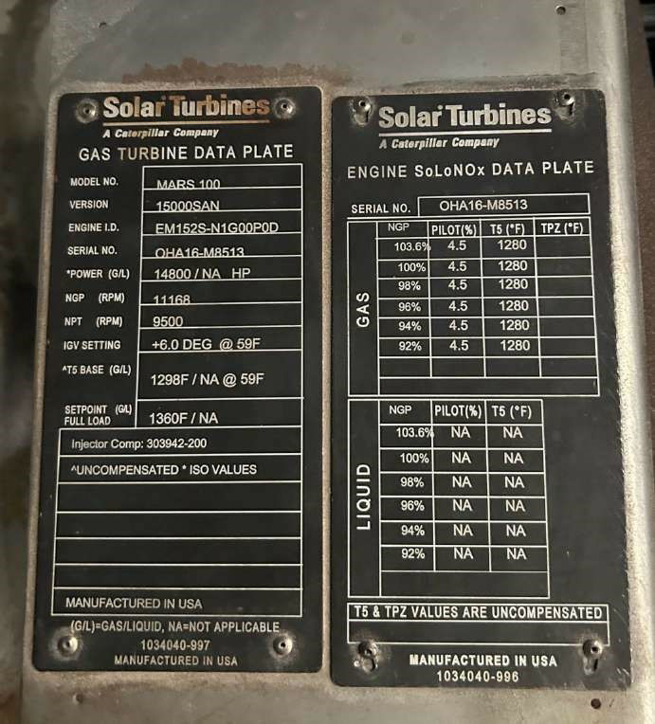

The technical characteristics of the turbines are shown in the attached table.

YEAR | MAKE | MODEL | Frequency | Condition | Power HP | MW  ISO | Quantity  Available
2011 | Solar | Mars 100  SoLoNOx | 60 Hz | Zero Hours -  Refurbished | 14800 | 11.3 | 2

Manufacturer: Solar Turbines.
Manufacture year: 2011.
Gas turbine model: Mars 100-Version 15000SAN. SoLoNOx Gas turbine power: 14800 HP.
Gas turbine power: 11.3 MW.
Gas turbine speed RPM: NGP 11168 NPT 9500 rpm.
Fuel Type: Natural Gas Maximum Supply Pressure 500 psig (3450 kPag). Frequency: 60Hz

SCOPE of SUPPLY: Complete Ga Turbine including:

- Gas turbine (axial compressor, combustion chamber, and power turbine).
- Intake volute, inlet silencers ✔ Exhaust volute, exhaust silencers
- Lubricating oil system, oil tank, heater, main and auxiliary oil pumps (main mechanical, AC electric pre/post, DC electric backup), filter, 120V DC starter, pressure and temperature regulator, oil mist separator, ventilation flame arrester
- Starter motor ✔ Oil pressure regulation system ✔ Thermostat valve ✔ Duplex filter holder with its 6-way valve ✔ CO2 piping system, fire detection, and fire extinguishing system CO2 ✔ Instrumentation associated with the turbine (pressure transmitters, vibration modules) ✔ Gas valves (primary, secondary, and PEC) ✔ IGV electro-actuator ✔ Oil supply and drainage hoses and pipes
- Enclosure with its panels and doors (enclosure)

- Local control panel with its PLC ✔ Cabin air intake duct with its fan, ventilation system ✔ Cabin air outlet ducts, ventilation system ✔ Filter house ✔ Damper with shutters for cabin insulation (cabin intake and discharge) ✔ Main oil tank ✔ Gas, flame, and heat detectors ✔ Thermocouples ✔ Skid internal pipes.
- Injectors ✔ Bleed valve ✔ Air and gas manifolds ✔ Electric Generator

Additional Scope of Supply:

- Zero hours, refurbished.

- Type of fuel used: Natural gas.

- Permanent suspension of activity: March/2023.

- Reason for interruption: End of subsidy for the acquisition of fuel (natural gas).

PHOTOS

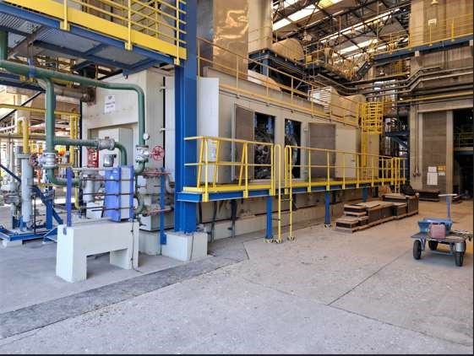

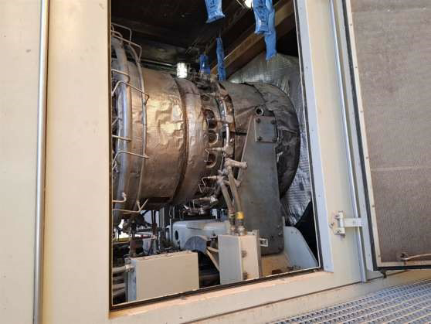

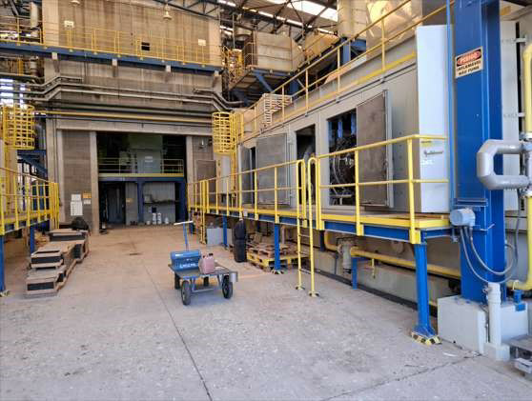

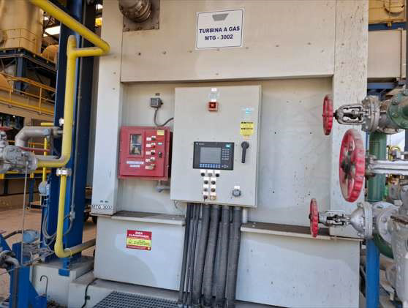

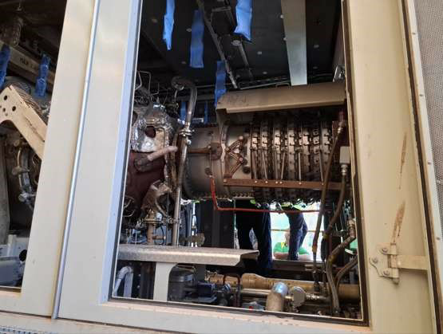

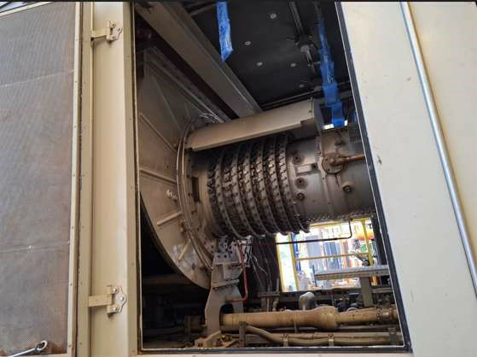

Price

- Solar Gas Turbine included an Electric Generator:
- Option Price 1:
Zero-hours: Delivery in approximately in 1 month's time at USD7,225,000 per unit FOB USA
Option Price 2:
As Decommmissioned (with hours) for Immediate Delivery at USD4,925,000 per unit FOB USA

- The Contract Price will be payable solely in US Dollars, the official currency of the United States of America.
The prices are based in USD $ and do not include taxes, customs duties, fees, levies, & any other duties. Any additional shipping, customs clearance documentation which require an official Embassy or Chamber of Commerce stamp(s) & signatures will be charged at an extra cost. Price to be determined upon application.

Terms and conditions of payment for each turbine

The following payment method is established for each turbine.

- A down payment fee of 1% of the price, payable upon signing the Sale Contract and before the inspection visit, is required. This amount serves as a security deposit, which is refundable if not utilized as presented.
- A deposit of 79% will be paid with the official purchase order (P/O) five working days after the inspection visit has been completed.
- C. The balance is 20% before shipping.

Delivery

- Core Engine Solar Turbines. Disassembled, EXW (Ex Works).
A month after receiving the purchase order. The refurbishment is in progress and will be ready in a month.

- Balance of plant (BOP) and Ancillary equipment. Disassembled, EXW (Ex Works). Immediately after receiving the purchase order.

Warranty

Twelve (12) months standard manufactured warranty, 8766 EHO, or eighteen months from the date of delivery, whichever occurs first.

Validity

This quotation is valid for 30 days and is subject to prior sale.

- Note:

- Equipment can be sold separately

- Attachment: Solar Mars 100 Brochure

