B7 (VR9 VP
materials that European CEN vehicle’s sides and the roof, a US NIJ level I transparent ar
WITH LATERAL BLAST PROTECTION – 15KG TNT

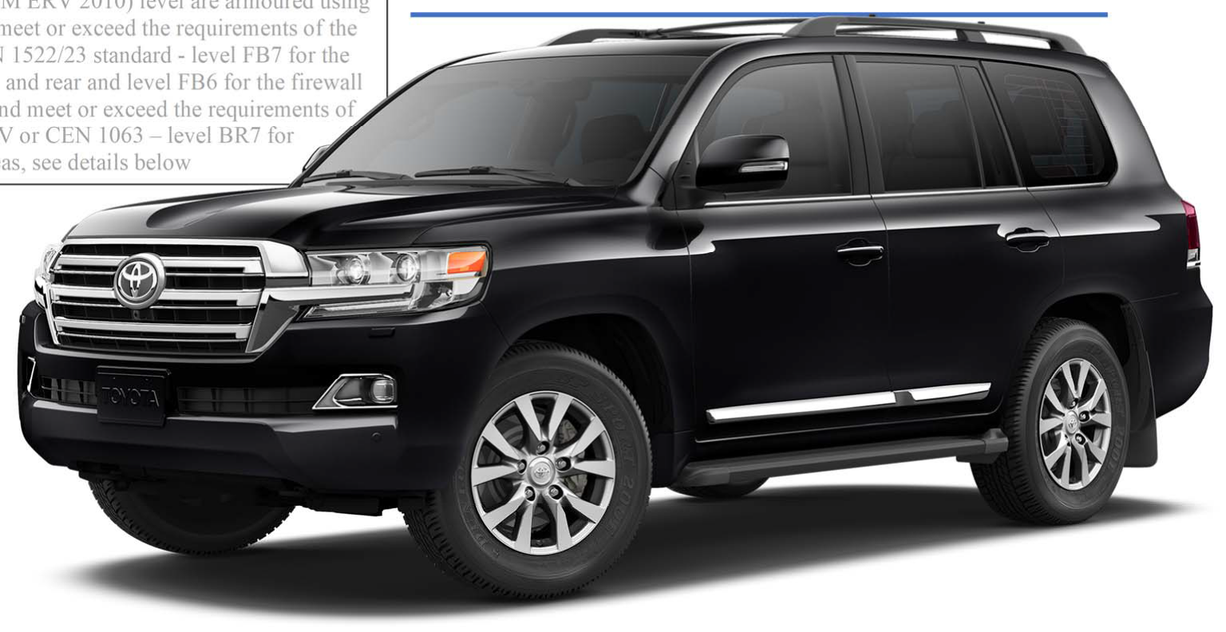
AM ERV 2010) level are armoured using
meet or exceed the requirements of the 1522/23 standard - level FB7 for the and rear and level FB6 for the firewall nd meet or exceed the requirements of
V or CEN 1063 – level BR7 for
eas, see details below

COLOR: BLACK

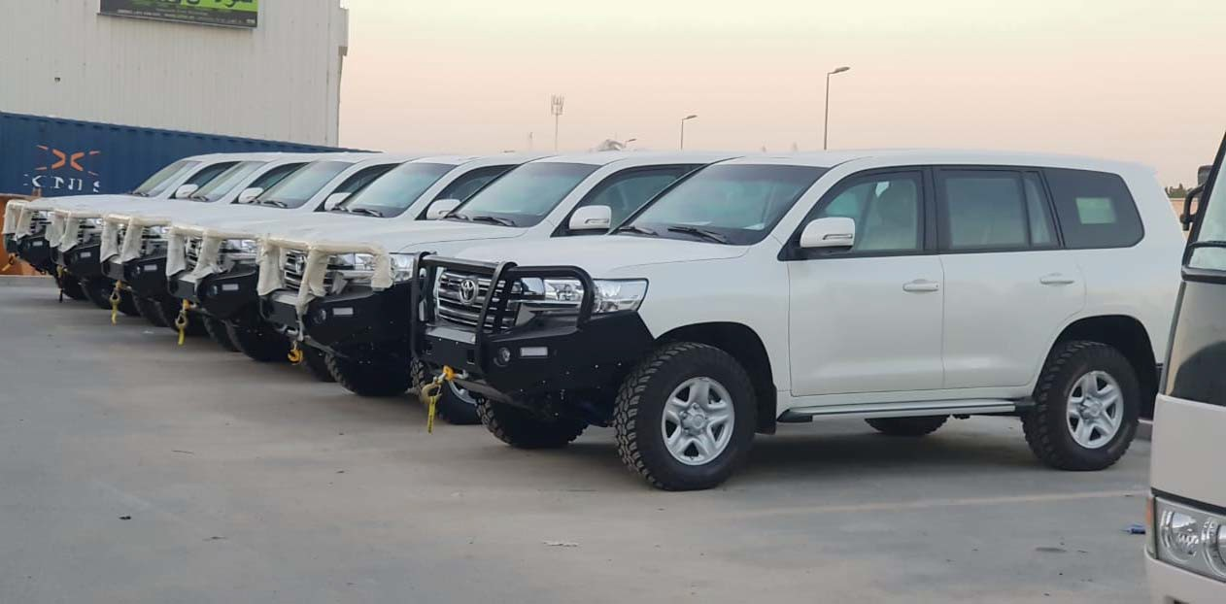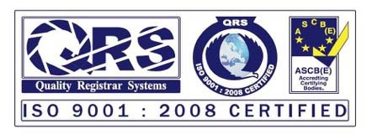

All the armoring works are performed at our fully-equipped manufacturing facility, where we have a team of experienced and certified engineers and technicians on hand. To ensure we deliver quality armoring solutions, ZH adhere to international
ballistic standards (CEN, NIJ, VPAM, STANAG). Our in-house quality management system is ISO 9001:2008 certified, and we have achieved third-party ballistic certifications for our materials and processes

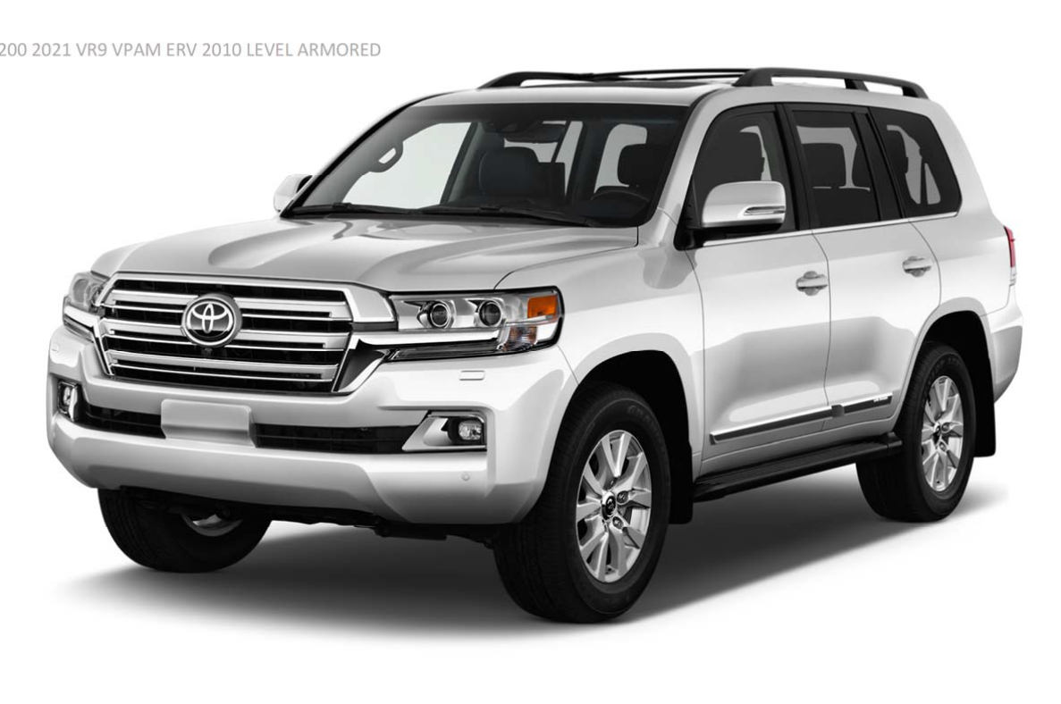TL

C200 2021 VR9 VPAM ERV 2010 LEVEL ARMORED
1

4
2 5

3

7

6

9
8 10

ARMORING DESIGN

- Cabin: The armoring is integrated inside the vehicle’s cab and forms a complete self‐supporting structure to avoid excessive stress on the vehicle’s original structure, made of special steel comprising doors, a body firewall, a roof and others.
- Bullet Proof Window Glasses and Wind Shield for protection against bullets and blast.
- The battery and control module of the engine are protected to the same level as the opaque areas.
- The interior armor‐frame provides overlap for the large‐surface armor components such as the door armor‐plates and the windows.
- Bulk Head : An Armored bulkhead is installed behind.
- Upgraded suspension to cope with the additional weight due to armouring
- Heavy‐duty hinges with in‐built door‐stop. Hinge mounting points are reinforced both in the pillars and in the doors in a way that the armoring of the door is supported by the armoring of the pillar
- The floor of the vehicle is designed to defeat DM 51 Grenade. Explosion proof blanket made of ballistic steel.
- Armoring of Fuel Tanks.
- Hutchinson Run‐Flat devices have been installed on all wheels. Forced drive running can be maintained even if a tire goes flat.

:H offers a specialized line of armored SUVs for those who value peace of mind over everything else. We have 35,000 square-foot production facility, which enables us to accomplish the most detailed and extensive of contracts quickly and cost-effectively.

- 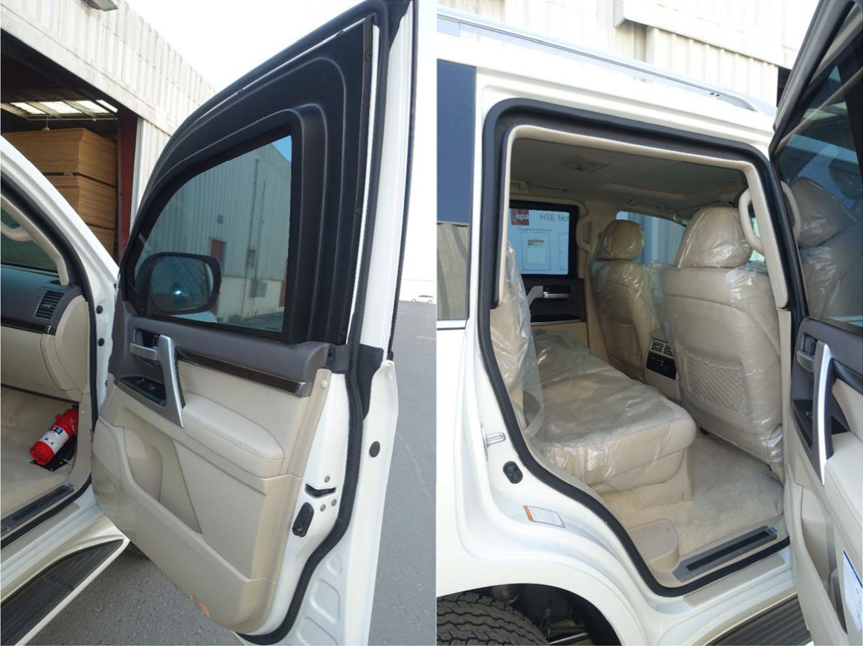Batteries and computer are stored in a bullet‐proof case.
- Bullet‐proof window glass is designed and processed to fit to the overlapping mounted to pillars.
- First Class Finishing of Bullet‐Proof glass and ceiling trim.
- Armored/Bullet‐proof rear bulkhead.
- Armored/Bullet‐proof glass and doors fit to the vehicle body snugly with any positional displacement or deformation.
- The fuel tank is protected with an armored explosion‐proof cover.
The whole underfloor function as a protector by preventing invasion of fragments and blast caused by explosions of DM51 NATO grenades.
- Firewall: Armored/Bullet‐proof
Partition
- Heavy‐Duty suspension to handle the extra weight added due to armoring.

BULLET PROOF WINDOW GLASS IS DESIGNED AND PROCESSED TO FIT THE OVERLAPPING MOUNTED TO PILLARS

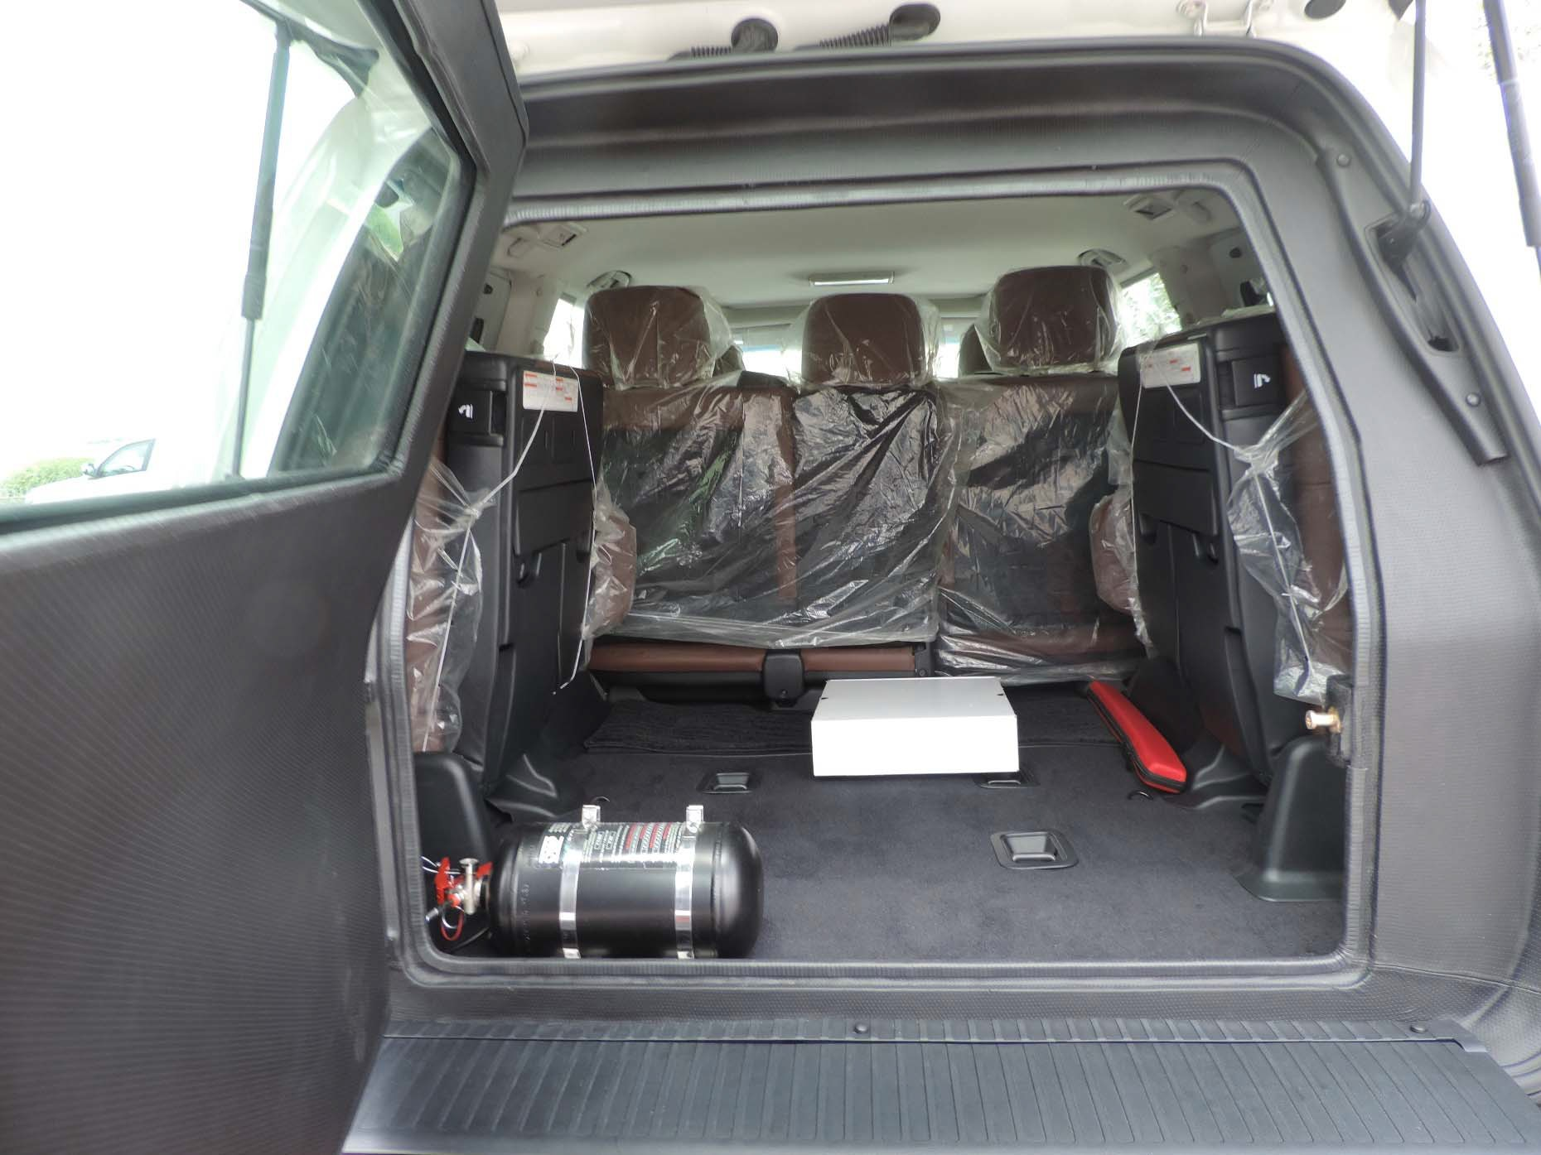

PASSENGER CABIN PROTECTION

The passenger cabin will be well protected according to minimum protection level BR7 including all sidewalls, doors, pillars, roof, ﬂoor, front, bulkhead, and rear door.

Edges and seams are armored by utilizing an overlap design system which minimizes gaps and preventing penetration.

The ballistic steel panels are covered with cathodic dip painting before installation.

The vehicle resembles a normal civilian low proﬁle vehicle – meaning that the vehicle is nearly visually identical to a standard vehicle. Therefore, unwanted attention while travelling is avoided.

ENGINE BAY PROTECTION

Batteries are to be protected within steel armored boxes within the engine compartment against projectiles and splinters. Armored boxes can be easily removed for maintenance or transportation.

The vehicle management system, including fuse boxes, which controls essential electrical vehicle functions, to be protected with armored steel to level BR7 protect it against splinters and fragmentation.

Full length armored steel to the level of BR7 ballistic certiﬁcation is to be mounted on both sides of the engine compartment behind the vehicle wings protecting the engine compartment.

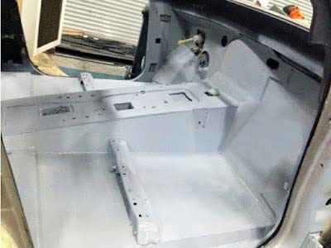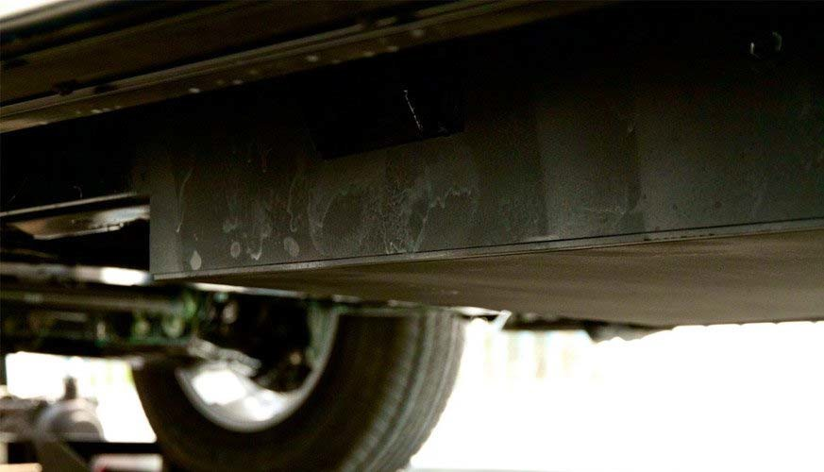FUEL TANK PROTECTION

All fuel tanks and fuel pipes will be armored using blast steel to combat ballistic and fragmentation attacks. Fuel line hoses will also be protected against blast and projectiles.

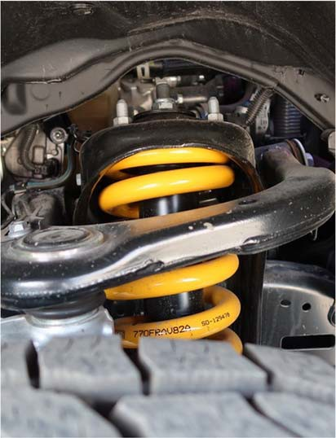HEAVY DUTY SUSPENSION SYSTEM
The standard original suspension system will be completely replaced with an engineered-for-purpose high performance suspension system providing constant loading. Off-the-shelf suspension system
components providing temporary loading, such as those manufactured for Armoring applications.

FIREWALL – ARMORED PARTITION

THE WHOLE FLOOR FUNCTIONS AS A PROTECTOR AGAINST INVASION OF FRAGMENTS CAUSED BY EXPLOSIONS

RUN FLAT DEVICES – HUTCHINSON USA

ALL FIVE WHEELS WILL BE FITTED WITH RUN-FLAT SYSTEMS RATED AT 50KM AT A SPEED OF 80 KM/H RUN-FLAT CAPABILITY SUPPLIED BY HUTCHINSON INTERNATIONAL

CEN 1063 BALLISTIC RESISTANCE LEVEL 7 ‐ SPECIFICATIONS BR7

OPAQUE AREAS

PASSENGER COMPARTMENT REAR BULKHEAD

- Calibre 7.62 x 39 mm, FMJ/PB/HCI, AK 47 Kalashnikov
- Calibre 5.56 x 45 mm, FJ/PB/SCP, M16 Colt (FB5‐FB6)
- Calibre 7.62 x 51 mm, FJ/PB/SC, FN “FAL/LAR” NATO rifle (FB6‐NIJ III)
- Calibre 7.62 x51mm, FJ/PB/HC (AP), FN “FAL/LAR” NATO rifle (FB7‐NIJ IV)

TRANSPARENT AREAS
- Calibre 7.62 x 39 mm, FJ/PB/FeC, AK 47 Kalashnikov
- Calibre 5.56 x 45 mm, FJ/PB/SCP, M16 Colt (BR5‐BR6)
- Calibre 7.62 x 51 mm, FJ/PB/SC, FN “FAL/LAR” NATO rifle (BR6‐NIJ III)

Calibre 7.62 x51mm, FJ/PB/HC, (AP), FN “FAL/LAR” Rifle (NIJ IV) (minimum spacing between impacts in excess of 120mm)

FLOOR The floor of the vehicle is designed to defeat the following:
  - Two DM 51 hand grenade (German Norm) detonated simultaneously

ENHANCED FLOOR PROTECTION
- 1x HG85 (equivalent to M67 Grenade) under vehicle

FIREWALL & ROOF The Roof of the vehicle is designed to defeat the following:
  - 2x DM51 Hand Grenade Placed directly on the roof

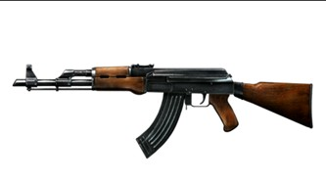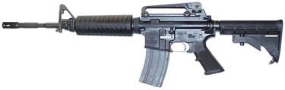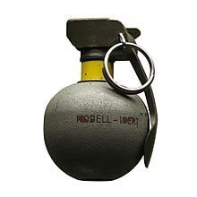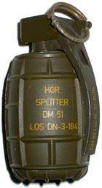ENHANCED ROOF PROTECTION
- 1x HG85 Hand Grenade (Equiv. to M67 Grenade) Placed directly on the roof

Ballistic Specifications: (VR9 VPAM ERV 2010)

Vehicles in B7 (VR9 VPAM ERV 2010) level are armoured using materials that meet or exceed the requirements of the European CEN
1522/23 standard - level FB7 for the vehicle’s sides and rear and level FB6 for the firewall and the roof, and meet or exceed the requirements of US NIJ level IV or CEN 1063 – level BR7 for transparent areas, see details below.

Armouring:

Opaque Areas: (VR9 VPAM ERV 2009)
Both sides of the passenger compartment and the rear bulkhead of the vehicle are protected using 15mm high-quality armour steel defeating the following ammunitions up to the 7.62x51mm P80 Nato Ball (U.S. NIJ level IV, CEN level FB7) at 0° incidence (90° to the surface) and 10m range according to CEN1522.
- Calibre 7.62 x 39 mm, FMJ/PB/HCI, AK 47 Kalashnikov
- Calibre 5.56 x 45 mm, FJ/PB/SCP, M16 Colt (FB5-FB6)
- Calibre 7.62 x 51 mm, FJ/PB/SC, FN “FAL/LAR” NATO rifle (FB6-NIJ III)
- Calibre 7.62 x51mm, FJ/PB/HC (AP), FN “FAL/LAR” NATO rifle (FB7-NIJ IV)

The firewall and the roof are protected using 6.5mm high-quality armour steel defeating the following ammunitions up to the 7.62x51mm M80 Nato Ball
(U.S. NIJ level III, CEN level FB6) at 0° incidence (90° to the surface) and 10m range according to CEN1522.
- Calibre 7.62 x 39 mm, FJ/PB/FeC, AK 47 Kalashnikov
- Calibre 5.56 x 45 mm, FJ/PB/SCP, M16 Colt (FB5-FB6)
- Calibre 7.62 x 51 mm, FJ/PB/SC, FN “FAL/LAR” NATO rifle (FB6-NIJ III)

Transparent Areas: (VR9 VPAM BRV 2009)
All transparent areas are multi-layer and polycarbonate coated, 72-75mm thick, to protect against the following and lesser weapons/ ammunitions up to the 7.62x51mm P80 Nato Ball (U.S. NIJ level IV, CEN level FB7) at 0° incidence (90° to the surface) and 10m range according to CEN1063.
- Calibre 7.62 x 39 mm, FJ/PB/FeC, AK 47 Kalashnikov
- Calibre 5.56 x 45 mm, FJ/PB/SCP, M16 Colt (BR5-BR6)
- Calibre 7.62 x 51 mm, FJ/PB/SC, FN “FAL/LAR” NATO rifle (BR6-NIJ III)
- Calibre 7.62 x51mm, FJ/PB/HC, (AP), FN “FAL/LAR” Rifle (NIJ IV) (minimum spacing between impacts in excess of 120mm)

OPTION: All transparent areas to defeat 7.62x51 P80 according to CEN1063 level FB7 (3 shots in triangle of 120mm side at 10m) Floor: (VR9 VPAM ERV 2010)
The floor of the vehicle is designed to defeat the following hand grenades

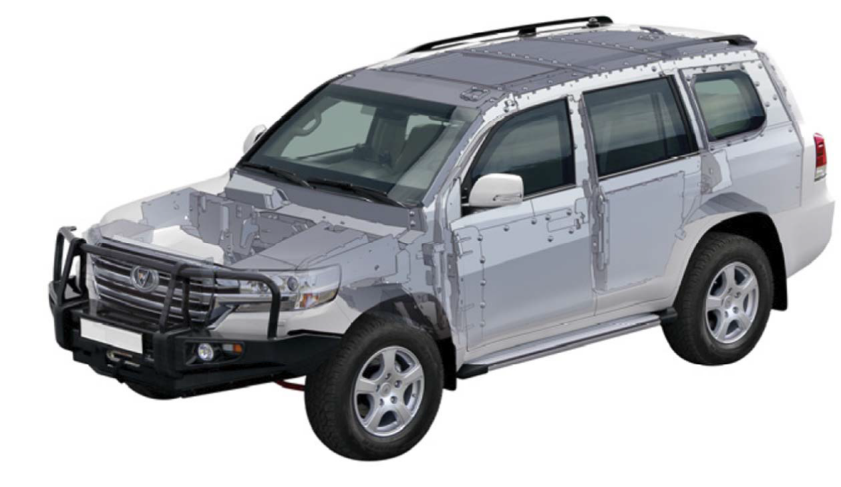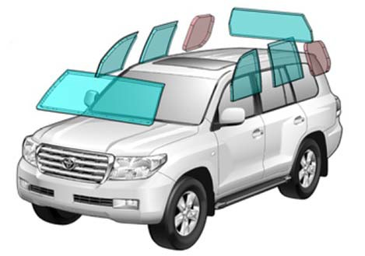
- Two DM 51 (German Norm) detonated simultaneously
- Two HG85 Fragmentation Handgrenades (under front and rear passenger seats)
- Two DM31 AP Landmines (under front and rear passenger seats)

FIREWALL & ROOF (Enhanced Roof Protection)
The firewall and the roof are protected using 6.5mm high-quality armour steel defeating the following ammunitions up to the 7.62x51mm M80 Nato Ball
NIJ level III, CEN level FB6) at 0° incidence (90° to the surface) and 10m range according to CEN1522.

- Calibre 7.62 x 39 mm, FJ/PB/FeC, AK 47 Kalashnikov
- Calibre 5.56 x 45 mm, FJ/PB/SCP, M16 Colt (FB5-FB6)
- Calibre 7.62 x 51 mm, FJ/PB/SC, FN “FAL/LAR” NATO rifle (FB6-NIJ III)
- 2x DM51 Hand Grenade Placed directly on the roof
- 1x HG85 Hand Grenade (Equiv. to M67 Grenade) Placed directly on the roof
- 2x HG85 Hand Grenades (Equiv. to 2xM67 grenades) placed directly on the roof

BGP armored glass ensures maximum security against threats with firearms while maintaining and ensuring the aesthetic and functional performance of the
original glass. 360 Degree complete body armouring.

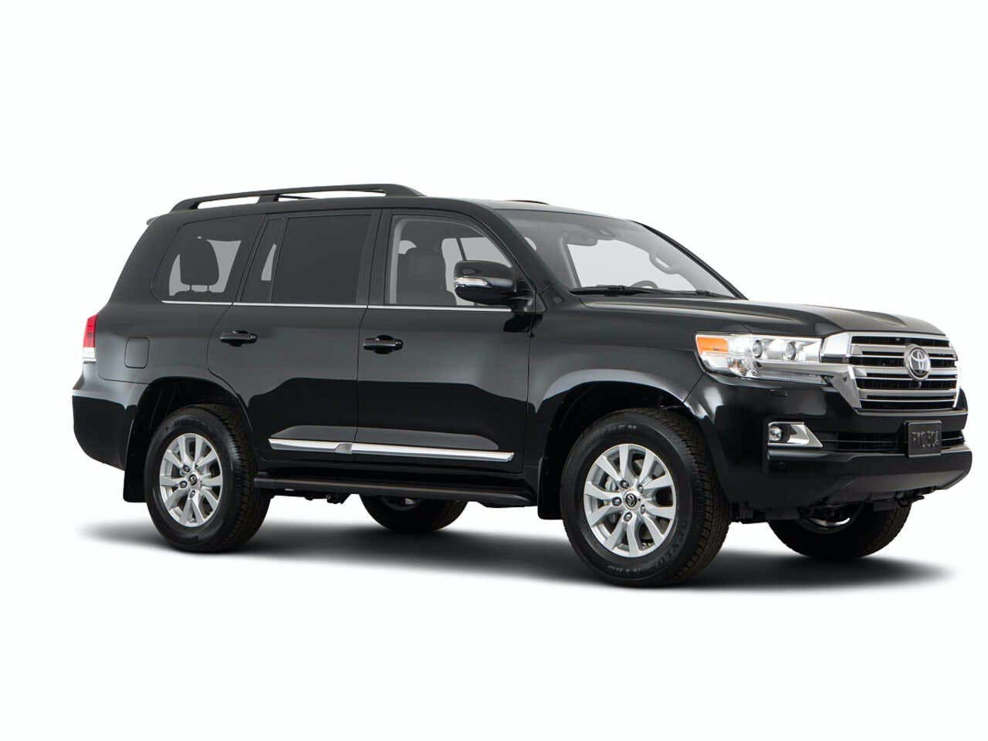

OEM VEHICLE SPECIFICATIONS:

MODEL DESCRIPTION: TOYOTA LAND CRUISER 5.7L PETROL A/T, VXR MY21 LUXURY – BLACK COLOR
YEAR:2021

ENGINE & TRANSMISSION
ENGINE:5.7L, V8, 32 VALVE, DOHC, DUAL VVT-I (3UR-FE)
OUTPUT (hp/rpm):362/5600 TORQUE (kg-m/rpm):54.0/3200
TRANSMISSION:8 SPEED AUTOMATIC TERRAIN:4x4 FULL-TIME

DIMENSION, CAPACITIES & SUSPENSIONS TYRES SIZE:285/60 R18
DIMENSIONS (mm):L5,095 X W1,980 X H1,930 FUEL TANK CAPACITY:138 L
GROSS WEIGHT (KG):3350 KG NUMBER OF DOORS:5 SEATING CAPACITY:8

INTERIOR FEATURES & SAFETY DUAL ZONE AUTO AC
CENTRAL LOCKING
CENTER CONSOLE COOLER BOX
LEATHER & WOOD-TRIMMED STEERING WHEEL TIRE PRESSUE MONITORING SYSTEM ELECTRONIC BRAKE-FORCE DISTRIBUTION (EBD) CRUISE CONTROL
MOQUETTE SEATS
ACTIVE TRACTION CONTROL (ATRC) PUSH START BUTTON
POWER STEERING
AUDIO/ AM/FM/CD / AUX/USB/BLUETOOTH 7"

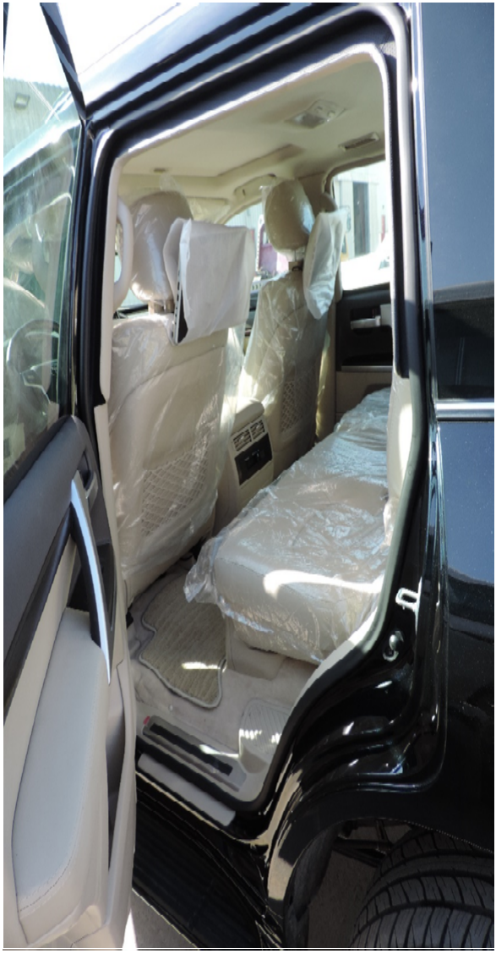NUMBER OF SPEAKERS ; 6 POWER WINDOWS
WOOD GRAIN INTERIOR PACKAGE
OPTITRON SPEEDOMETER WITH 4.2" COLOR TFT DISPLAY AUTO DIMMING REAR VIEW MIRROR
DUAL FRONT AIRBAGS/SIDES/CURTAIN/KNEE VEHICLE STABILITY CONTROL (VSC)
CRAWL CONTROL (CC) DRIVER POWER SEAT
HILL START ASSIST CONTROL (HAC)
FRONT DOOR SCUFF PLATE ILLUMINATION ANTI-LOCK BRAKE SYSTEM (ABS)
STEERING WHEEL CONTROL FOR AUDIO/TELEPHONE BRAKE ASSIST (BA)

EXTERIOR FEATURES 18" ALLOY WHEELS
TOWING HITCH WITH PINTLE HOOK WIRELESS DOOR LOCK
SMART KEYLESS ENTRY FRONT FOG LAMPS
SIDE STEPS WITH COVER
DOOR MIRRORS - POWERED/RETRACTABLE WITH REVERSE TILT FUNCTION MANUAL HEADLIGHT LEVELING
SUNROOF
LED HEADLIGHTS WITH DRL'S
Note: Specification listed for information only. Specification levels may vary depending on the Grade and specific model, and may change without prior
notice. OEM specifications can only be confirmed upon reception of the base chassis and will be carried over where applicable.

TEST REPORTS/ PRODUCT LIABILITY

All materials used in the production of the cabin were successfully tested against projectiles and explosives by independent laboratories. Test reports can be presented upon request or during a factory visit. The armoring of the vehicle provides protection against a wide range of projectiles and explosives. However, complete protection is not possible for reasons of design and modern military weapon technology.

Weight and Dimensions:

DIMENSIONS (MM) | L 5,095 X W 1,980 X L 1,890
GROSS WEIGHT (KG) Post Armoring +/- 5% | 5200

Additional equipment included:

  - Stop-tech break system
  - Exhaust protection mesh
  - Back door configuration manual/electronic Changeover switch
  - Batteries armour protection
  - Batteries isolator switch
  - Door restrains
  - Re-enforced hinges
  - Protected fuel tanks
  - Protected vehicle management system (ECU)
  - Run flat system x 5
  - Rear cargo windows – ballistic
  - Side wing full length engine compartment Armour (Armoured fenders)
  - Upgraded suspension system
  - Tailgate/interior "kill switch"
  - No remote-control door opening (mechanical key) - Driver door only
  - Front air bags disconnected
  - Parking sensors
  - 2 Way intercom
  - Siren / PA System
  - Red & Blue Strobe Lights
  - 360° Camera

Main Components Used for Manufacturing of your Armoured Vehicle:
Steel: SSAB Domex 500 Grade (Sweden) & Arcellor Mittal Mars 240 Grade (France) both approved by Beschussamt, Germany. Glass: Lumi Glass UAE & TEZJEN, Turkey - test reports and certificates from Wiltshire Ballistic Services & HP White Laboratory. Suspension: TJM suspension, Australia – certificate of conformity from TUV Rheinland
Runflats: Rodgard, Hutchinson, USA
Brake Pad: Hawk, USA
Rotor - DBA, Australia

ADDITIONAL OPTIONS INCLUDED:

- 360 Degree Armouring intergrated to the OEM Body
- Ballistic steel interior door frame for window to contain explosive shock wave pressure (anti-explosion system with ballistic frame for retention of door and hatches armored glasses)
- The rear hatch of the safety cell mounted behind the rear tailgate with Handle.
- Heavy Duty manual internal locks
- German Upgraded suspension system for vehicles weighing more than 5000kg, including reinforced coil, springs, shock absorbers, torsion bar and stabilizer bar
- Brake upgrade – stage 3 (big ventilated discs, 6-piston calipers front, 4- piston calipers rear and pads) to handle the additonal weight of Armouring and can handle up to 8,000 kg
- Heavy Duty hinges, fixed on a ballistic plate to support the weight and the opening of armored doors, complete of end-of-stroke bands door opening (Reinforcement of door and hatches supports, with integrated restraint system)
- IBS Battery System - Electrical system with two batteries (double switch - "battery relay switch")
- ECU and Battery protection of both batteries
- Engine Bay Armored completely including side engine compartment & bulkheads
- Fuel Tank Protection
- Front airbags override button
- 5 seats with microfiber/fabric seats
- Factory Rear glazing tinting with VLT factor not exceeding 30%
- Side running boards with nonslip surface
- Double-leaf rear tailgate
- Spare wheel with run flats
- Engine Fire Suppression system
- Hydraulic jack 5tons
- Rear camera
- Rear coupling/ Pintle hook;
- Front bull bar
- Second spare tire with run flat.

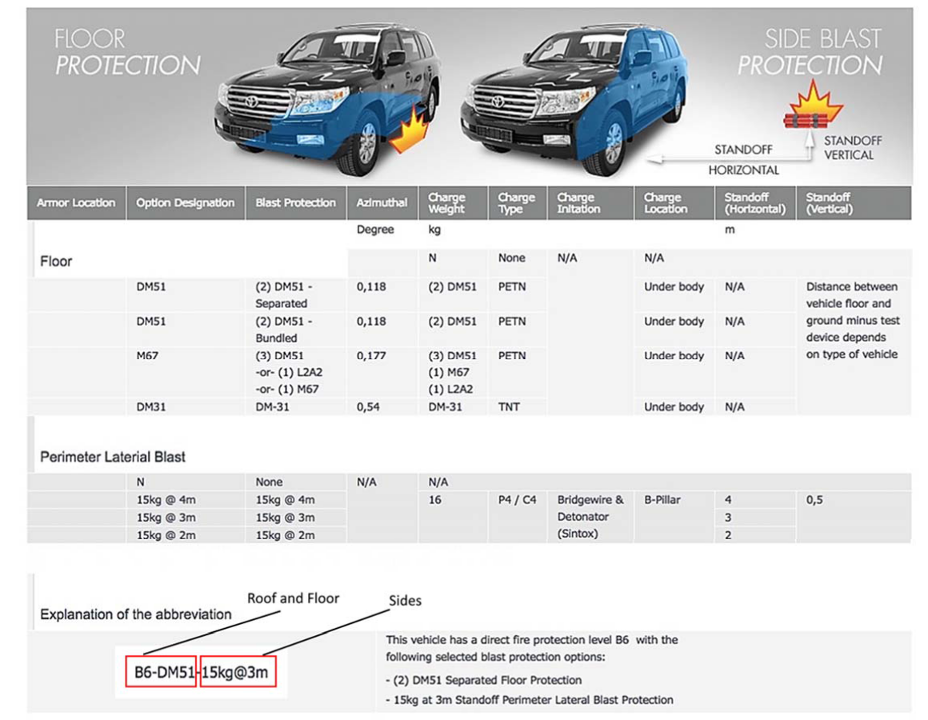

VPAM ERV 2010. - 2021YM LAND CRUISER 5.7, V8, TURBO CHARGED

BLAST PROTECTION: VPAM ERV 2010

- 1×DM51 grenades detonated under the floor

- 1x HG85 (equivalent to M67 Grenade) under vehicle

- 2×DM51 grenades detonated on the roof

- Lateral protection against minimum 15Kg of TNT exploding at a distance of 3 meters from the vehicle, at a height of 1 meter. (Sides of th e Vehicle)

The armor design of the vehicle has been tested and certified by Security Vehicles LLC.

- 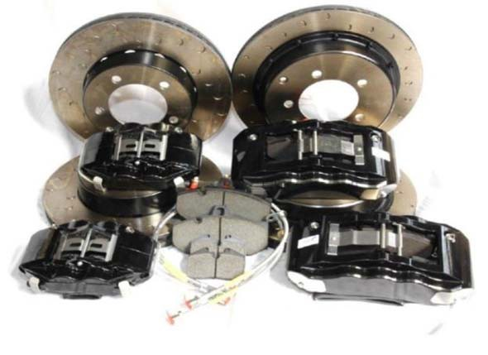Run flat system allows driving up to 50 km with speed up to 80 km according to the standard FINABEL 2.0
- Spare wheel with run flat system
- External anti-mine shield
- Ballistic protection of the battery, air filter and the Electronic Control Unit (ECU), protection level VPAM 7 (B6)
- Homologated heavy-duty suspension, tested and proven for the increased weight

- 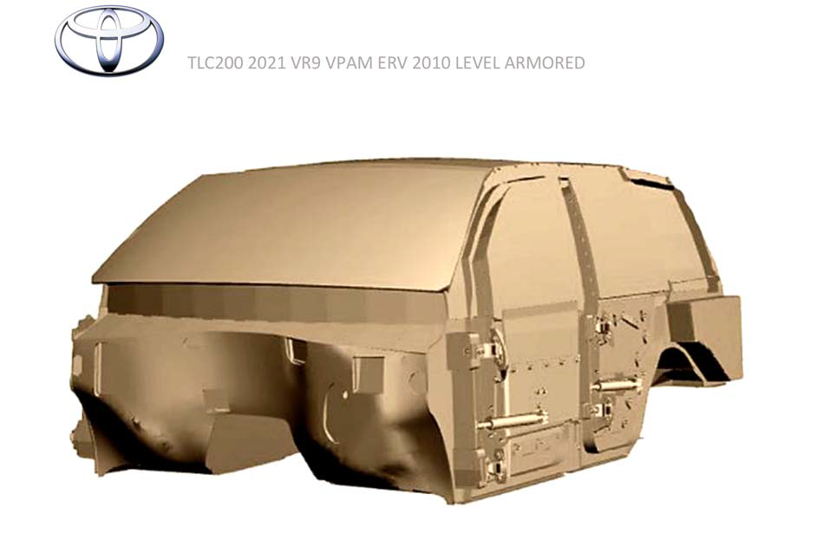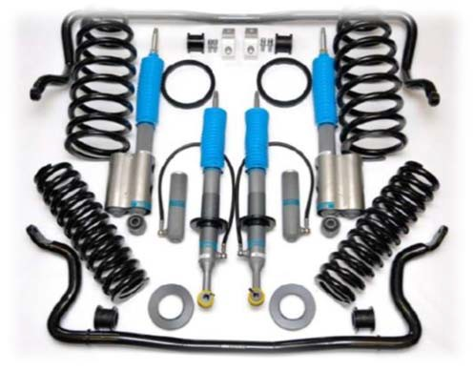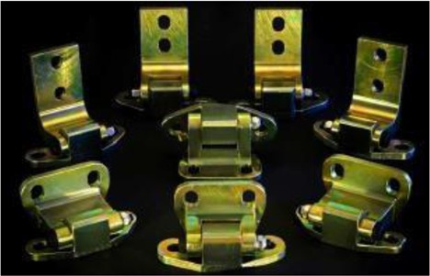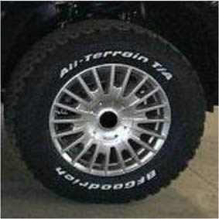Hinges milled from a single piece of steel tested to hold the doors even during the blasts. No sagging guaranteed.

TLC200 2021 VR9 VPAM ERV 2010 LEVEL ARMORED
➢ Homologated heavy-duty alloy rims and tires

- Homologated heavy-duty brake system. Please note we install six-piston (front) and four-piston (rear) calipers.

Optional Equipment available for Armored Land Cruisers

SI | Optional Equipment’s | Brand | Price / Unit
1 | Operable Front door windows | Wales, UK | $ 500.00
2 | Ballistic Radiator protection | Swebor, Sweden | $ 1,500.00
3 | Brake upgrade – stage 2 (slotted discs + Pads ) | Hawk, USA | $ 1,100.00
4 | Brake upgrade – stage 3 (big discs, 6-piston calipers front, 4- piston calipers rear and pads) | Alcon, UK | $ 3,800.00
5 | Suspension upgrade – stage 2 Coil + Shocks | TJM, Australia | $ 980.00
6 | Suspension upgrade – stage 3 (high performance springs and dampers for high-speed driving) | Eibach, Germany | $ 3,800.00
7 | Gun-ports | Custom | $ 650.00
8 | 2-way intercom | Wolfelec, UK | $ 850.00
9 | Front and rear strobe-lights integrated in OEM light lenses | CRC | $ 350.00
10 | Police siren/Public address system | Wales, UK | $ 600.00
11 | Bull-bar – ( Steel ) | TJM, Australia | $ 1,250.00
12 | Codan NGT VR | Codan, USA | $ 5,800.00
13 | Video recording | Wales, UK | $ 2,000.00
14 | Under-belly blast-shield | Swebor, Sweden | $ 3,800.00
15 | AGP Glass Set for Land Cruiser | AGP, Peru | $ 4,000.00
16 | Fire Suppression System | OMP, Italy | $ 1,800.00
17 | Emergency Recovery Kit | TJM, Australia | $ 400.00
18 | Air Compressor | TJM, Australia | $ 450.00
19 | Intelligent Battery System with Gel Battery | IBS, Switzerland | $ 1,400.00
20 | Winch 9000 Lbs. | TJM, Australia | $ 900.00
21 | Spare Runflat (5 No’s ) | Hutchinson, USA | $ 1,750.00
22 | Halogen Driving Long Throw Lights ( Round ) | Ligt Force, Australia | $ 600.00
23 | Remote Control Search Lights ( Approved by US Military ) | LightON , USA | $ 800.00
24 | 360 Degree Bullet Catcher | Swebor, Sweden | $ 1,000.00
25 | Additional Ballistic Protection (Land Mine or other Ordinances) | SSAB, Finland | $ 10,000.00
26 | Customized VIP Luxury Interiors | Carat, Russia | $ 25,000.00
27 | Snorkel | TJM, Australia | $ 1,400.00

TEST REPORTS/ PRODUCT LIABILITY

All materials used in the production of the cabin were successfully tested against projectiles and explosives by independent laboratories. Test reports can be presented upon request or during a factory visit. The armoring of the vehicle provides protection against a wide range of projectiles and explosives. However, complete protection is not possible for reasons of design and modern military weapon technology.

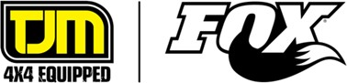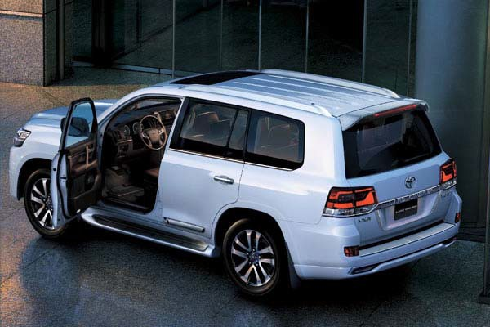

WARRANTY AND AFTER SALES t

warrants any armor related items installed, and conversion related custom workmanship, including transparent armor*, for the period
of 1 year or 20,000km, whichever comes first. Any suspected warranty related work must first be confirmed as being necessary by means of technical consultation with a representative of Security Vehicles.
Warranty work authorized to be directly covered by Security Vehicles shall be performed locally at the nearest authorized facility**, and billing forwarded directly to IDFWRU\. After careful assessment of said invoice, )DFWRU\ shall, upon consultation and approval, make
payment for any/all repairs deemed to be of a reasonable nature*** by our Warranty Service and Engineering Departments.

COMMERCIAL OFFER – BR7 - VR9 VPAM ERV 2010 ARMORING FOR 200 5.7 Petrol V8 2021
ITEM No. | ITEM DESCRIPTION | COO | QTY | UNIT | ExW RATE | ExW TOTAL
1 | BR7 - VR9 VPAM ERV 2010 Level of Armoring - According to CEN 1063, Toyota Land Cruiser 200 5.7 Petrol V8 2021YM with STANAG Floor | UAE | 1 | UNIT | USD 210,000.00 | USD 210,000.00
2 | Run Flat Devices on all wheels. | USA | 1 | SET | INCLUDED | INCLUDED
3 | Bullet Catcher | SWEDEN | 1 | SET | INCLUDED | INCLUDED
4 | ECM, Fuse Box & Battery Protection. | SWEDEN | 1 | SET | INCLUDED | INCLUDED
5 | Full Engine Bay Protection | SWEDEN | 1 | SET | INCLUDED | INCLUDED
6 | Fender & Fuel Tank Protection | SWEDEN | 1 | SET | INCLUDED | INCLUDED
7 | Heavy Duty Suspension System | GERMANY | 1 | SET | INCLUDED | INCLUDED
8 | HD-Sway Bar | GERMANY | 1 | SET | INCLUDED | INCLUDED
9 | HD Brake Upgrade | UK | 1 | SET | INCLUDED | INCLUDED
10 | HD Full Wheel Assymbly – Includes - All Terrain Tyres, Runflats, HD Wheels from Hutchinson USA | USA | 1 | SET | INCLUDED | INCLUDED
11 | HD Door Hinges and Door Stoppers | AUSTRALIA | 1 | SET | INCLUDED | INCLUDED
12 | IBS Battery System - Dual | USA | 1 | SET | INCLUDED | INCLUDED
13 | Window Actuator – Driver and Co passenger | UK | 1 | SET | INCLUDED | INCLUDED
14 | Second spare tire with run flat. | USA | 1 | SET | INCLUDED | INCLUDED
15 | High Grade Blast Protection for Explosive for Floor STANAG | SWEDEN | 1 | SET | INCLUDED | INCLUDED
16 | Fire Suppression System - Engine Bay | UK | 1 | SET | INCLUDED | INCLUDED
17 | Hydraulic Jack | USA | 1 | SET | INCLUDED | INCLUDED
18 | 360 Degree Camera | USA | 1 | SET | INCLUDED | INCLUDED
19 | Rear coupling/ Pintle hook | USA | 1 | SET | INCLUDED | INCLUDED
20 | First Aid Kit | AUSTRALIA | 1 | SET | INCLUDED | INCLUDED
21 | Exhaust mesh protection | SWEDEN | 1 | SET | INCLUDED | INCLUDED
22 | Anti Corrosive and Acid Attack Protection Paint | USA | 1 | SET | INCLUDED | INCLUDED
23 | Radiator Protection | SWEDEN | 1 | SET | INCLUDED | INCLUDED
24 | Fire Extinguisher | UK | 1 | SET | INCLUDED | INCLUDED
25 | Lateral Blast Protection – 15 Kg TNT | SWEDEN | 1 | SET | INCLUDED | INCLUDED
TOTAL |  |  |  |  |  | USD 210,000.00

BUYER:
PROPOSAL REFERENCE | 01-27-2026- -BR7-VR9 ERV 2010 TLC200 5.7 PETROL V8 2021
VALIDITY
DATE

PAYMENT AND DELIVERY TERMS

VEHICLE ORDER | MANUFACTURING LOCATION | MANUFACTURING DATE | COMPLETION DATE
1 | UAE | EX STOCK | EX STOCK

  - 90% advance payment on price is due on order for new production vehicles, balance 10% prior to shipping.
  - Full payment of price is required within 5 working days of Buyer receiving notice of completion of the vehicle and prior to shipping/releasing vehicles for shipping.

Please contact us if you require any further details or assistance from our side. Thanks & Best Regards,

