THE FOLLOWING HFO FIRED POWER PLANT IS AVAILABLE FOR SALE WITH US WITH IMMEDIATE DELIVERY

1 No. –107.088 MW WARTSILA (2011) make HFO Fired Power Plant having the following technical specifications:

1.0: PLANT KEY DATA & MAJOR EQUIPMENTS – SUMMARY:

: Plant Key Data:

01. | Plant Capacity (gross) | 107.088 MW
02. | Plant Capacity (Net as per last PPA with BPDB) | 100 MW
03. | Designed Operation Philosophy (Base Load/Peaking) | Peaking Load
04. | Power generation & evacuation voltage | 11KV & 132 KV
05. | Types of usable fuel | HFO
06. | Date of Commissioning/COD | 21st July 2011
07. | Date of termination of PPA (three terms, 12 years) | 23rd April’2026

  - : Plant Major Equipment Data:

No. | Equipment | Manufacturer | Model | Quantity | Capacity
01. | Prime Mover | WARTSILA | W20V32 | 12 | 9200 KW
02. | Generator | AVK | DIG 167 F/8 | 12 | 11155 KVA
03. | Main Power Transformer | Crompton Greaves Ltd | IEC 60076 | 03 | 40/50 MVA
04. | Station Transformer | LTL Transformers (Pvt) Limited | L1 75 AC  28/AC 3 | 03 | 2000 KVA
05. | Black Start Generator | LEROY SOMER  Alternators | 47.2VS3 J 6/4 | 01 | 375 KVA
06. | Fuel Treatment Separator | GEA WESTFALIA,  GmbH | OSE80-0136- 067/60 | 03 | 15400 dm³/h
07. | Lube Oil Separator | GEA WESTFALIA,  GmbH | OSE20-0196- 067/15 | 12 | 2850 dm³/h
08. | Exhaust Gas Boiler | AALBORG  INDUSTRIES OY, FINLAND | H TYPE 2A | 04 | 1700 KW
09. | Auxiliary Boiler | AALBORG  INDUSTRIES OY, FINLAND | BH-1500 L | 01 | 1000 KW
10. | Starting Air Compressor | HATLAPA | L160 | 02 | 151 m3/h
11 | Starting Air Compressor | ATLAS COPCO | LT-25-30 W KE | 01 | 90 m3/h
12. | Instrument Air Compressor | KAESER | SK25 | 02 | 15 KW
13. | Plant Control System | Wärtsilä Operator’s  Interface System (WOIS)

- PLANT OVERALL PERFORMANCE EVALUATION:

  - : Operational Data:

Machine Identification | DG1 | DG2 | DG3 | DG4 | DG5 | DG6
Running Hours | 51914 | 48387 | 44660 | 47184 | 47096 | 47786
Machine  Identification | DG7 | DG8 | DG9 | DG10 | DG11 | DG12
Running  Hours | 55477 | 46471 | 45199 | 47961 | 44613 | 52961

  - : The Specific Fuel Consumption (SFC) and Specific Lube oil consumption (SLOC) calculated based on the Actual Energy injected into the grid:

Year (April – March) | Availability (In %) | Net Specific Engine Fuel  Consumption (gm/Kwh) | Net Plant Specific Fuel Consumption (gm/Kwh) | Specific Lube Oil Consumption (gm/Kwh) | Plant Load Factor (in %)
COD – 21st  July’2011 | 99.29 | 210.054 | 215.619 | 0.347 | 93.08
2011 – 2012 | 99.12 | 211.514 | 216.635 | 0.431 | 92.53
2012 – 2013 | 96.80 | 214.407 | 219.456 | 0.436 | 92.95
2013 – 2014 | 88.29 | 214.452 | 219.303 | 0.446 | 89.27
2014 – 2015 | 92.17 | 215.583 | 220.576 | 0.431 | 84.28
2015 – 2016 | 94.31 | 215.608 | 220.551 | 0.469 | 85.97
2016 – 2017 | 90.24 | 213.074 | 218.034 | 0.491 | 88.85
2017 – 2018 | 92.45 | 213.988 | 219.173 | 0.507 | 88.49
2018 – 2019 | 99.86 | 216.983 | 222.636 | 0.414 | 87.02
2019– 2020 | 97.69 | 216.831 | 222.202 | 0.430 | 91.11
2020-2021 | 99.46 | 218.325 | 223.130 | 0.386 | 91.89
2021-2022 | 94.13 | 219.814 | 224.715 | 0.512 | 89.64
2022-2023 | 92.39 | 219.303 | 225.171 | 0.607 | 88.41
April’2024- 17th August’2024 | 92.10 | 219.583 | 226.021 | 0.762 | 87.74

  - : Major Overhauling Information:

GENSET:

Engine no. | Maint. Infor. | 12000 Hrs SM | 24000 Hrs SM | 36000 Hrs SM | 48000 Hrs SM
DG1 | Running Hrs | 16814 | 27129 | 34310
DG1 | Maint. Date | 06/07/2014 | 10/04/2016 | 24/06/2018
DG2 | Running Hrs |  | 23259 | 37263
DG2 | Maint. Date |  | 06/03/2016 | 31/05/2020
DG3 | Running Hrs |  | 24036
DG3 | Maint. Date |  | 10/07/2016
DG4 | Running Hrs |  | 28695
DG4 | Maint. Date |  | 23/08/2017
DG5 | Running Hrs |  | 30302
DG5 | Maint. Date |  | 08/11/2017
DG6 | Running Hrs |  | 27101
DG6 | Maint. Date |  | 11/05/2017
DG7 | Running Hrs | 19578 |  | 39340
DG7 | Maint. Date | 26/11/2014 |  | 29/10/2018
DG8 | Running Hrs |  | 24146
DG8 | Maint. Date |  | 22/05/2016
DG9 | Running Hrs |  | 28966
DG9 | Maint. Date |  | 28/12/2017
DG10 | Running Hrs |  | 29070
DG10 | Maint. Date |  | 08/06/2017
DG11 | Running Hrs | 14547 | 31711
DG11 | Maint. Date | 06/09/2014 | 20/05/2018
DG12 | Running Hrs | 19682 |  | 37631
DG12 | Maint. Date | 06/01/2015 |  | 31/01/2018

Power Transformer – OLTC:
(150,000 Tap change or 7 years interval schedule maintenance):

Sl.  No. | Power TX  # | OLTC information |  | Maint. information
Sl.  No. | Power TX  # | Model | Sl. No. | Date | Tap Count
01 | 1 | IEC 60076 | ET09903/1 | 16-02-2018 | 047512
02 | 2 | IEC 60076 | ET09903/2 | 16-02-2018 | 047615
03 | 3 | IEC 60076 | ET09903A/2 | 16-02-2018 | 046004

TECHNICAL INFORMATION FOR MAJOR EQUIPMENT:

: Prime Mover – 12 Nos.

Type : W20V32
Year of Manufacture : 2010 Number & Arrangement of Cylinders : 20, V type Cylinder Bore Diameter : 320 mm
Stroke Length : 400 mm
Engine Speed : 720 rpm
Mean Piston Speed : 10.0 m/s
Swept Volume per Cylinder : 32.17 liters
Compression Ratio : 16:1
Output : 9200 kW
Governor Manufacture : WOODWARD
Type : PG – EG 58
Wet sump capacity : 5300 liters
Cooling water volume of engine : HT 940 liters LT 310 liters

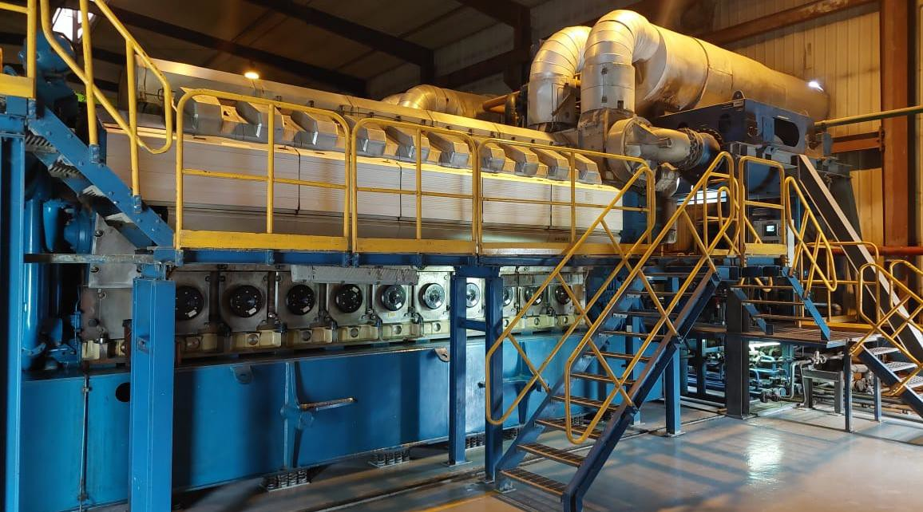

Fig: Engine

  - : Turbocharger:

Type : TPL67-C34
Approx. Speed : 30000 rpm (Max.)
Lubrication : SAE 40
Quantity 24

: Generator - 12 Nos.
Type : DIG 167 f/8
Year of Manufacture : 2010
Rated apparent power : 11155 KVA Rated Voltage : 11000 V
Rated Current : 585 A
Rated Frequency : 50 Hz
Number of phases 3
Rated Speed : 750 rpm
Number of poles 8
Connection : STAR
Power factor : 0.80

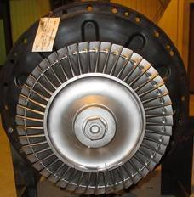

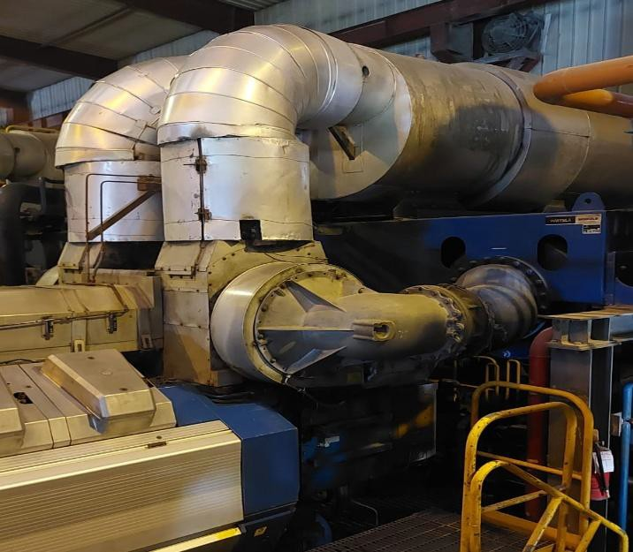Fig: Turbocharger

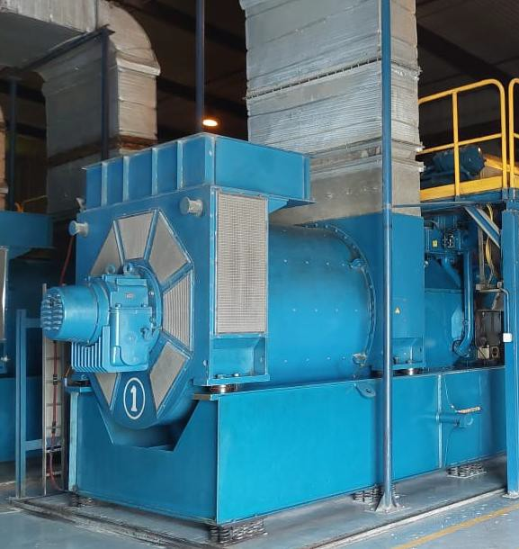
Fig: Generator

Geenerator Identification | DG1 | DG2 | DG3 | DG4 | DG5 | DG6
Generator Serial No. | 8430804  B304 | 8430385  B101 | 8430385  C101 | 8430778  B102 | 8430778  B202 | 8430417  B101
AVR – | 004007 | 002018 | 002337 | 004136 | 004218 | 1364181

Generator Identification | DG7 | DG8 | DG9 | DG10 | DG11 | DG12
Generator Serial No. | 8430804  B404 |  | 8430385  G104 | 8430185  J101 | 8430385  K101 | 8430385  H101
AVR – | 004123 | 002333 | 002335 | 002311 | 1361006 | 002030

- ELECTRICAL SYSTEMS:

  - : Main Power Transformer – 3 Units:

Rated Power : 40/50 MVA
Rated Frequency : 50 Hz
Phases : 3
Rated Voltage (HV/LV) : 132/11 KV Rated Current (HV/LV) : 218.7/2624.3 A Vector Group : YNd11
% Impedance on 50 MVA : 13.44%, 12.54%, 11.13%
Types of cooling : ONAN / ONAF
Transportation weight : 88200 Kg
Oil Volume : 27500 Ltr
Year of Manufacture : 2010
Standard : IEC 60076
Manufacturer : Crompton Greaves Ltd
No of Tap positions : 21
Tap changer Model : ED100S
OLTC Manufacturer : MR
Year of OLTC Mfg. : 2010
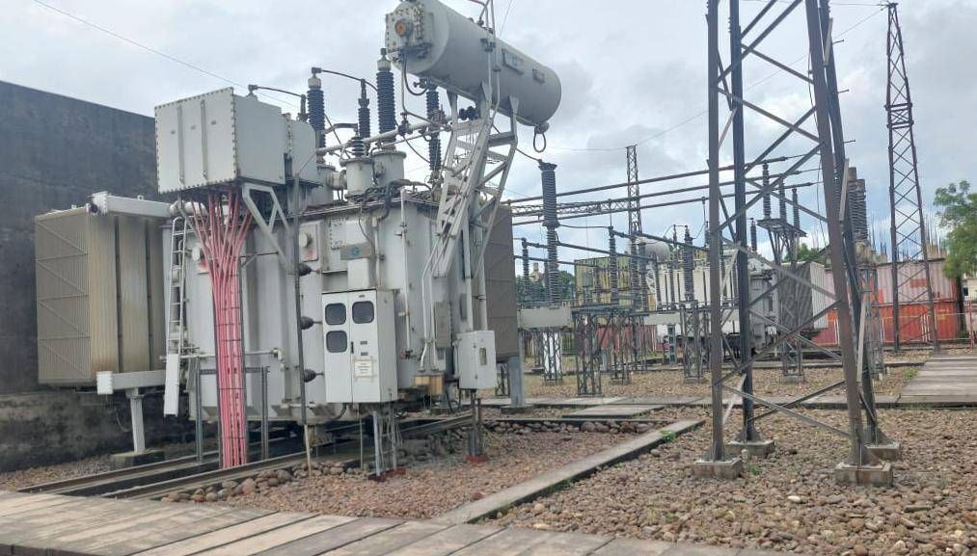

Fig: Main Power Transformer

  - : Station Transformer - 3 Units:
Rated Power : 2000 KVA

Rated frequency : 50 Hz

No of Phases : 3

Rated Voltage (HV/LV) : 11000/433 V Rated Current (HV/LV) : 2666.7/104.27 A Vector Group : Dyn11
% Impedance : 7.18%

Types of cooling : ONAN

No of Tap positions : 5 Approx. Masses (Total) : 6510 Kg Year of Manufacture : 2011
Standard : IEC-60076:2000

Manufacturer : LTL Transformers (Pvt) Limited

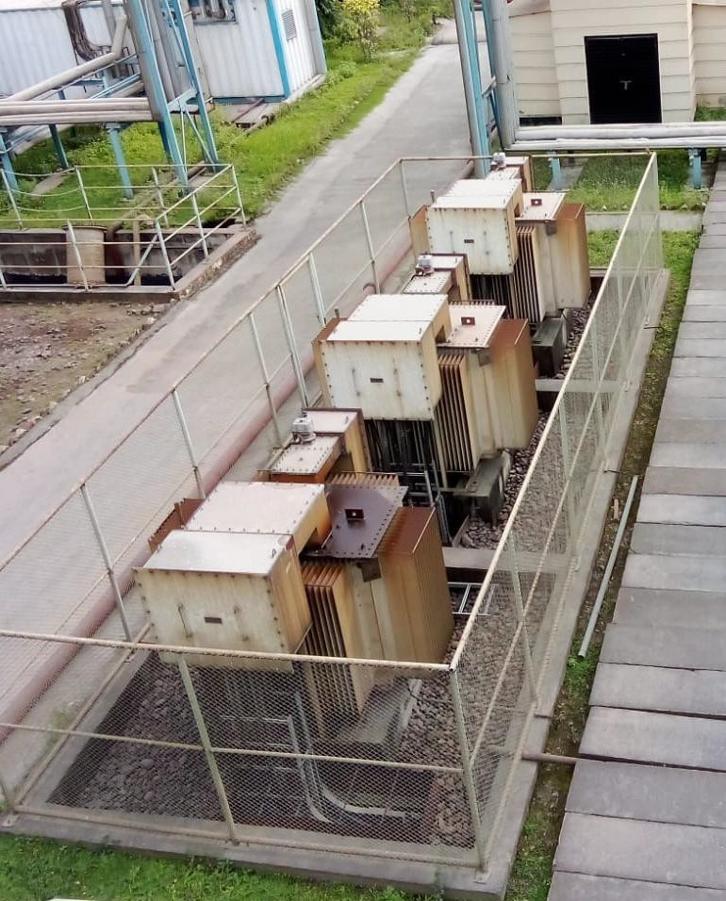

Fig: Station Transformer

  - : High Voltage Switchgear System:

    - : Main breakers : 4 units

Type : SF6
Manufacturer : Crompton Greaves Ltd
Year of mfg. : 2010
Rated Voltage : 145 KV
Rated Current : 1250 A
Rated Frequency : 50 HZ

: Disconnector with Earthing switch : 1 units

Model : CD101
Type of drive : Motor Drive/ Manual
Rated Current : 1250 A Manufactured by : COELME, egic Year of Mfg. : 2010

: Disconnector without Earthing switch : 4 units

Model : CD101
Type of drive : Motor Drive/ Manual
Rated Current : 1250 A Manufactured by : COELME, egic Year of Mfg. : 2010

: Potential transformer : 03 units

Type : IVT
Model :
Rated Voltage : 132 kV
Rated Voltage Ratio : 132 KV/110 V
Class of Accuracy : Cl. 0.2
Rated Sec. Burden : 50 VA
Rated Frequency : 50 Hz
No of Phase : 3 Phase
Manufactured by :
Year of Mfg. : 2010

: Potential transformer : 03 units

Type : CVT
Model :
Rated Voltage : 132 KV
Rated Voltage Ratio : 132 KV/110 V
Class of Accuracy : CL. 0.5 / Cl. 3P
Rated Sec. Burden : 50 VA
Rated Frequency : 50 Hz
No of Phase : 3 Phase
Manufactured by :
Year of Mfg. : 2010

: Potential transformer : 03 units

Type : Line CVT
Model :
Rated Voltage : 132 KV
Rated Voltage Ratio : 132 KV/110 V
Class of Accuracy : CL. 0.5 / Cl. 3P
Rated Sec. Burden : 50 VA
Rated Frequency : 50 Hz
No of Phase : 3 Phase
Manufactured by : EWH1020978
Year of Mfg. : 2010

: Potential transformer : 9 unit

Type : VTI-24-1
Model :
Rated Voltage : 11 kV
Rated Voltage Ratio : 11 KV/110V
Class of Accuracy : CL. 0.5 / CL. 6P
Rated Sec. Burden : 50 VA
Rated Frequency : 50 Hz
No of Phase : 3 Phase
Manufactured by : TRAFINDO
Year of Mfg. : 2010

: Current transformer : 3 units (Out)

Type : EWH1020978
Rated Voltage : 132 kV
Rated Current Ratio : 800/1 A
Class of Accuracy : CL. 0.2, / CL. 5P20
Rated Sec. Burden : 30 VA
Rated Frequency : 50 Hz
No of Phase : 3 Phase
Manufactured by : ELSTER
Year of Mfg. : 2010

: Current transformer : 9 units

Type :
Rated Voltage : 132 kV
Rated Current Ratio : 300/1 A
Class of Accuracy : CL. 0.5, / PX / 5P20
Rated Sec. Burden : 30 VA / 15 VA
Rated Frequency : 50 Hz
No of Phase : 3 Phase
Manufactured by :
Year of Mfg. : 2010

Current transformer : 09 units

Type :
Rated Voltage : 11 kV
Rated Current Ratio : 2500/1 A
Class of Accuracy : CL, 5P20
Rated Sec. Burden : 30 VA
Rated Frequency : 50 Hz
No of Phase : 3 Phase
Manufactured by :
Year of Mfg. : 2010

: Lightening Arrester : 9 units

Type : Zinc Oxide Surge Arrester
Model : ZLA-3E
Rated voltage : 120 KV Discharge Current : 10 KA Rated Frequency : 50 Hz
Manufacturer : ZINC OXIDE SURGE ARRESTER Year of Mfg. : 2010

: Lightening Arrester : 3 units

Type : Zinc Oxide Surge Arrester
Model : ZLA-3E
Rated voltage : 120 KV Discharge Current : 10 KA Rated Frequency : 50 Hz
Manufacturer : ZINC OXIDE SURGE ARRESTER Year of Mfg. : 2010

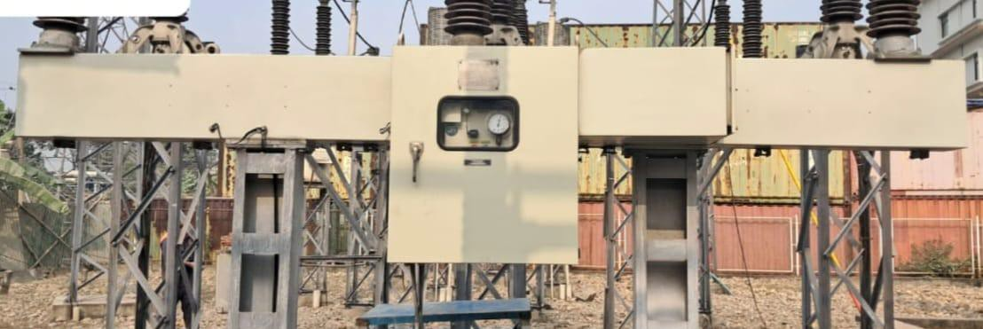

Fig: Main breakers

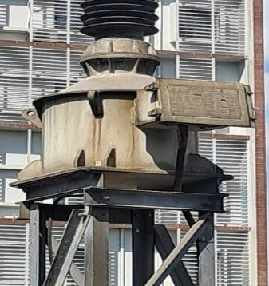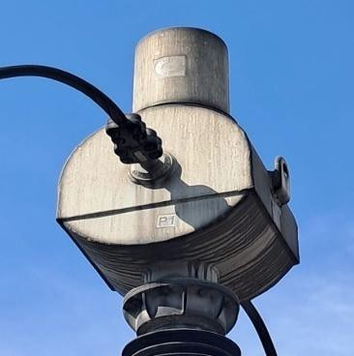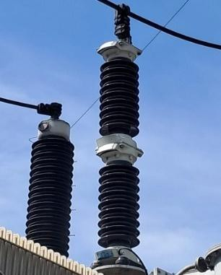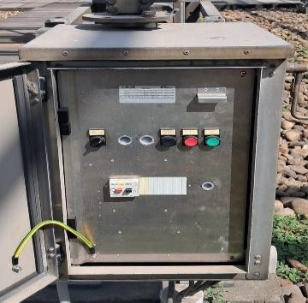

Fig: Earthing Switch Fig: PT Fig: CT Fig: Lighting Arrestor

: Medium Voltage Switchgear System:

Operating Voltage : 11 KV Rated Voltage : 12 KV
Rated Current : 2500 A
Frequency : 50 Hz
No of phases 3

: Generator Cubicles : 12 units

Breaker type : LF2 Manufacturer : SCHNIDER Model : E2 C2 M2 Rated voltage : 12 KV Rated current : 630 A
Year of Mfg. : 2010

4.4.3: Station TX Cubicles : 3 units

Breaker type : LF2 Manufacturer : SCHNIDER Model : E2 C2 M2 Rated voltage : 12 KV Rated current : 630 A

4.4.5: Outgoing Cubicles : 3 units

Breaker type : LF2 Manufacturer : SCHNIDER Model : E2 C2 M2 Rated voltage : 11 KV Rated current : 2500 A Year of Mfg. : 2010

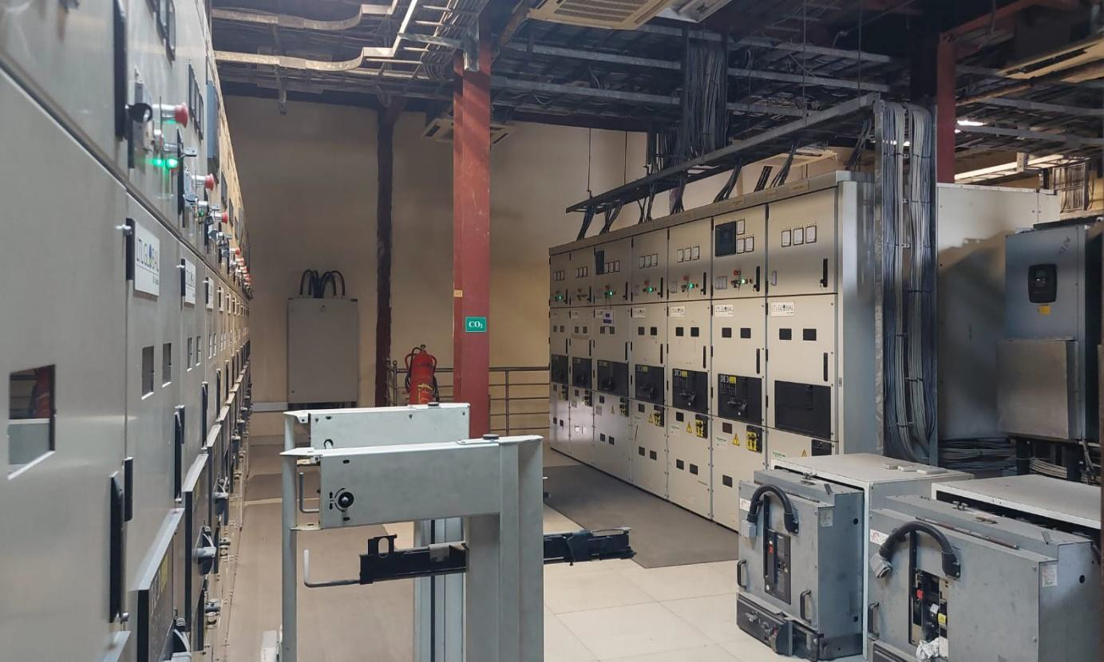Fig: 4.4

  - : Low Voltage Switchgear System:

    - : Black Start Generator : 1 units

Breaker type : LKE-606-FIXED
Manufacturer : LKE
Model :
Rated voltage : 1000 V
Rated frequency : 50 Hz
Rated current : 600 A

4.5.1: Main breakers : 6 units

Breaker type : LKE-632-FIXED
Manufacturer : LKE
Model :
Rated voltage : 1000 V
Rated frequency : 50 Hz
Rated current : 3200 A

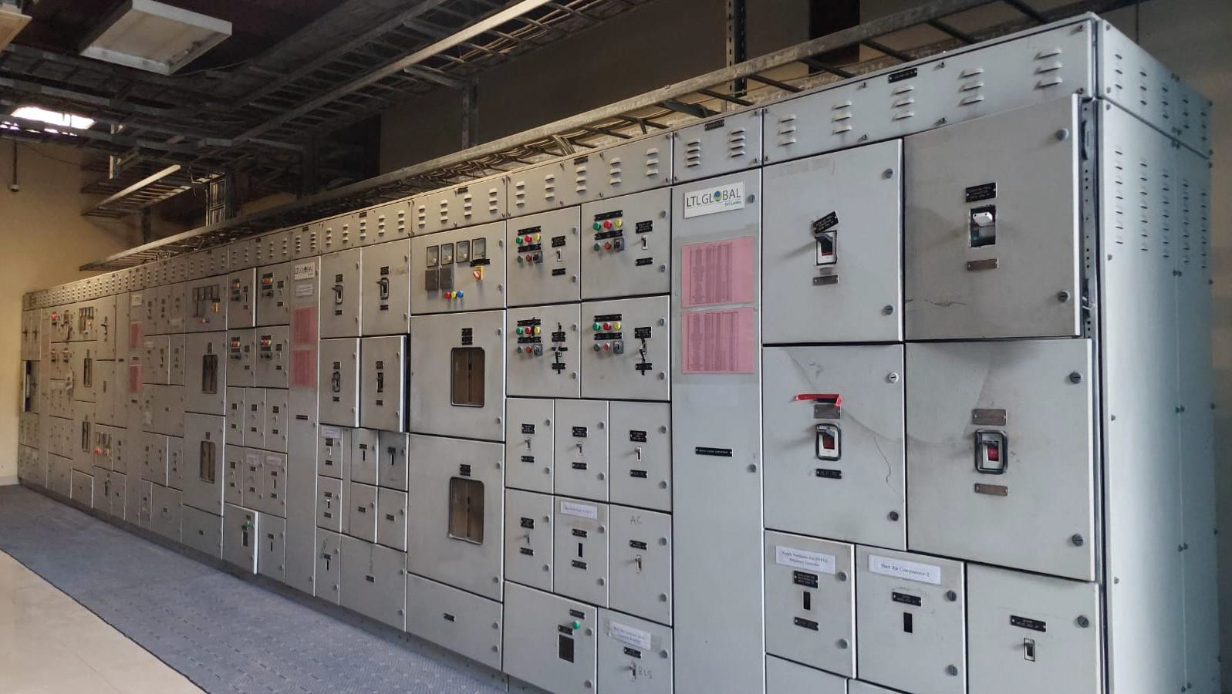Fig: 4.5

  - : DC System:

    - : Battery Charger : 01 units

Type/Model : DTP
A.C input voltage : 415V
D.C output voltage : 110V
D.C output current : 100A
Manufacturer : ENERGYPAC
Year of Mfg. : 2024

: Battery Charger : 2 units

Type/Model : EIPS 110-1800.4 D1
A.C input voltage : 400/230V
D.C output voltage : 120-145V
D.C output current : (1-4) *15A
Manufacturer : EFORE
Year of Mfg. :

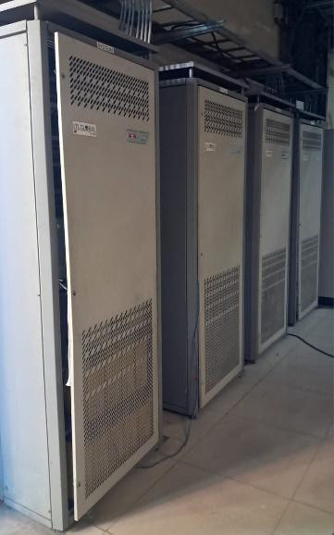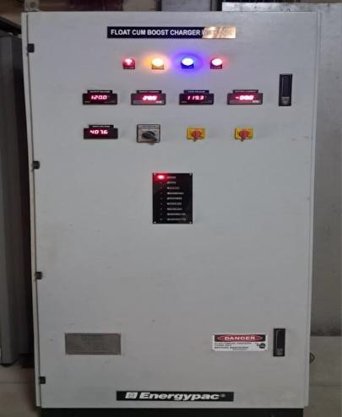

Fig: 4.6.1 Fig: 4.6.2

- PLANT AUXILIARY SYSTEMS
  - : Lube oil Purification System

    - : LO Separator – GEA WESTFALIA, GmbH

Quantity : 12
Type : OSE20-0196-067/15
Density : 0.912 kg/ dm3@15 °C
Viscosity : 55 cSt @ 100 °C (SAE40)
Feed temperature : 60 °C (Minimum)
Separating temperature : 95 °C
Separating capacity : 2850 dm³/h
Bowl speed : 12000 rpm

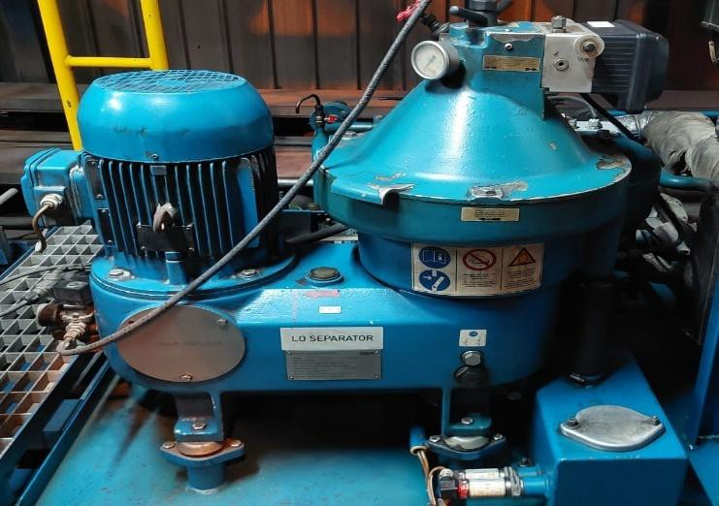

Fig: LO Separator

Pump Kind : Gear Pump Aggregate
Type : KF40 RF2-D15
Capacity : 3360 l/h (56 l/min)

Separator EL. Motor
Capacity : 7.5 KW
Manufacturer : WEG
Model : 20MAI10 1007905763

Feed Pump EL. Motor
Capacity : 1.5 KW
Manufacturer : ADDA ANTRIEBSTECHNIK
Model :

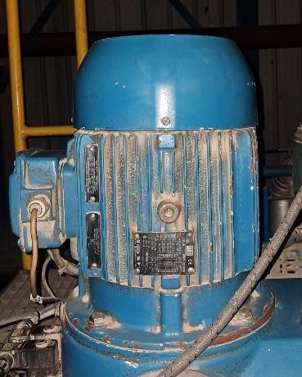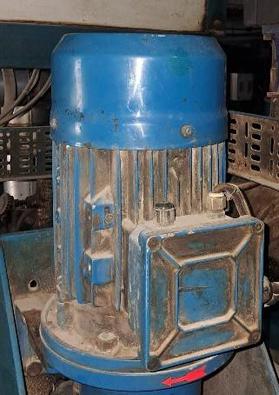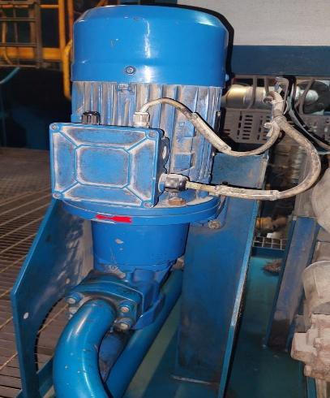

Fig: LO Sep. Feed Pump Fig: LO Sep. Motor Fig: LO Sep. Feed Pump Motor

5.2: Fuel Purification System

5.2.1: HFO Separator – GEA WESTFALIA, GmbH

Quantity : 3 units
Type : OSE80-0136-067/60
Density : up to 1.01 kg/ dm³at 15 °C
Viscosity : 380 cSt @ 50 °C
Feed temperature : 60 °C (Min.)
Separating temperature : 98 °C
Separating capacity : 15400 dm³/h
Bowl speed : 6800 rpm

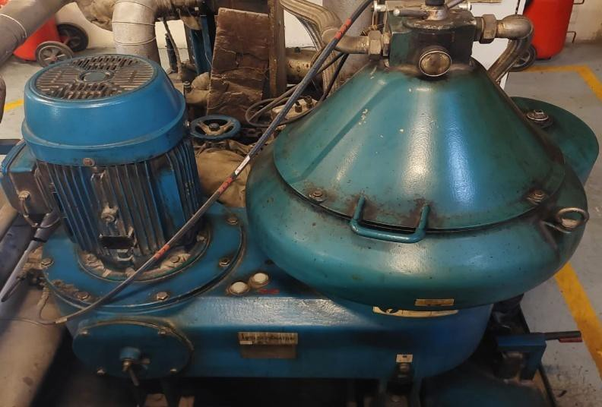
Fig: HFO Separator

Pump Kind : Gear Pump Aggregate
Type : PUAG KF 4/180-WS 5.50 KW
Capacity : XX l/h (XX l/min)

Separator EL. Motor
Capacity : 22 kW
Manufacturer : WEG
Model : 132S-02

Feed Pump EL. Motor
Capacity : 5.5 KW
Manufacturer : ECHTOP
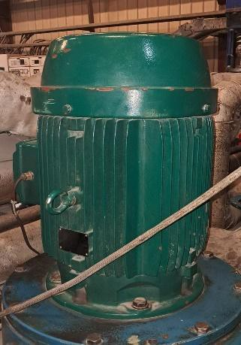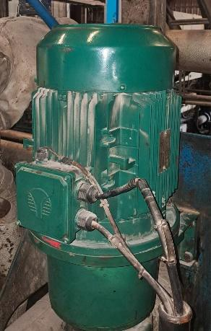Model : TFC132S-4

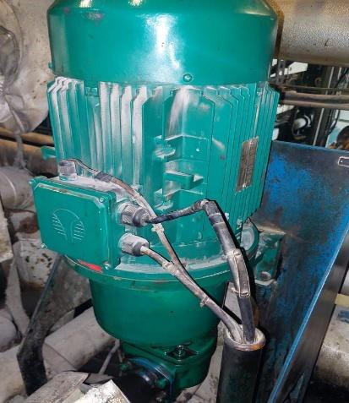

: Fuel Transfer Units

HFO Transfer Unit

Transfer Pump : 2 Nos
Type : ACG 070D7 NTBP
Capacity : XX m3/ h, XX bar, XX cSt
Make : IMO AB

El. Motor : 2 Nos
Capacity : 11 kW
Manufacturer : BROOK CROMPTON
Model : WD - DA160MJ-4

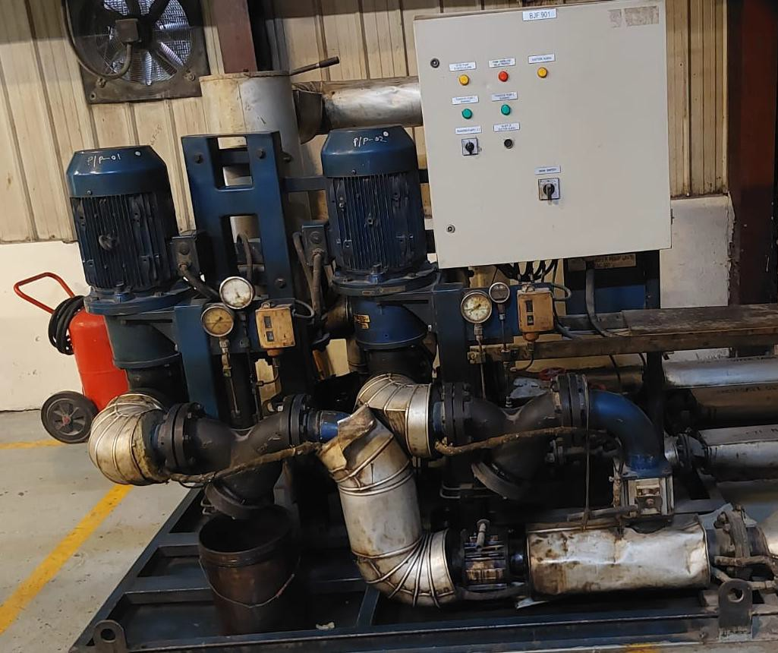

Fig: HFO Transfer Unit

  - : HFO / LFO Feeder Unit

HFO Viscosity : 700 cSt @ 50 °C
Fuel consumption maximum : 18 m3/h
Viscosity set point minimum : 16-24 cSt Injection temperature maximum : 110-120 °C Fuel pres. At unit maximum : 08 bar
HFO day tank temperature : 90-92 °C

    - : Automatic Filter (01 Nos) Manufecturer: Boll & KIRCH Filterbau GMBH Type : 6.61 DN100
Filter : 34 microns

    - : Simplex Filter (XX Nos)
Manufecturer: Boll & KIRCH Filterbau GMBH Type : 1.03.2.265.500 DN100
Filter : 34 microns

: Viscosity Meter (01 Nos)
Type : M003138
Rated Power : 6 Watt
Make : Aura Marine

: HFO Feed Pump (02 Nos)
Pump type/Model : ACG 070N7 NTBP
Pump Capacity : 3 - 4 m3/ h, 07 bar, XX cSt Manufacturer : IMO AB

El. Motor capacity : 11 kW Manufacturer : HOYER MOTORS
Model : Y2E2-160M-4

    - : LFO Feed Pump (01 Nos) Pump type/Model : ACG 060N7 NVBP Pump Capacity : 3-4 m3/h, 07 bar, Manufacturer : IMO AB

El. Motor capacity : 7.5 kW Manufacturer : HOYER MOTORS
Model : MS 132S2-2

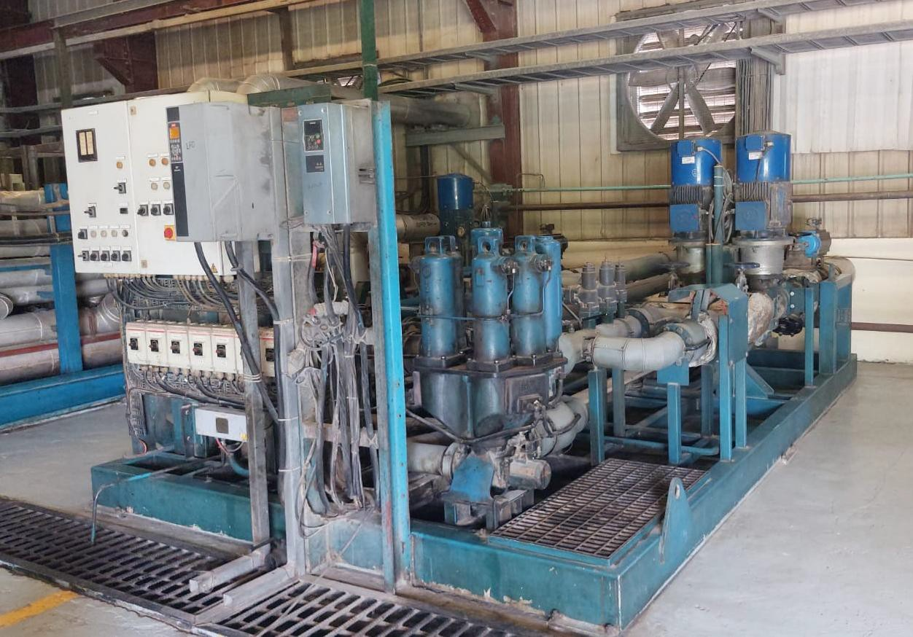

  - : Compact Booster Unit – 01 unit for each Engine

    - : Fuel filter
Type : 470240 (Duplex Filter)
Make : Parker/ Fin

: Heater
Type : VISTA MX15 75 L600
Make : Aalborg Industries

: Clean leak pump
Type : ACE 025L3 NTBP
Capacity : 30 l/min
Make : IMO AB

: Dirty leak pump
Type : Diaphragm Pump
Capacity : 0.5 – 0.6 m3/hr
Make : Wildon

: Fuel Oil Flow Meter
Type : PROMASS 80
Make : Endress+Houser

: Engine Fuel Booster Pump
Type : ACG 045K7 NTBP
Capacity : XX m3/hr
Make : IMO AB

El. Motor Capacity : 7.5 kW Manufacturer : ABB
El. Motor type : M3AA 132 SC 2

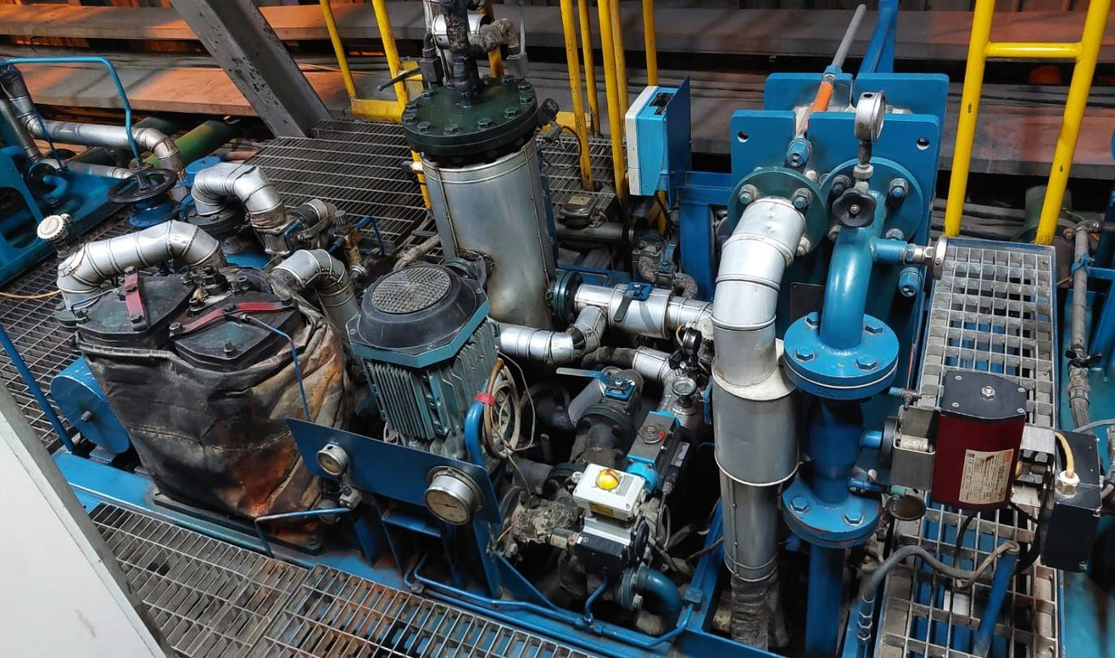

  - : HT/LT Cooling Water Radiators (24 Pcs)

Manufacturer : Afa Laval Vantaa Oy
Type : FBLGS-1260-12-6A8-
Min/ Max. Temperature : -100/ 120 °C Design/ Test Press : 6/9 Bar
Casing Material : Hot – dip Galvanized Sheet Steel
Finned Coil : Copper
Internal Volume : 860 liters
Fin Spacing : 2.5 mm
Dry weight : 5000 kg
Max working pressure : 6 bar

Electrical Motors
No of Motors : 144
Capacity : 7.6 kW, 725 rpm, (380-420) V, 50 Hz
Type :
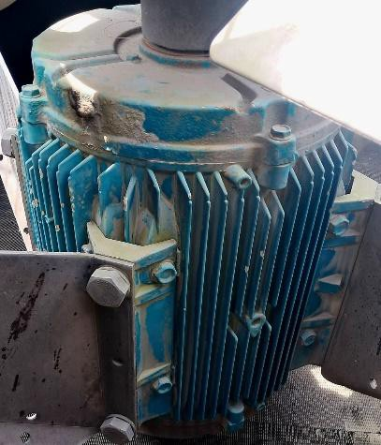Make :

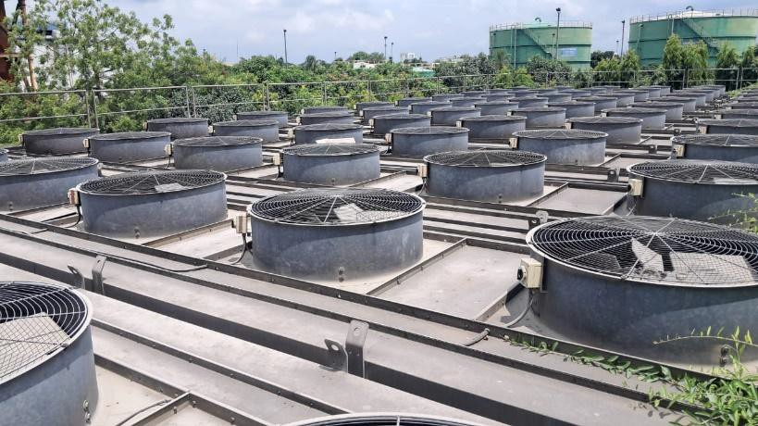

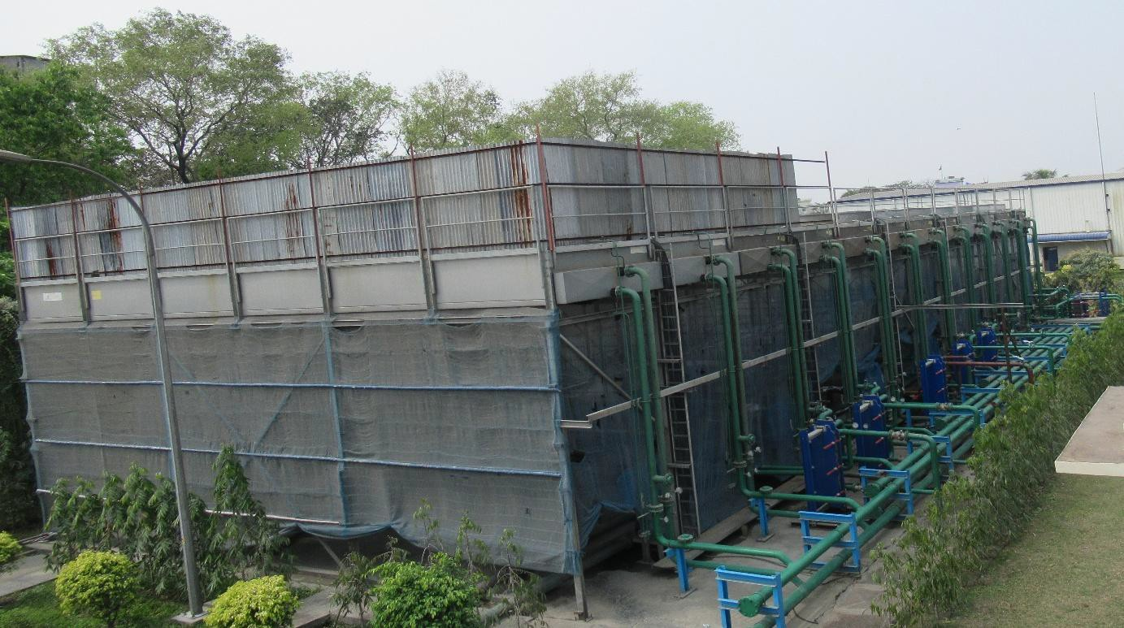

: Engine Pipe Module

    - : Lube Oil Cooler (12 Nos.)
Manufacturer : Alfa Laval (India) Ltd.
Type :
Nominal Capacity :
Working pressure :

: LFO Cooler
Manufacturer : Alfa Laval (India) Ltd.
Type : M6M-FG
Nominal Capacity : Up to 16 kg/s Heat transfer surface : XX m2
Working pressure : 7.85 bar (8.0 ATG)

: Lube Oil Filter (Automatic)
Manufacturer : BOLL & KIRCH
Model : 6.48 DN125
Capacity : 6.48 m3/hr
Mesh size : 30 microns

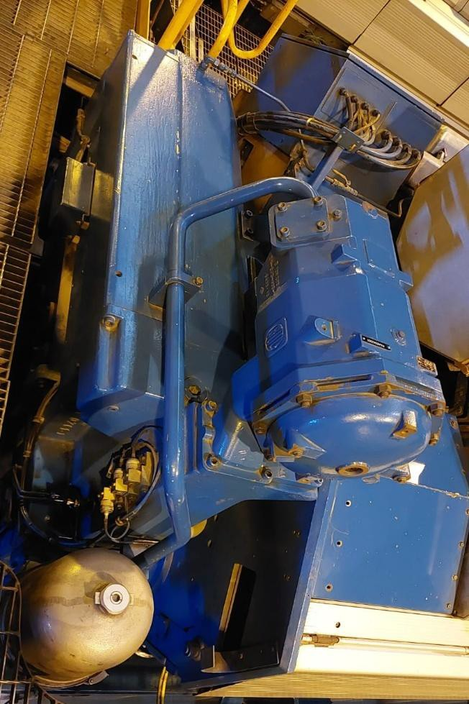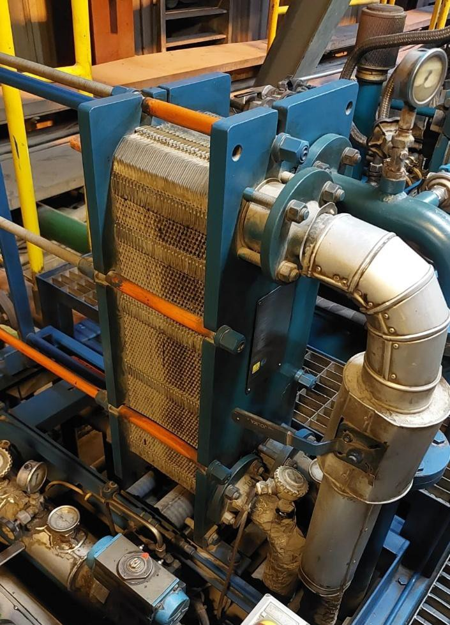

Fig: 5.7.1 – 5.7.3

  - : Pre-lube Pump – Pre lubricating of Engine

Pump Type : EAAE 085988 (SOP 26)
Capacity : XX m3/hr
Make : KRACHT D58791 WERDOHL

El. Motor Capacity : 15 kW Manufacturer : ABB
El. Motor type : 3GAA162042-BDG,96

  - : Pre-heating Pump of Engine

Pump Type : AE-25/2
Capacity : m3/hr
Make : KOLMEKS Finland

El. Motor type : OKN-841DN12 El. Motor Capacity : 0.65 KW Manufacturer : KOLMEKES

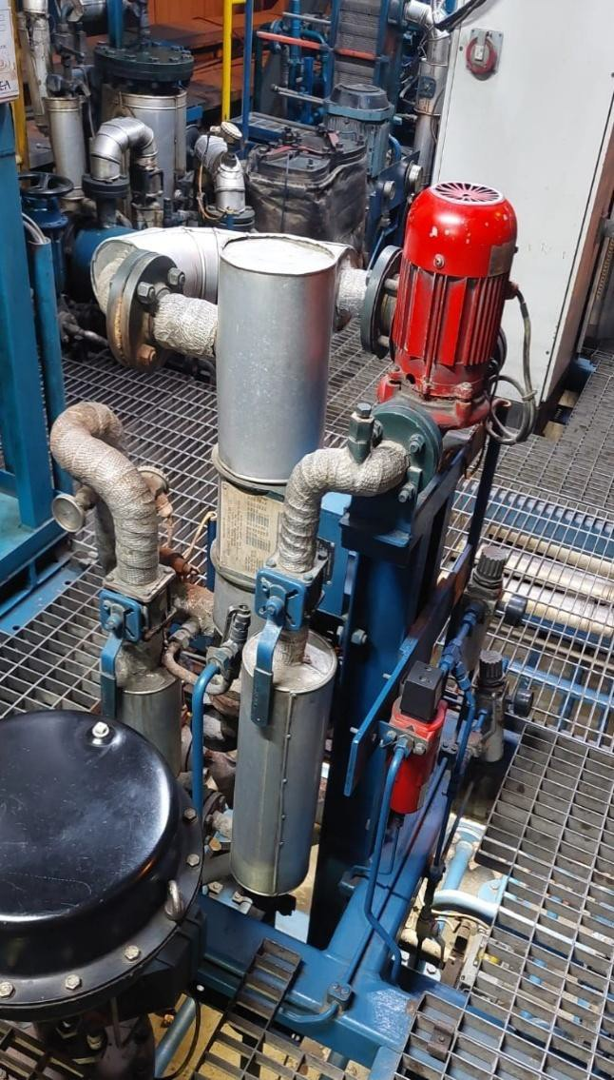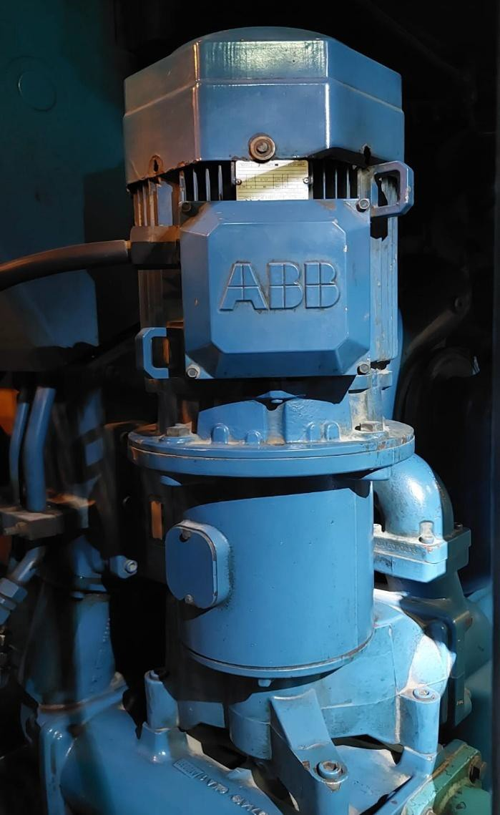

Fig: Pre-Lube Pump with Motor Fig: Pre-heating Unit

5.10: Turning Gear of Engine

Type : LKV 132-272 H1
Capacity : 1500 Nm (Max. Torque)
Make : KATSA, Finland

El. Motor type : M2AA 100LA El. Motor Capacity : 2.2 KW
Manufacturer : BB MOTORS LTD.

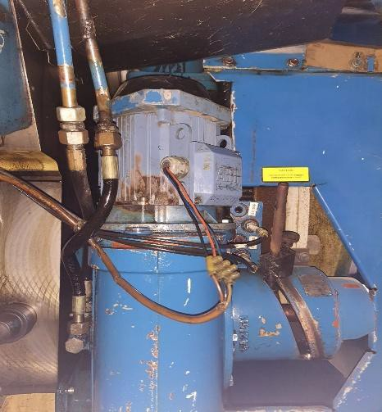

Fig: Turning Gear with Motor

6.0: Compressed Air System

    - : Starting Air System –03 Sets
Compressors : 02 Nos
Type : L160
Make : HATLAPA
Capacity : 151 m3/h

Compressors : 01 Nos
Type : LT-25-30 W KE
Make : ATLAS COPCO
Capacity : 90 m3/h

: Starting air vessel- 04 vessels
Capacity : 3 m3
P max : 4.5 MPa

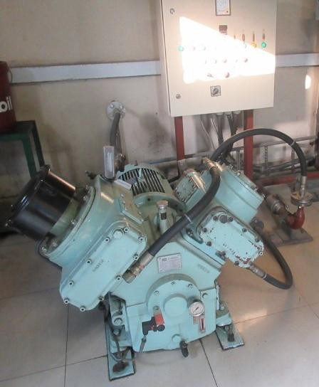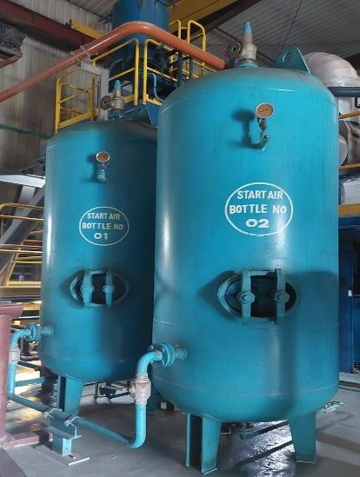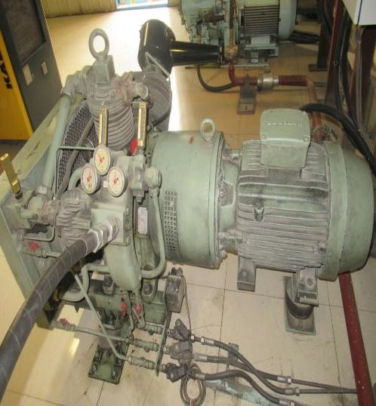

Fig: Hatlapa Air Compressor Fig: Atlas Copco Compressor Fig: Starting Air Vessels

    - : Instrument Air Compressor-02 units
Type : SK25
Make : KAESER
Capacity : XX m3/min
Rated pressure : 8 Bar
Rated power : 15 KW

: Instrument air vessel- 04 vessels
Capacity : 250 L
P max : 11 Bar

6.1.4.1: Portable Air Compressor-01 unit
Type : JZW - 0.9/10
Make : JIEBAO AIR COMPRESSOR
Capacity : 0.9 m3/min
Rated pressure : 10 Bar
Rated power : 10 HP

: Instrument Air Dryer-02 units
Model : TC 31
Make : KAESER
Capacity : 115 cfm (1.95 m3/min apprx.) Rated pressure : 16 Bar (LP), 18 Bar (HP) Rated power : KW

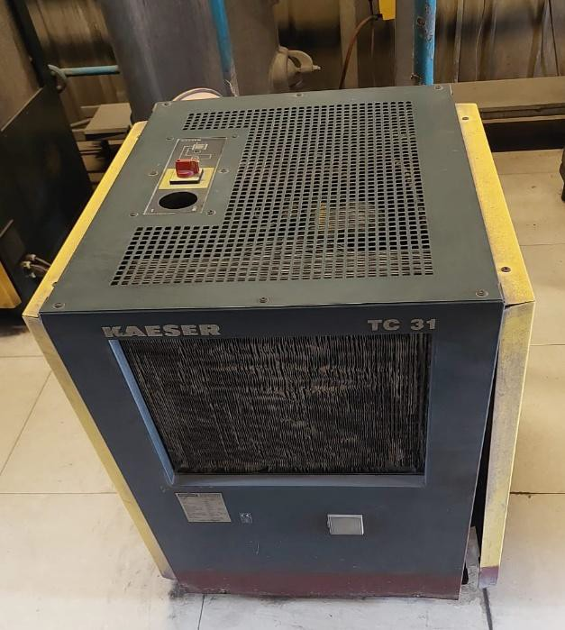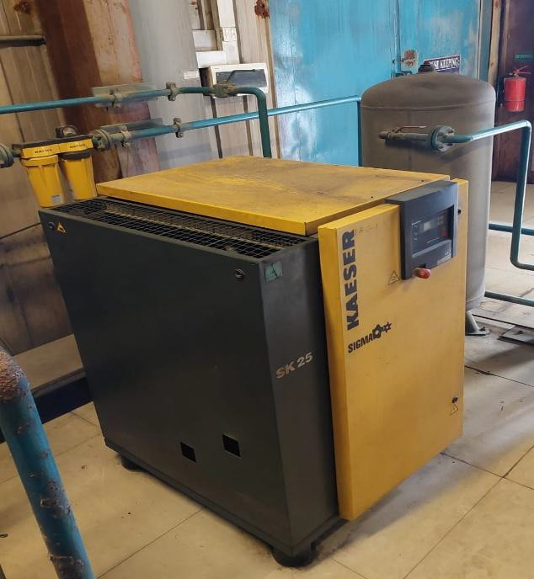

Fig: Instrument Air Compressor Fig: Instrument Air Dryer

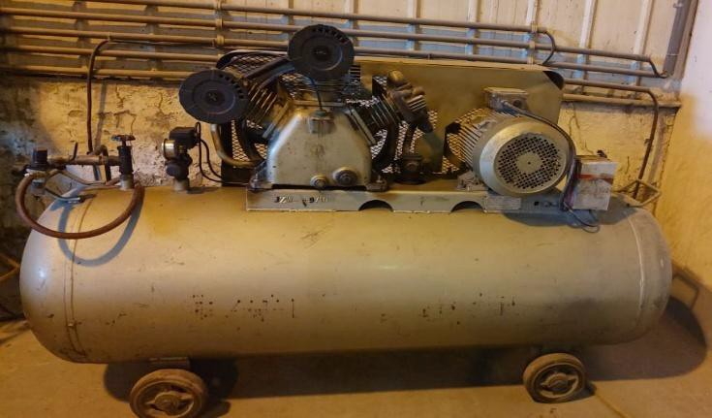

Fig: Portable Air Compressor

  - : Heat Recovery Steam Generation:

    - : Exhaust gas boilers – 04 Nos.
Type : H TYPE 2A
Manufacturer : AALBORG INDUSTRIES OY, FINLAND
Design pressure : 16.7 bar
Working pressure : 10 bar
Capacity/ output : 1700 KW
Exhaust gas flow : XX kg/s Exhaust gas temperature max : XX C
Main dimensions : XX
Water volume (operation) : 8.1 m³

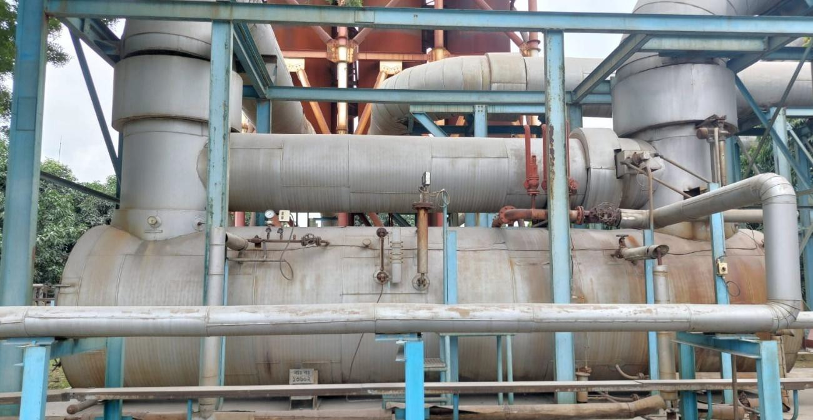

Fig: Exhaust Gas Boiler

    - : Auxiliary Boiler – 01 Nos.
Type : BH-1500L
Boiler Manufacturer : AALBORG INDUSTRIES OY, FINLAND
Heat Section : Water tube Configuration
Classification : Low Pressure Boiler
Burner Type : KP – 90 H
Burner Manufacturer : Finland
Design pressure : 16 bar
Working pressure : 10 bar
Capacity/ output : 1000 KW
Main dimensions : L=XX, W=XX, H=XX, ø XX mm
Water volume (operation) : 3.61 m³

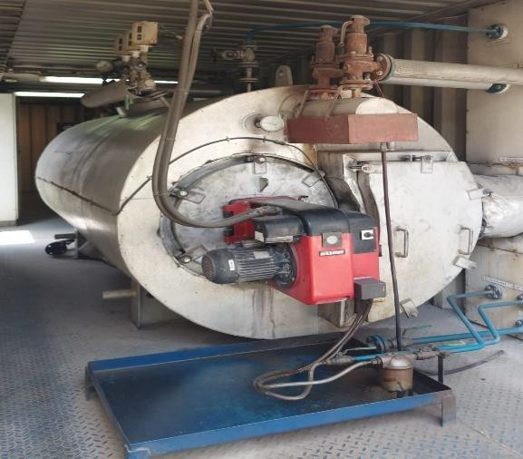

Fig: Auxiliary Boiler with Burner

    - Steam Header – 01 Nos.
Model : SH-250D
Manufacturer : Aalborg Industries
Design pressure : 16 bar
Working pressure : 10 bar
Main dimensions : XX
Water volume (operation) : XX m³

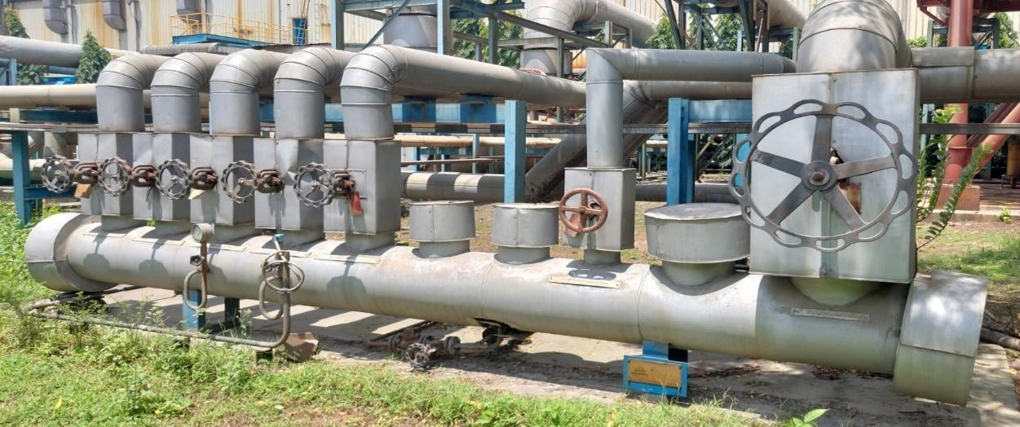

Fig: Steam Header

    - Feed water tank – 01 Nos.
Model : SVS -7
Manufacturer : AALBORG INDUSTRIES OY, FINLAND
Design pressure : 3.5 bar
Working pressure : 0.5 bar
Temperature (operation) : 100 0C
Main dimensions : XX
Water volume (operation) : 7 m³

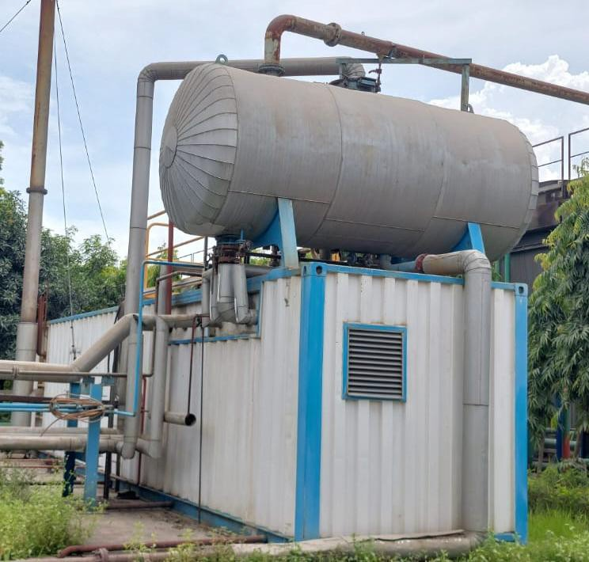

Fig: Boiler Feed Water Tank With Auxiliary Boiler Container

6.2.5: Feed water pump – 02 Nos.
Type : CR15-10 A-F-A-E-HQQE
Model : A96501901P11031
Manufacturer : GRUNDFOS (Denmark)
Pmax/Tmax : 16 bar/ 120 °C
Capacity : 17 m3/hr
Pump speed : 2924 rpm
Design : Single System 1*100%
Main dimensions : L=XX, W=XX, H=XX

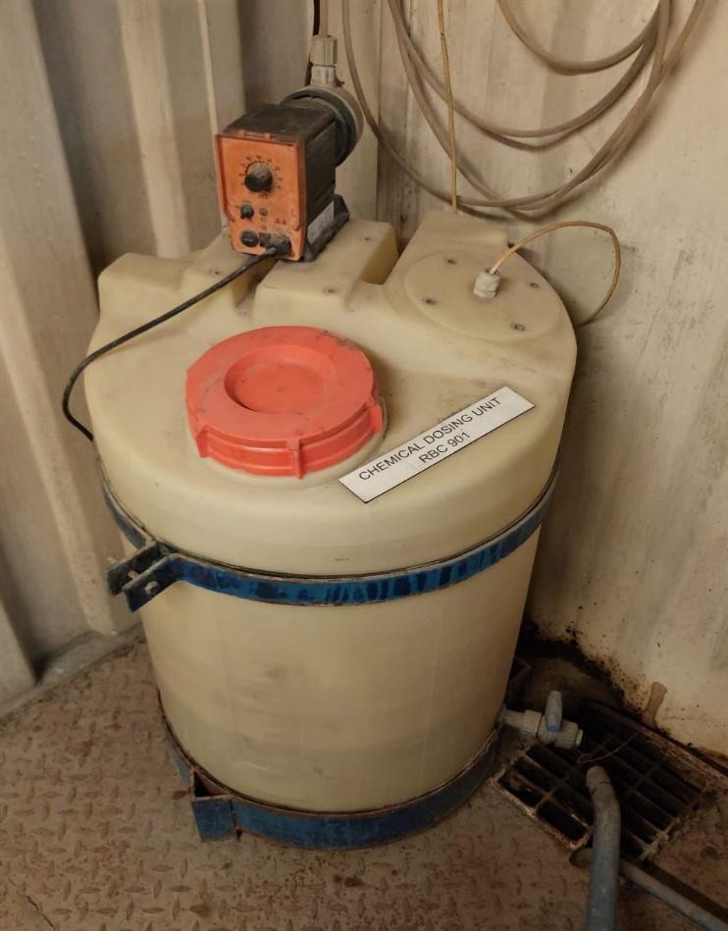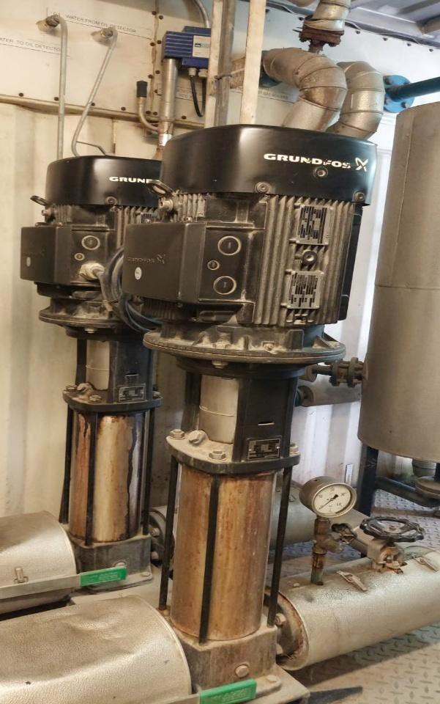

Fig: Feed water pump Fig: Chemical dosing unit

  - : Black Start Generator Unit

    - : Alternator

Manufacturer : LEROY SOMER
Model : 47.2VS3 J 6/4
Rated Power Continuous : 500 kVA Active Power : 400 kW
Power factor : 0.8
Voltage : 440 V
Frequency : 60 Hz
Dimensions (L*W*H) mm :

: Engine

Manufacturer : VOLVOPENTA
Model : TAD941GE
Rated Power : 323 kW
Rated speed :1500 rpm

: Liner Honing Machine

Manufacturer : CHRIS-MARINE
Model : UB (Serial no. 06754)
Quantity 01

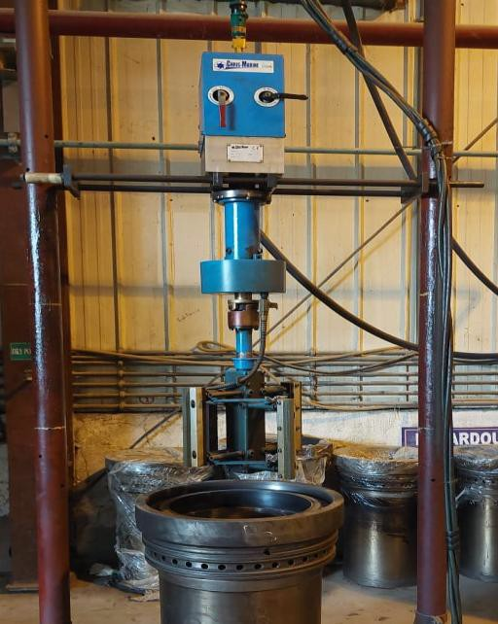

Fig: Liner Honing Machine

  - : Lathe Machine

Manufacturer : A-ONE Engineering Works
Model :

Quantity 01

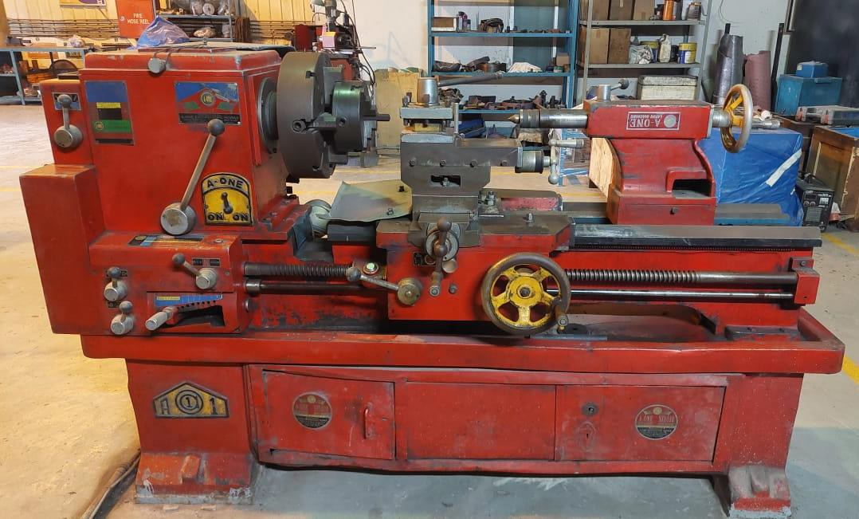

Fig: Lathe Machine

  - : Drilling Machine

Manufacturer : LT, China

Model : LT – 32 GF
Quantity 01

: Welding Machine
Manufacturer : Welding Industries Malaysia
Model : AC300 Rated Output : 320 Amp Quantity 01

: Seat Ring Cutting Machine

Manufacturer : CHRIS-MARINE

Model : VSL (06732)

Quantity 01

: Cylinder Head Washing Machine

Manufacturer : TeiJO PESUKONEET OY, Finland

Model : C – 1600 HSS KD

Quantity 01

: Fuel Injection Valve Pressure Testing Machine

Manufacturer : IOP MARINE, Denmark

Model : VPUD 1100 MK1 4 pos

Quantity 01

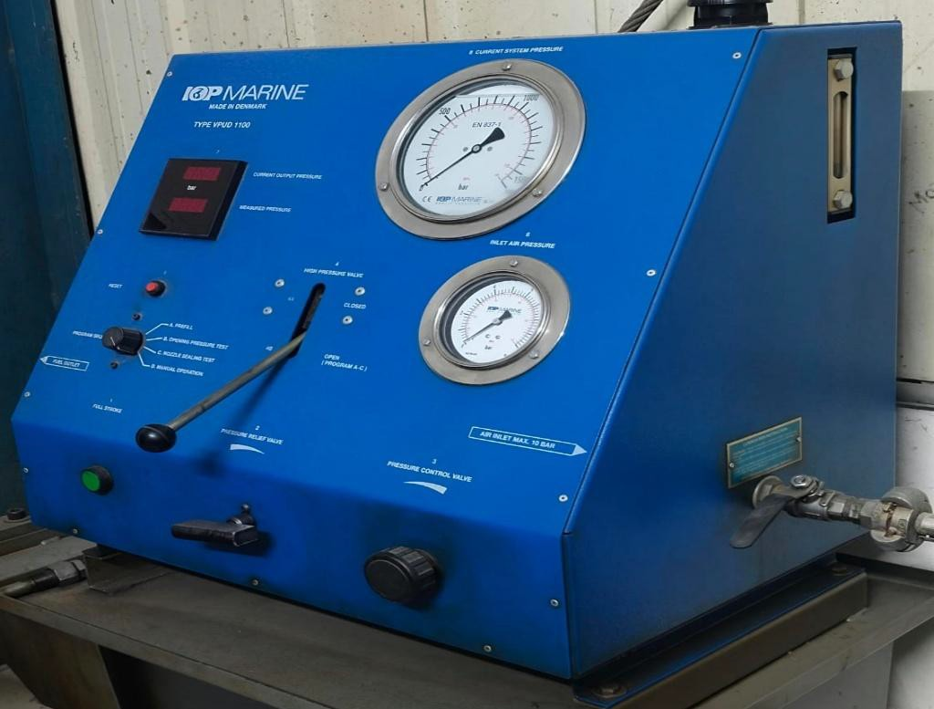

Fig: FIV Pressure Testing Machine

- FIRE SYSTEMS

  - : Fire Fighting Pump (01 No.)
Manufacturer : KSB
Model : ETANORM M 080 250 M10
Capacity : 120 m3/h Year of Manufacture : 2011

: Fire Fighting Motor (01 No.)
Manufacturer : SIEMENS
Type : 1LG4 253-2AB60-7
Volt : 400V, Frequency: 50HZ, KW: 55, RPM: 2970,

: JOCKEY PUMP (01 No)
Manufacturer : KSB (Movitec VF 2/14 B) Serial no. : 4501641734
Capacity: 2.1 m3/h
Year of Manufacture : 2011

JOCKEY PUMP MOTOR (01 No.)
Manufacturer : IE2 Model: WEA90S2
Volt: (230/400)V, Frequency: 50HZ, KW: 1.5, Current: (5.05/2.90)A RPM: 2900,

8.5: Engine Drive Fire Pump – 01 unit Manufacturer : AGCO SISU POWER INC, Finland Type: AGCO SISU POWER 320 DTP
Serial no. : X01760
Capacity: 59 Kw Seed : 1800 RPM
Year of Manufacture : 2011

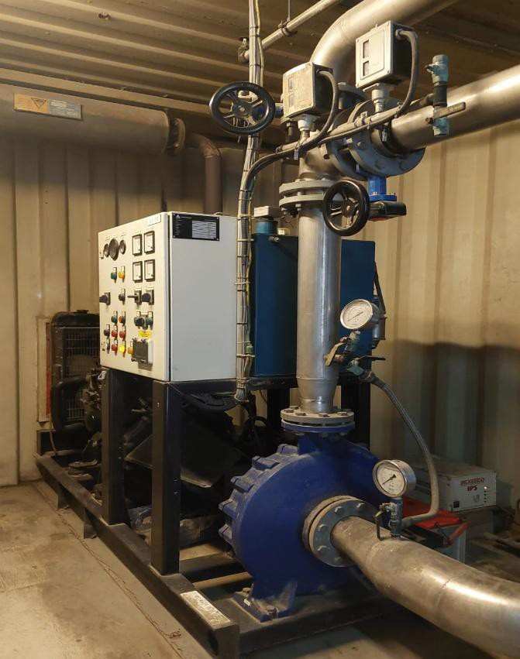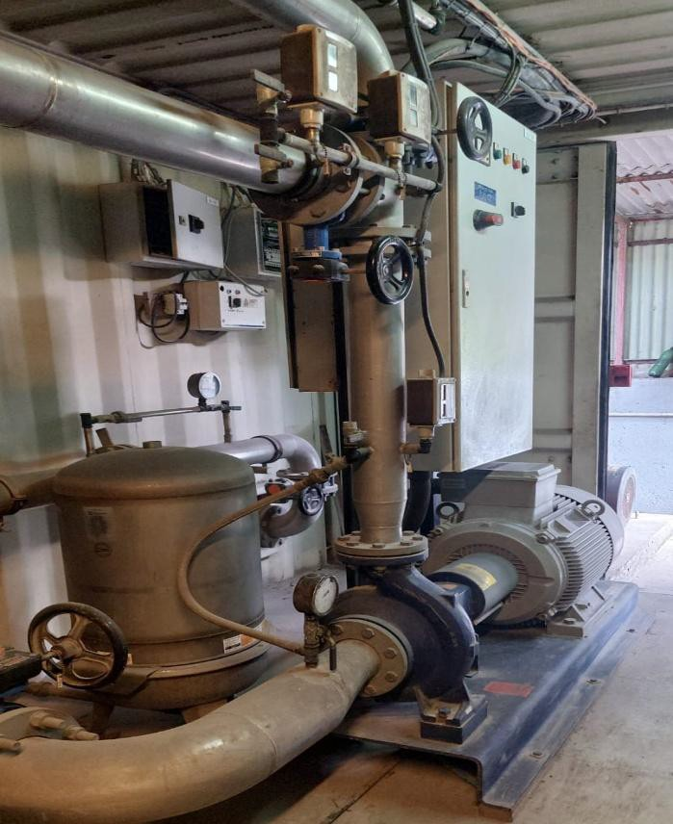

Fig: Firefighting Pump With Motor Fig: Engine Drive Fire Pump

    - Foam water system/ Foam Applicator (installed in 4 nos fuel tanks)
    - Gas suppression system (installed in Control room, MV/LV room & Battery room)
    - Different portable fire extinguishers

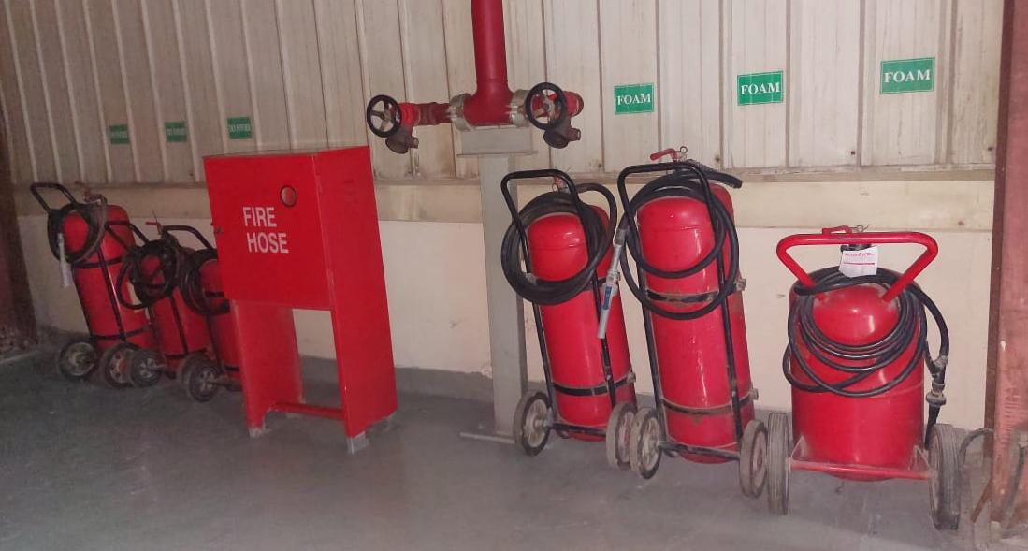

Fig: Different type of Portable Fire Extinguishers

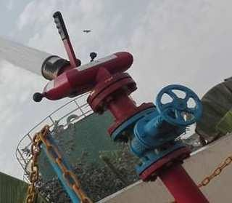
Fig; Fixed Spray System

9.0 Cooling Water System

  - : RAW water pump

Quantity: 08

Manufacturer: Milnars-Yanshan Joint Venture Type: ETA125 - 40BR
Capacity: 70 m3/h
Speed: 1500 RPM
Year of Manufacture: 2017

: Raw Water Pump Motor 8 Nos:

Manufacturer : Milnars-Yanshan Joint Venture El. Motor Capacity : 22 KW
Type : 180M-2

RPM : 2940

9.3: RAW water pump

Quantity: 01
Manufacturer: Milnars-Yanshan Joint Venture Type: ETA100 - 20BR
Capacity: 150 m3/h
Speed: 2900 RPM
Year of Manufacture: 2018

9.4: Raw Water Pump Motor 1 Nos:

Manufacturer : Milnars-Yanshan Joint Venture El. Motor Capacity : 30 KW
Type : Y2-200L-4
RPM 1500

: RAW water pump

Quantity: 02
Manufacturer: Milnars-Yanshan Joint Venture Type: ETA100 - 33
Capacity: 100 m3/h
Speed: 1450 RPM
Year of Manufacture: 2016

  - : Raw Water Pump Motor 2 Nos: Manufacturer : Crompton Graves Ltd El. Motor Capacity : 37 KW

RPM 1470

  - : Cooling water pump

Quantity: 07
Manufacturer: Milnars-Yanshan Joint Venture Type: ETA100 - 20 BR
Capacity: 225 m3/h
Speed: 2900 RPM
Year of Manufacture: 2017

9.8: Cooling Water Pump Motor 1 Nos:

Manufacturer : Milnars-Yanshan Joint Venture El. Motor Capacity : 30 KW
Type : 200L1-2
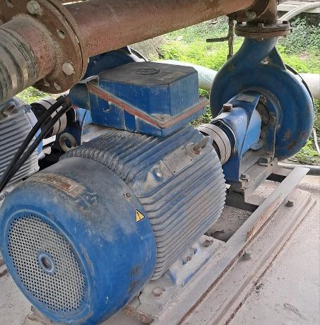RPM : 2950

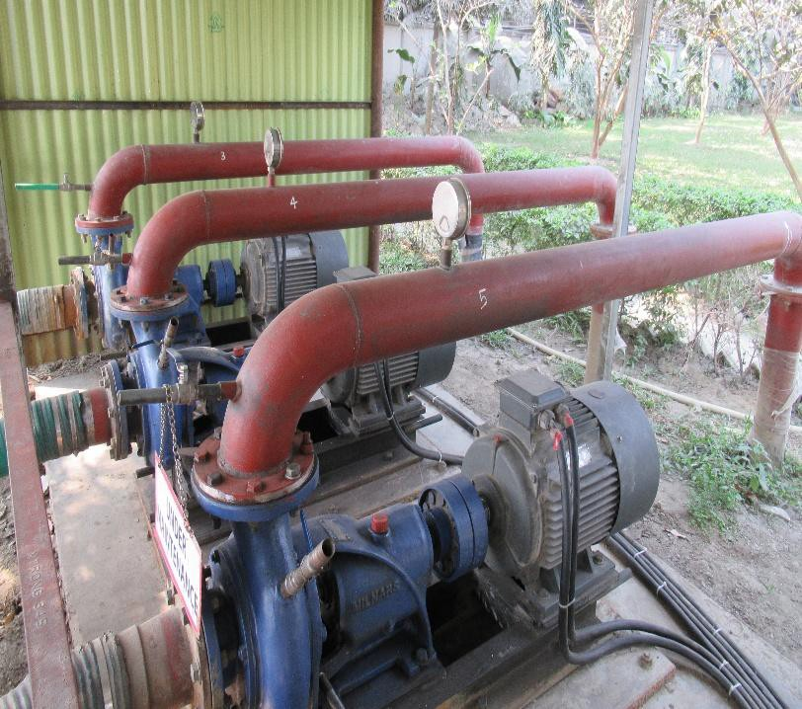

Fig: Raw Water Pump

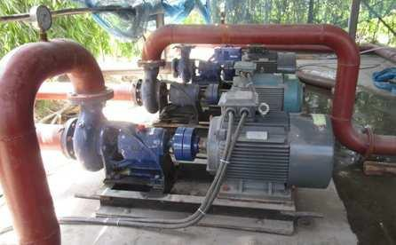

Fig: Cooling Water Pump

10.0: Sludge Management: 10.1: Oily Water Separator:
Quantity 01
Manufacturer : MAHLE Industriefiltration GmbH Model : PPT - BWS/MESB 2500
Design pressure : 5.25 bar Max temp. :60 deg C
Flow rate : 2.5 m3/h
Volume : 980 L
Year of Mfg. : 2010

  - Oily Bilge Pump:

Quantity 01

Manufacturer : Seepex.com
Type : BN 2 - 6L
Serial No. : 244847 Year of Manufacture : 2010

  - : Oily Water Pit Pump (Pneumatic pump):

Quantity 05

Manufacturer : DEPA
Type : DL25 - FA - NNN
Serial no. : 1008267 Max. Working Press. : 7 bar Max. Temp. : 90 deg C
Year of Mfg. : 2010

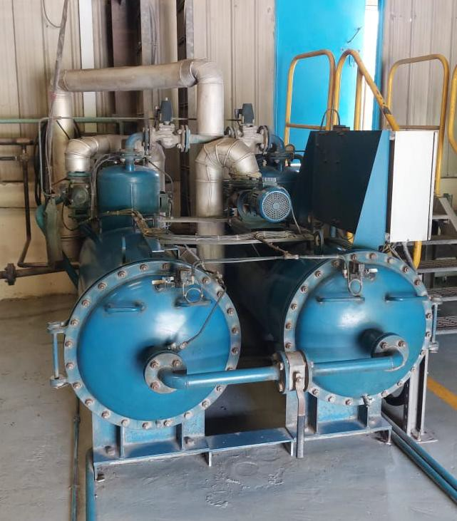

Fig: Oily Water Separator Unit

  - : TANK

  - : HFO Buffer Tank:

Quantity: 01

Manufacturer: : LTL Global
Capacity: : 117 m3 Year of Manufacture: : 2010

  - : HFO Service Tank:

Quantity 01

Manufacturer : LTL Global
Capacity : 267 m3
Year of Manufacture : 2010

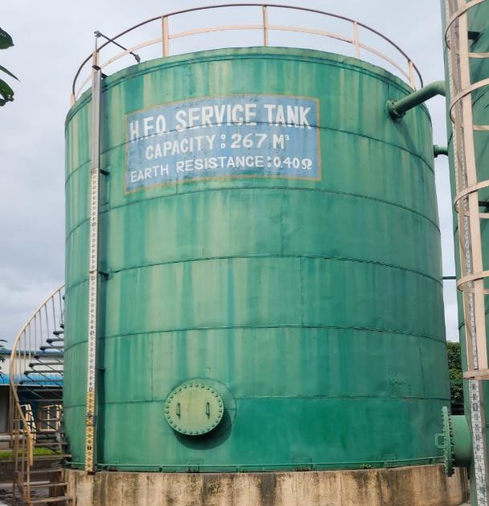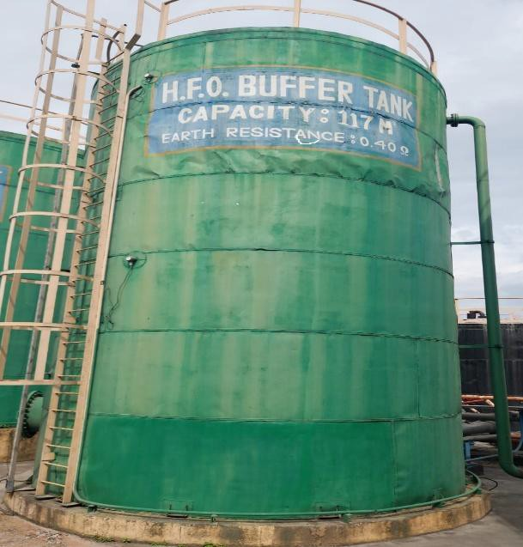
Fig: HFO Buffer Tank Fig: HFO Service Tank

  - : LFO Storage Tank:

Quantity 01

Manufacturer : LTL Global
Capacity : 300 m3
Year of Manufacture : 2010

  - : LFO Service Tank:

Quantity 01

Manufacturer : LTL Global
Capacity : 100 m3
Year of Manufacture : 2010

  - : Auxiliary Boiler LFO Tank:

Quantity 01

Manufacturer : LTL Global
Capacity : 02 m3
Year of Manufacture : 2010

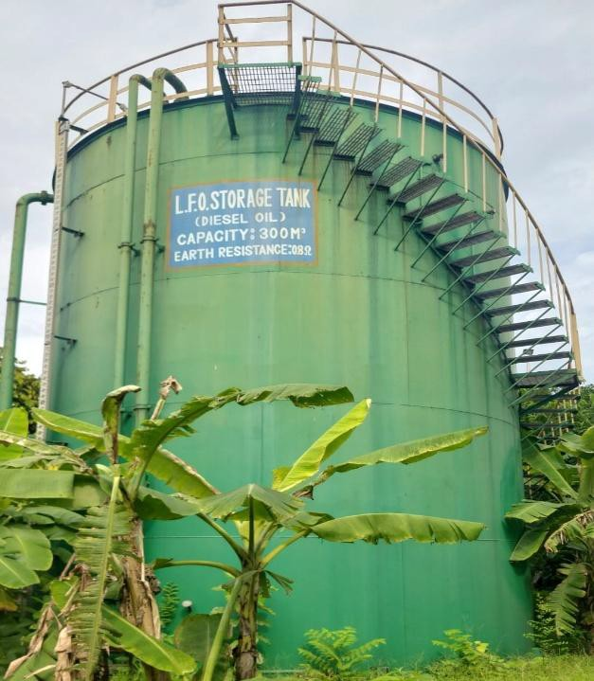
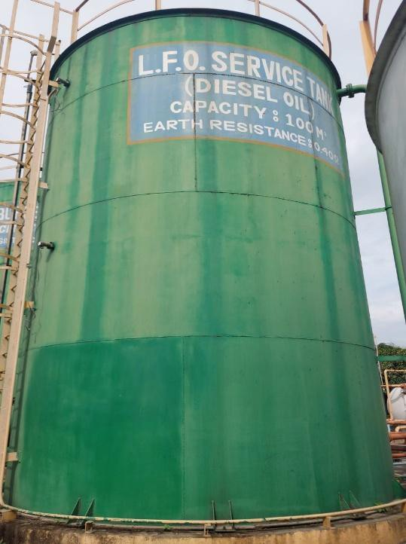Fig: LFO Storage Tank Fig: LFO Service Tank

  - : Clean Lube Oil Tank:

Quantity 01

Manufacturer : LTL Global
Capacity : 55 m3
Year of Manufacture : 2010

  - : Maintenance LO Tank:

Quantity 01

Manufacturer : LTL Global
Capacity : 07 m3
Year of Manufacture : 2010

  - : Used Lube Oil Tank:

Quantity 01

Manufacturer : LTL Global
Capacity : 20 m3
Year of Manufacture : 2010

  - : Oily Water Buffer Tank:

Quantity 01

Manufacturer : LTL Global
Capacity : 55 m3
Year of Manufacture : 2010

12.0: Sludge Tank:
Quantity 01

Manufacturer : LTL Global
Capacity : 80 m3
Year of Manufacture : 2010

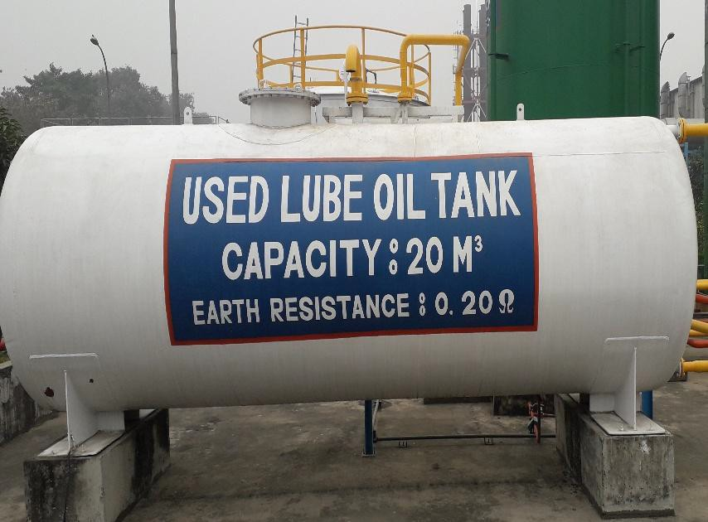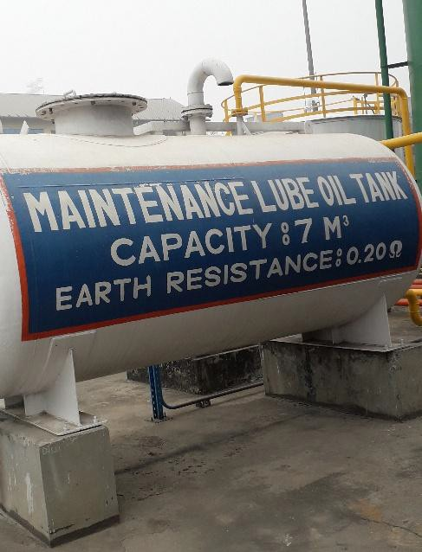

12.01: Treated Water Tank:

Quantity 01

Manufacturer : LTL Global
Capacity : 35 m3
Year of Manufacture : 2010

13.0: Other Equipment

  - : Building air cabins

  - : Exhaust ducts, silencers, stack, steel structure
  - : Cooling water, fuel, oil, pipes, valves 13.4: Radiator steel structure
13.5:Water treatment system

13.6: Control panels 13.7: Water treatment

