
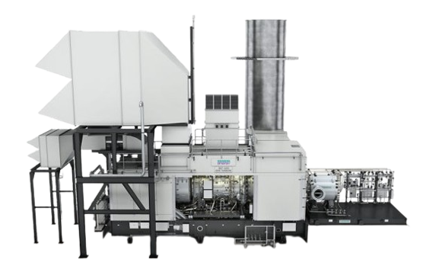
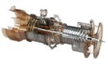

SIEMENS SGT-600 GENERATOR PACKAGES

Prepared for: Maxum International
Document reference: 25-49
Revision: 01


SIEMENS SGT-600 PROPOSAL
VG ENGINEERING CONSULTANTS LTD
Registered in England and Wales under number: 0866 7924 | VAT registered in the UK under number: 170741126 Registered address: Chusan, Newtown Road, Penperlleni, Pontypool, NP4 0AW
www.vg-eng.com

CONTENTS
- INTRODUCTION 2
- SCOPE OF SUPPLY 2
  - GAS TURBINE GENERATOR SET 2
  - GENERATOR AND EXCITATION SYSTEM 3
  - CONTROL SYSTEM 3
  - AUXILIARY SYSTEMS 3
  - BALANCE OF PLANT EǪUIPMENT 3
- INTERFACES 3
  - MECHANICAL INTERFACES 3
  - ELECTRICAL INTERFACES 3
  - INSTRUMENTATION G CONTROL INTERFACES 4
- TECHNICAL PERFORMANCES 4
- PROJECT EXPERIENCE 4
- OVERHAUL SCOPE 4
- COMMERCIAL TERMS 5
- CONCLUSIONS 5

SIEMENS SGT-600 PROPOSAL

INTRODUCTION

We are pleased to present this technical offer for the supply of two (2) Siemens SGT-600 60Hz Open-Cycle Gas Turbine Generator Packages. The SGT-600 is a proven 25 MW class unit offering high availability, dual-fuel flexibility, and low emissions (DLE configuration).

We thank you for the opportunity to present this proposal for your consideration and are certain it will meet with your expectations and requirements. Should you have any questions, queries, or concerns relating to this proposal please get in touch with us to discuss these at your convenience.

SCOPE OF SUPPLY

This proposal includes the supply of the following equipment and systems for each of the two (2) SGT-600 generator packages:
NO | EǪUIPMENT | DESCRIPTION | ǪTY (SETS)
1 | Gas Turbine Gen Set | Siemens SGT-600 open-cycle gas turbine (25 MW, 60 Hz, YOM 2008) with Dry Low Emissions combustor system | 2
 | Generator C Excitation System | ABB LBA-1120 LC 4-pole synchronous generator with brushless excitation and AVR | 2
2 | Control System | Siemens AC160 control panels with PCS7- compatible workstations and vibration monitoring | 2
3 | Auxiliary Systems | MOOG fuel valves, lube oil system, main gearbox, HVAC, fire protection, gas detection skids | 2
4 | Balance of Plant Equipment | Fuel skid, starter transformer, DC battery module, MCC panels, foundations and spares | 2

GAS TURBINE GENERATOR SET

Siemens SGT-600 open-cycle gas turbine (25 MW, 60 Hz)

Year of Manufacturing: 2008

Dry Low Emissions (DLE) combustor system

Dual-fuel capability (natural gas and liquid fuel)

B2 flex coupling gas generator rotor
VG ENGINEERING CONSULTANTS LTD
Registered in England and Wales under number: 0866 7924 | VAT registered in the UK under number: 170741126 Registered address: Chusan, Newtown Road, Penperlleni, Pontypool, NP4 0AW
www.vg-eng.com

SIEMENS SGT-600 PROPOSAL

GENERATOR AND EXCITATION SYSTEM

ABB LBA-1120 LC 4-pole synchronous generator (26 250 kVA @ 0.8 pf, 13800 V)

Brushless excitation with dual automatic voltage regulator (AVR)

Pulse-filtration and air-cooled stator cooling system

CONTROL SYSTEM

Siemens AC160 turbine control panel (PCS7-compatible)

Operator and engineering workstations

Vibration monitoring and protection modules

DC supply and distribution system

AUXILIARY SYSTEMS

MOOG fuel control valves and actuators

Frequency drives for lube oil and auxiliary pumps

Lube oil system with filters and Unity CC Jensen VRU oil cleaning skid

Main gearbox and starter/barring gear

Air filtration and cooling air skid

Exhaust stack and silencer assembly

HVAC ventilation for control shelter and generator house

Fire protection and CO₂ suppression system

Gas and fire detection, NOₓ and CO₂ monitoring skid

BALANCE OF PLANT EǪUIPMENT

Fuel skid (gas and liquid) with separators, heaters, instrumentation

Starter transformer (10 kV/690 V dry type)

DC battery module and charger

MCC panels with UPS

Embedded foundation parts and installation spares

INTERFACES

MECHANICAL INTERFACES

Gas inlet connection flange

Exhaust flue tie-in to customer stack or HRSG

Cooling water supply and return

Lube oil and drainage connections

ELECTRICAL INTERFACES

Generator HV terminal connection

Control power and auxiliary power terminations
VG ENGINEERING CONSULTANTS LTD
Registered in England and Wales under number: 0866 7924 | VAT registered in the UK under number: 170741126 Registered address: Chusan, Newtown Road, Penperlleni, Pontypool, NP4 0AW
www.vg-eng.com

SIEMENS SGT-600 PROPOSAL

Synchronization and protection wiring to customer switchboard

INSTRUMENTATION G CONTROL INTERFACES

Signal terminations to customer DCS

Local I/O junction boxes for field devices

TECHNICAL PERFORMANCES

ISO Performance Data (Simple Cycle):

Power Output: 25 MW

Electrical Efficiency: ~ 35%

Exhaust Temperature: ~ 570°C

NOx Emissions: <=15 ppmv (15% O₂)

Dual-fuel capability: Natural gas / diesel

PROJECT EXPERIENCE

Over 300 SGT-600 units in operation worldwide with more than 4 million operating hours

Proven flexibility in distributed power, peaking, and emergency applications

Extensive service network in Europe, Asia, and the Americas

OVERHAUL SCOPE

VG Engineering Consultants provides a complete overhaul and reinstallation scope for both Siemens SGT-600 units.

This includes, but is not limited to, the following:

Gas Turbine Overhaul (Both Units A G B)

Level D inspection of the gas turbines

Disassembly, inspection, and reconditioning of major components

Reassembly and functional testing

Gearbox Overhaul

Basic inspection of each main gearbox

Replacement of worn or out-of-spec parts as needed

Re-lubrication and operational testing

Generator Overhaul

Basic inspection of both ABB LBA1120 LC generators

Testing of insulation and excitation systems

Replacement of serviceable parts if required
VG ENGINEERING CONSULTANTS LTD
Registered in England and Wales under number: 0866 7924 | VAT registered in the UK under number: 170741126 Registered address: Chusan, Newtown Road, Penperlleni, Pontypool, NP4 0AW
www.vg-eng.com

SIEMENS SGT-600 PROPOSAL

Logistics and Handling

Removal of each unit from site and shipment to port (port Location)

Management of transport and documentation

Reinstallation on-site after overhaul completion

Not included to the OH scope:

Installation G Commissioning

Site civil works (concrete, foundations, piping, etc.)

Reinstallation of overhauled equipment

Electrical and instrumentation loop-checks

Calibration and cold/hot commissioning support

COMMERCIAL TERMS
Equipment: Two (2) complete SGT-600 Dual Fuel Turbine Generator Packages in OH condition Price: $17,250,000 USD (Seventeen Million Two Hundred Fifty Dollars) Each.
Delivery Terms: EXW Factory Europe. Shipping port to be confirmed.
Delivery Time: X months after order confirmation

Warranty: Twelve months or 2 000 operating hours (whichever occurs first) following successful overhaul, covering parts and workmanship.

Payment Terms:

For standard equipment purchase:

40% deposit upon contract signature

40% upon completion of dismantling

20% upon shipment from the factory For overhaul scope:

50% upfront payment upon order confirmation

50% upon completion of overhaul and readiness for dispatch

CONCLUSIONS

The Siemens SGT-600 open cycle package offers a compact, reliable, and flexible solution for 25 MW power requirements.

VG Engineering Consultants is ready to support supply, installation, and commissioning to ensure optimal performance and uptime for your facility.

We appreciate the opportunity to submit this proposal and remain at your disposal for any further clarifications.
VG ENGINEERING CONSULTANTS LTD
Registered in England and Wales under number: 0866 7924 | VAT registered in the UK under number: 170741126 Registered address: Chusan, Newtown Road, Penperlleni, Pontypool, NP4 0AW
www.vg-eng.com

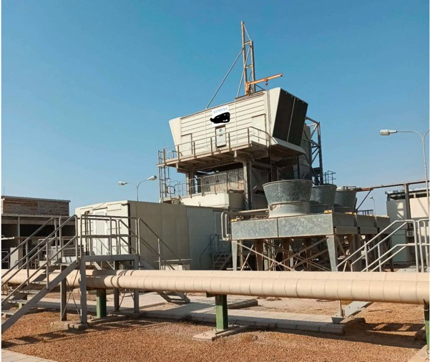
SIEMENS SGT-600 PROPOSAL
VG ENGINEERING CONSULTANTS LTD
Registered in England and Wales under number: 0866 7924 | VAT registered in the UK under number: 170741126 Registered address: Chusan, Newtown Road, Penperlleni, Pontypool, NP4 0AW
www.vg-eng.com

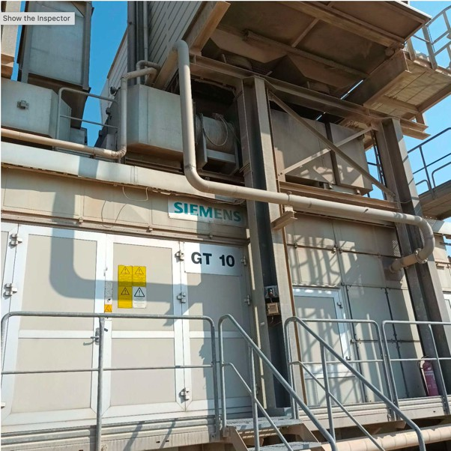
SIEMENS SGT-600 PROPOSAL
VG ENGINEERING CONSULTANTS LTD
Registered in England and Wales under number: 0866 7924 | VAT registered in the UK under number: 170741126 Registered address: Chusan, Newtown Road, Penperlleni, Pontypool, NP4 0AW
www.vg-eng.com

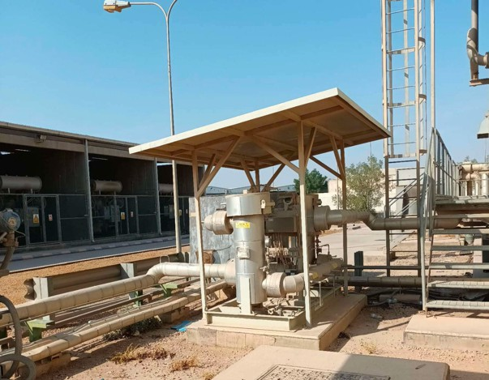
VG ENGINEERING CONSULTANTS LTD
Registered in England and Wales under number: 0866 7924 | VAT registered in the UK under number: 170741126 Registered address: Chusan, Newtown Road, Penperlleni, Pontypool, NP4 0AW
www.vg-eng.com
SIEMENS SGT-600 PROPOSAL

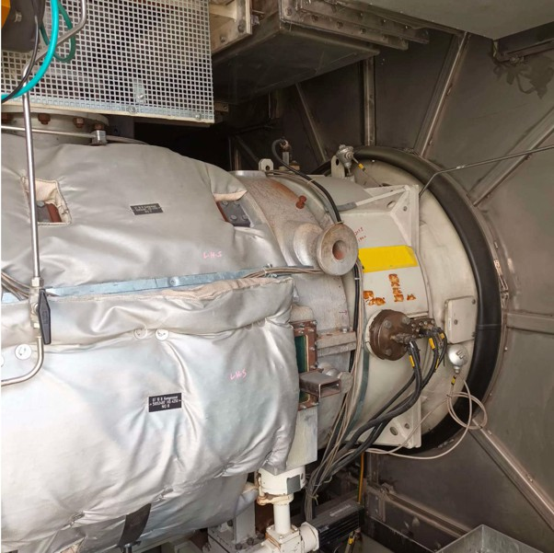
SIEMENS SGT-600 PROPOSAL
VG ENGINEERING CONSULTANTS LTD
Registered in England and Wales under number: 0866 7924 | VAT registered in the UK under number: 170741126 Registered address: Chusan, Newtown Road, Penperlleni, Pontypool, NP4 0AW
www.vg-eng.com

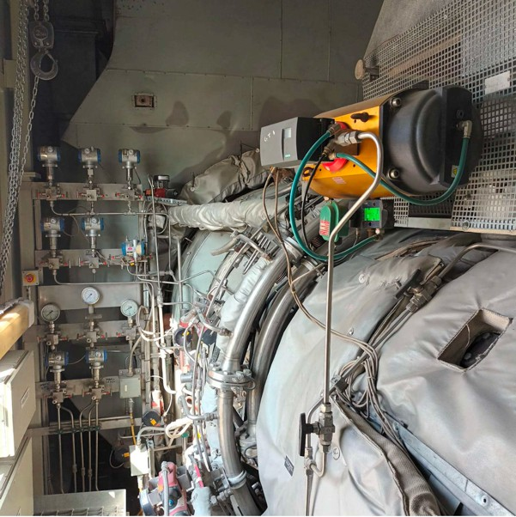
SIEMENS SGT-600 PROPOSAL
VG ENGINEERING CONSULTANTS LTD
Registered in England and Wales under number: 0866 7924 | VAT registered in the UK under number: 170741126 Registered address: Chusan, Newtown Road, Penperlleni, Pontypool, NP4 0AW
www.vg-eng.com

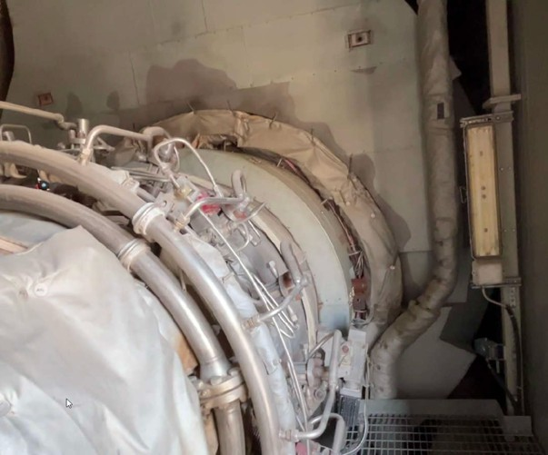
SIEMENS SGT-600 PROPOSAL
VG ENGINEERING CONSULTANTS LTD
Registered in England and Wales under number: 0866 7924 | VAT registered in the UK under number: 170741126 Registered address: Chusan, Newtown Road, Penperlleni, Pontypool, NP4 0AW
www.vg-eng.com

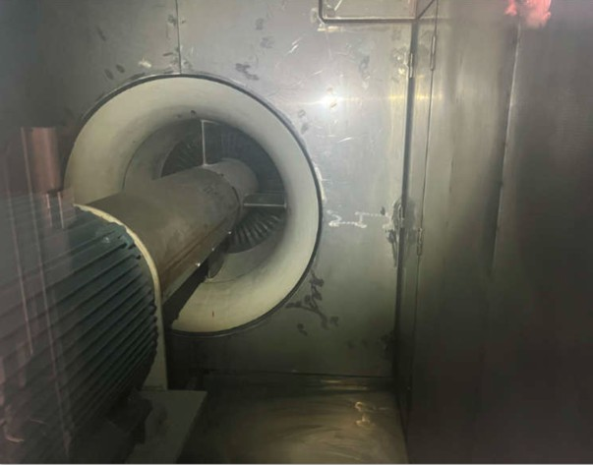
VG ENGINEERING CONSULTANTS LTD
Registered in England and Wales under number: 0866 7924 | VAT registered in the UK under number: 170741126 Registered address: Chusan, Newtown Road, Penperlleni, Pontypool, NP4 0AW
www.vg-eng.com
SIEMENS SGT-600 PROPOSAL

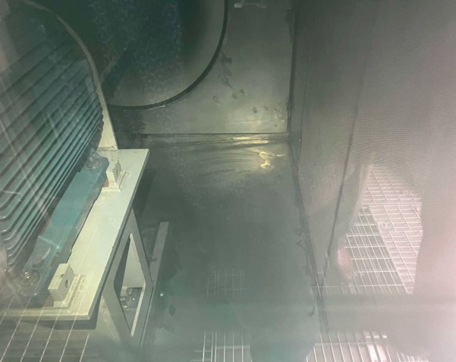
VG ENGINEERING CONSULTANTS LTD
Registered in England and Wales under number: 0866 7924 | VAT registered in the UK under number: 170741126 Registered address: Chusan, Newtown Road, Penperlleni, Pontypool, NP4 0AW
www.vg-eng.com
SIEMENS SGT-600 PROPOSAL

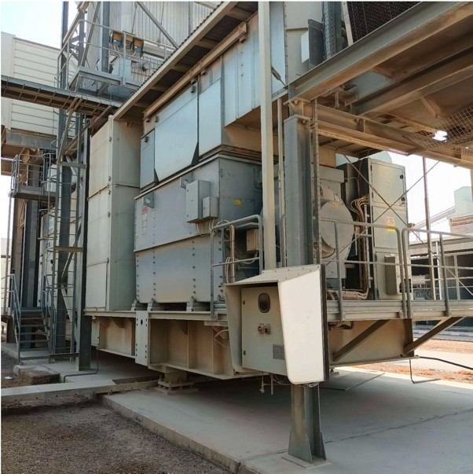
SIEMENS SGT-600 PROPOSAL
VG ENGINEERING CONSULTANTS LTD
Registered in England and Wales under number: 0866 7924 | VAT registered in the UK under number: 170741126 Registered address: Chusan, Newtown Road, Penperlleni, Pontypool, NP4 0AW
www.vg-eng.com

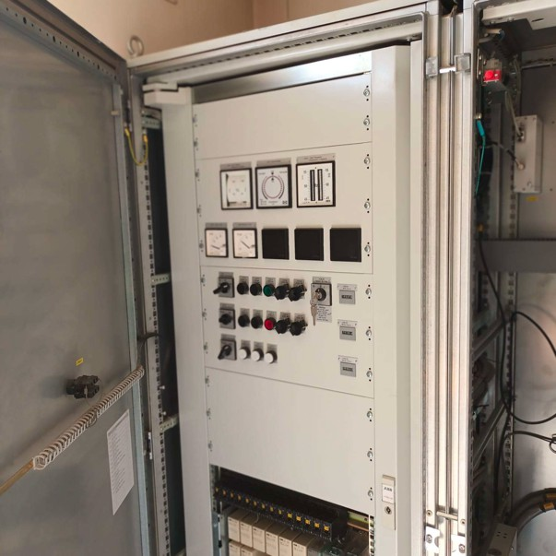
SIEMENS SGT-600 PROPOSAL
VG ENGINEERING CONSULTANTS LTD
Registered in England and Wales under number: 0866 7924 | VAT registered in the UK under number: 170741126 Registered address: Chusan, Newtown Road, Penperlleni, Pontypool, NP4 0AW
www.vg-eng.com

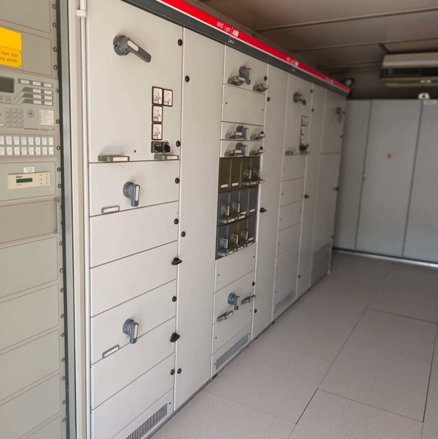
SIEMENS SGT-600 PROPOSAL
VG ENGINEERING CONSULTANTS LTD
Registered in England and Wales under number: 0866 7924 | VAT registered in the UK under number: 170741126 Registered address: Chusan, Newtown Road, Penperlleni, Pontypool, NP4 0AW
www.vg-eng.com

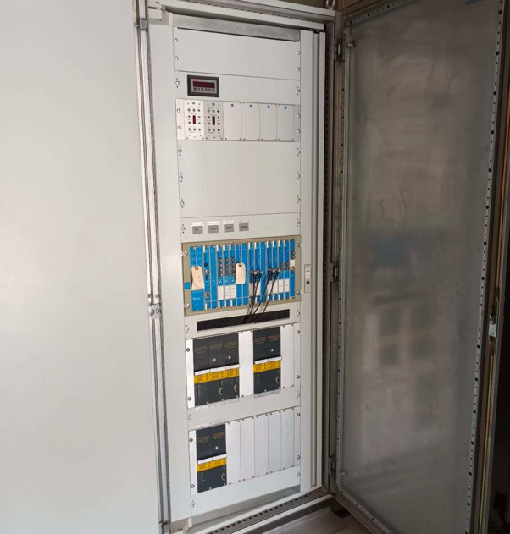
SIEMENS SGT-600 PROPOSAL
VG ENGINEERING CONSULTANTS LTD
Registered in England and Wales under number: 0866 7924 | VAT registered in the UK under number: 170741126 Registered address: Chusan, Newtown Road, Penperlleni, Pontypool, NP4 0AW
www.vg-eng.com

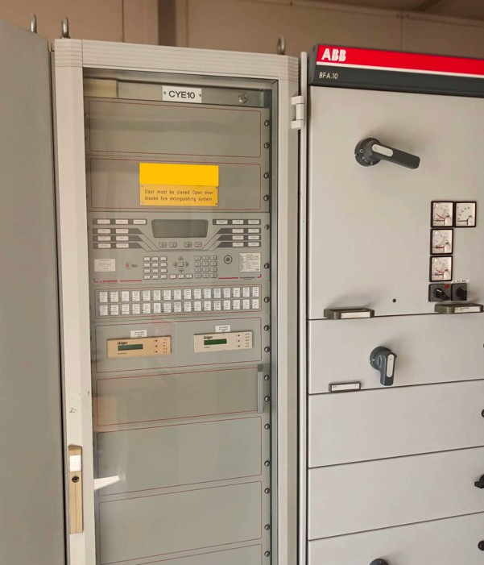
SIEMENS SGT-600 PROPOSAL
VG ENGINEERING CONSULTANTS LTD
Registered in England and Wales under number: 0866 7924 | VAT registered in the UK under number: 170741126 Registered address: Chusan, Newtown Road, Penperlleni, Pontypool, NP4 0AW
www.vg-eng.com

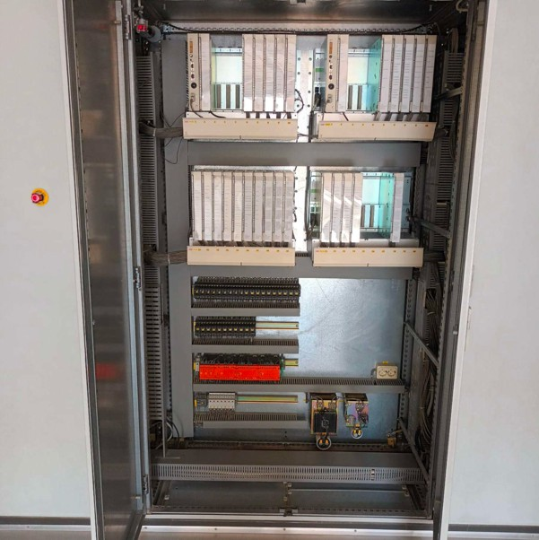
SIEMENS SGT-600 PROPOSAL
VG ENGINEERING CONSULTANTS LTD
Registered in England and Wales under number: 0866 7924 | VAT registered in the UK under number: 170741126 Registered address: Chusan, Newtown Road, Penperlleni, Pontypool, NP4 0AW
www.vg-eng.com

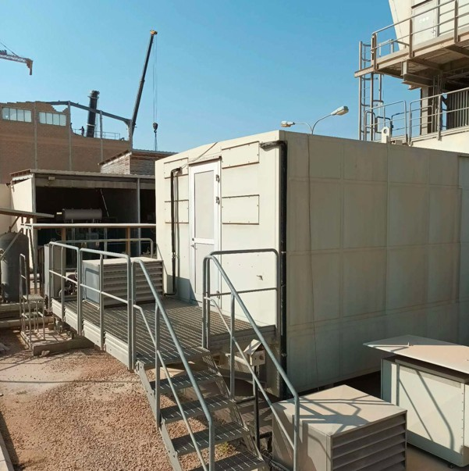
SIEMENS SGT-600 PROPOSAL
VG ENGINEERING CONSULTANTS LTD
Registered in England and Wales under number: 0866 7924 | VAT registered in the UK under number: 170741126 Registered address: Chusan, Newtown Road, Penperlleni, Pontypool, NP4 0AW
www.vg-eng.com

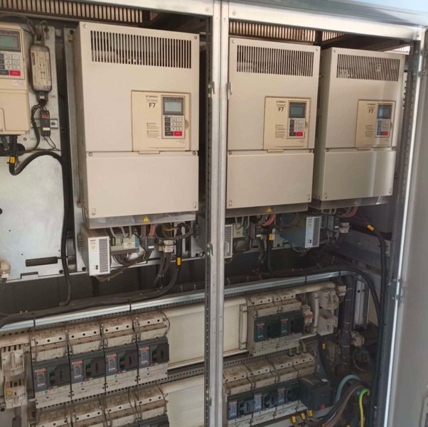
SIEMENS SGT-600 PROPOSAL
VG ENGINEERING CONSULTANTS LTD
Registered in England and Wales under number: 0866 7924 | VAT registered in the UK under number: 170741126 Registered address: Chusan, Newtown Road, Penperlleni, Pontypool, NP4 0AW
www.vg-eng.com

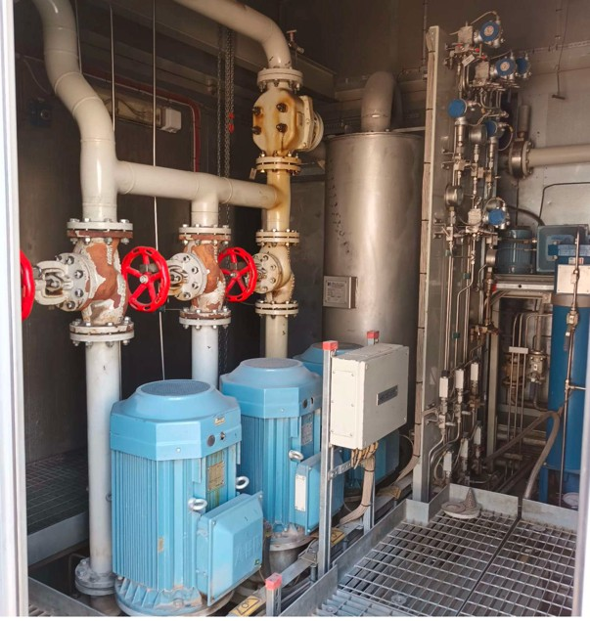
SIEMENS SGT-600 PROPOSAL
VG ENGINEERING CONSULTANTS LTD
Registered in England and Wales under number: 0866 7924 | VAT registered in the UK under number: 170741126 Registered address: Chusan, Newtown Road, Penperlleni, Pontypool, NP4 0AW
www.vg-eng.com

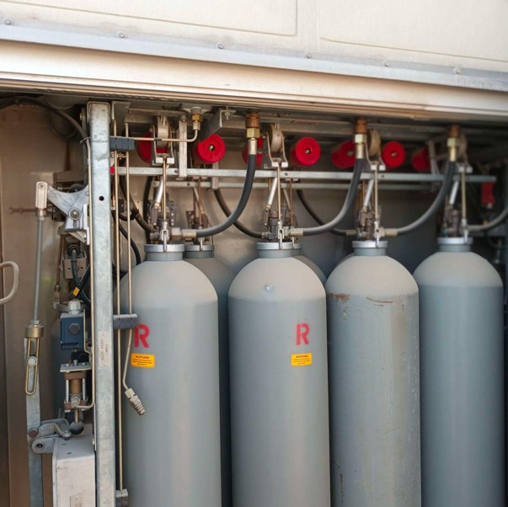
SIEMENS SGT-600 PROPOSAL
VG ENGINEERING CONSULTANTS LTD
Registered in England and Wales under number: 0866 7924 | VAT registered in the UK under number: 170741126 Registered address: Chusan, Newtown Road, Penperlleni, Pontypool, NP4 0AW
www.vg-eng.com

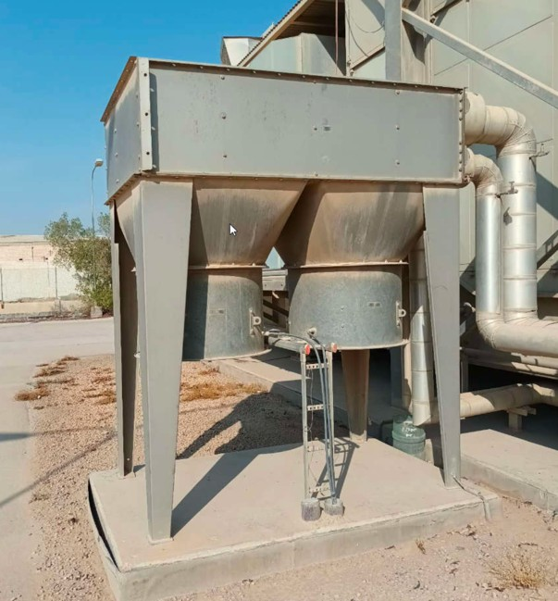
SIEMENS SGT-600 PROPOSAL
VG ENGINEERING CONSULTANTS LTD
Registered in England and Wales under number: 0866 7924 | VAT registered in the UK under number: 170741126 Registered address: Chusan, Newtown Road, Penperlleni, Pontypool, NP4 0AW
www.vg-eng.com

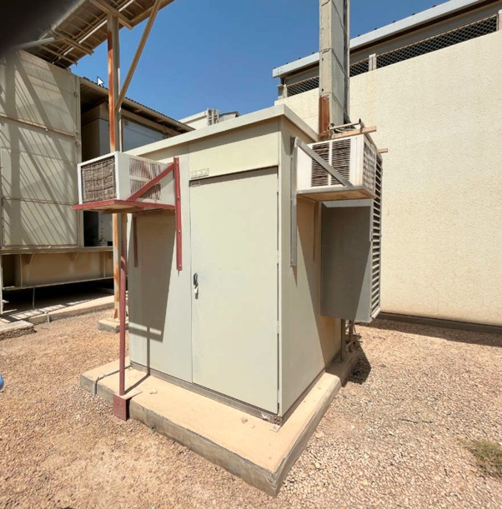
SIEMENS SGT-600 PROPOSAL
VG ENGINEERING CONSULTANTS LTD
Registered in England and Wales under number: 0866 7924 | VAT registered in the UK under number: 170741126 Registered address: Chusan, Newtown Road, Penperlleni, Pontypool, NP4 0AW
www.vg-eng.com

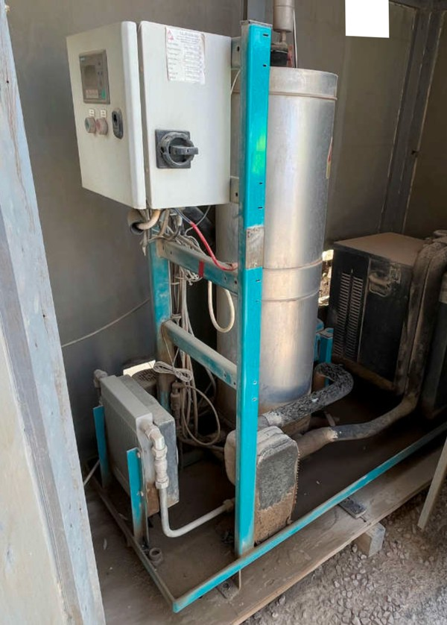
SIEMENS SGT-600 PROPOSAL
VG ENGINEERING CONSULTANTS LTD
Registered in England and Wales under number: 0866 7924 | VAT registered in the UK under number: 170741126 Registered address: Chusan, Newtown Road, Penperlleni, Pontypool, NP4 0AW
www.vg-eng.com

