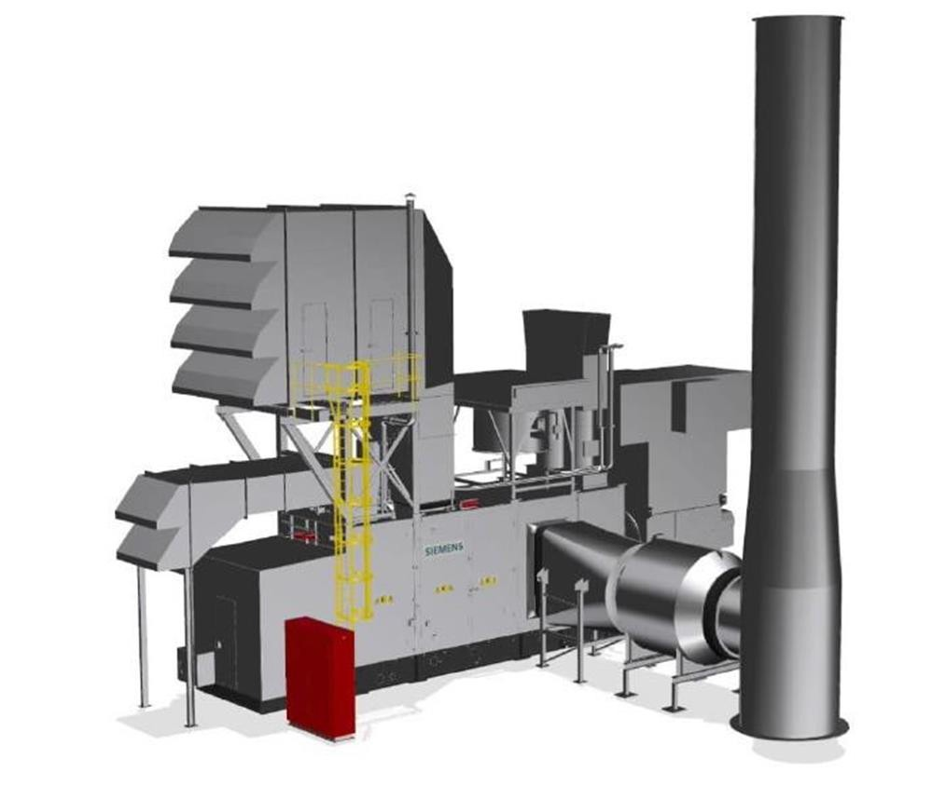

SIEMENS Gas Turbine SGT 400

Scope of Supply & Additional Notes

Manufacturer Siemens

Model SGT-400

Year 2022

Condition new

Category Natural Gas Turbines

Subcategories 10 - 99 MW

Wattage 13 MW

Hours Zero

Frequency 50/60 Hz

Fuel type Natural Gas

Voltage 230 V

Un it s av ai lab le 3 x 13 M W U nit s, 50 / 60 H z

SGT – 400 Gas Turbine Generator Set, with integral Local Equipment Room:
Units to be supplied are unused, with zero running hours, never installed.

Gas Turbine Package:
Original year of assembly: 2022 SGT 400 Gas Turbine Core Engine Original assembly location: Europe Never installed

AC Generator:
Original assembly location: SIEMENS Electrical Machines Original year of assembly: 2022
Package and core engine serial numbers will be confirmed upon placement of order
The unit’s supporting documentation is available for review at any time with prior notice

Scope of Supply: Driven unit
AC Generator
230 V
- phases 50/60 Hz
- poles
0.8 power factor
Cylindrical pole brushless type Filter ventilated
Class F insulation with class F total temperature rise Generator bearing temperature instrumentation Lubricating oil piping from gas turbine to driven unit

Gas Turbine Engine
SGT 400 Gas turbine engine – ISO Rating 13 MW(e) – two-stage uncooled variable free power turbine offers nominal shaft speed up-to 6,600 rpm
Gas generator Air inlet casing
Compressor rotor
Compressor stator wit variable Guide Vanes (VGV) Centre casing
Combustion system – Dry Low Emissions (DLE) for dual fuels Compressor turbine rotor
Compressor turbine stator
Power turbine Hot gas interdict
Power Turbine rotor Power turbine stator Output shaft drive Exhaust outlet casing
Engine arranged for hot end drive
Engine bearing temperature and vibration instrumentation

Under base
Under base – fabricated carbon steel construction, arranged for - multi point mounting Mounting assemblies for the gas turbine core, auxiliary gearbox, auxiliaries, and main gearbox Driven unit – separate under base
Integral lubrication oil tank – carbon steel

Quantity 4 units SGT 400 generator packages available
Ready for shipment depending on site – specific requirements Gas and Liquid fuel system included
DLE combustion system

Start System
Hydraulic motor and pump – AC electric motor driven

Gears, Couplings and Guards
Gearbox seismic vibration instrumentation
Auxiliary gearbox incorporating drives to start system and lubricating oil pump Drive coupling – high speed – flexible element dry type – turbine to gearbox
Drive coupling – low speed – flexible element dry type – gearbox to AC generator Coupling guard – high speed – (carbon steel) – turbine to gearbox
Coupling guard – low speed – (carbon steel) – gearbox to driven unit

Lubricating Oil System
Integral mineral oil lubricating system serving the gas turbine, gearbox and driven unit Lubricating oil pump main – gas turbine gearbox driven
Lubricating oil pump auxiliary – AC motor driven Lubricating oil pump emergency – DC motor driven Lubricating oil system filter
Duplex filter arrangement
Continuous flow transfer valves Conforms to API 614
Filter body – carbon steel
Differential pressure indicator
Temperature and Smart type pressure & level transmitters – aluminium bodies Lubricating oil tank immersion heater
Lubricating oil system breather
Lubricating oil breather oil mist eliminator
Lubricating oil breather ducting – austenitic stainless steel Lubricating oil system cooler
Air blast simplex lubricating oil cooler – package roof mounted
Cooler fan – single (100% duty) Suitable for a non - hazardous area
Lubricating oil cooler piping supply and return – austenitic stainless steel

Gas Fuel System
Pilot fuel flow control system with actuator and integrated pressure transmitters Main fuel flow control system with actuator and integrated pressure transmitters Rapid acting gas shut – off – valves (2-off)
Temperature transmitter – aluminium body
Gas fuel block and vent valve assembly – off package

Acoustic Enclosure
Acoustic enclosure – painted carbon steel, fitted over gas turbine, gearbox and auxiliaries Doors for personal access and maintenance
83 dB(A)
Integral lifting beam for maintenance Integral lightning
Acoustic system transmitters – Siemens standard smart type – aluminium
Excluded – ground level enclosure access platforms and steps

Acoustic Enclosure Ventilation System Ventilation air inlet filter pad type
Enclosure ventilation inlet and outlet dampers – air operated
Ventilation fan – single – AC electric driven – Zone 2 Ventilation air system – negative pressure Ventilation air silencer
Ventilation air inlet and outlet ducting
Integral support for turbine enclosure ventilation system

Gas Detection System
Gas detection equipment comprising
- – I.R. point gas detectors (vent outlet)

Fire Protection System
Fire protection system comprising
- – I.R. multi spectrum flame detectors 2 – Heat detectors
Single sounder / beacon (end of package) 1 – Beacon (inside package)
Status indicator (end of package) 1 – MAC (Manual Alarm Contact)

Fire Extinguishing
Fire shot CO2 fire protection system – in accordance with NFPA 12 Cylinders housed in a weatherproof cabinet
Extinguisher system distribution pipework and nozzles Piping from cabinet to package

Combustion Air Inlet System
Combustion air filter – simple static element – painted carbon steel Combustion air filter – weather hood
Combustion air filter – mist eliminator Combustion air filter – EPA filter stage Combustion air silencer – painted carbon steel
Combustion air inlet ducting – painted carbon steel
Integral support for combustion air inlet system
Maintenance access platform and ladder – combustion air filter

Combustion Exhaust System
Exhaust diffuser – ferritic stainless steel – horizontal orientation
Exhaust silencer – ferritic stainless steel hot section – coated carbon steel outer casing Exhaust stack – ferritic stainless steel – floor standing vertical orientation – 15 m height Thermal insulation and aluminium cladding – personnel protection only

Package Electrical Systems
Integral Local Electrical Room (LER)
Designed to provide environmental protection for the SGT-400 package control panels and its operators. Fully equipped with lighting, power and environmental controls consisting of:
400 V AC – Package motors and heaters supply 230/110V 50/60Hz distribution board
Internal and external lighting Industrial 220/110V 50/60 Hz outlet

Air conditioning/heat pump unit capable of maintaining control room at 20°C in all ambient conditions A baseplate designed to support the control panel shelter and internal tread plates which will attach to the end of the SGT-400 package driver unit baseplate to allow for a single point lift of the driver package
A single control panel cubicle with support frame
The combined control panel will consist of a battery charger, unit control panel for turbine and generator control and monitoring and motor control centre
Batteries – VRLA type, sized to ensure a safe run-down of the turbine and driven unit in an emergency case

Package Auxiliaries
Turbine compressor – mobile cleaning system – 316 stainless steel tank – on and off-line wash Drain tanks on package
Auxiliary module pressure & level transmitters – Smart type – aluminium bodies Instrument tagging – row tags – SIEMENS standard P&ID references Package finish according to SIEMENS onshore standard

Control System
Package Control System Hardware
Control system mounted within integral LER
Unit Control System section – simplex, incorporating a SIEMENS SIMATIC PLC platform Control and monitoring of the package systems
Standard start-stop and load control functions – on-package control panel HMI PC panel mounted
Operator display language – English Machinery vibration monitoring
Ethernet TCP/IP communications data link to DCS Generator Control Panel section containing Automatic voltage regulator
Synchronizing facility – automatic & manual with check synchronizer Generator metering equipment and electrical protection

SIEMENS Turbomachinery Applications – Remote Monitoring System – STA-RMSTM STA-RMS allows improved support for engine operators
Required operation during warranty period and thereafter with Long Term Programs (LTP) service contracts
SIEMENS common Remote Service Platform secure communication through Virtual Private Network (VPN) via customer’s internet service STA-RMS primary functions:
Automatic transfer of engine operation data to Remote Diagnostic Centre allowing: Routine monitoring Predictive trending
Anomaly detection
Improved downtime prediction and scheduling Access to historic data
Fleet and unit performance reports
Remote access to the Human Machine interface allowing:
Direct operation of the Human Machine Interface by SIEMENS’ support personnel Software updates during fault rectification helpdesk call
Faster troubleshooting and support

Testing Gas Turbine
Gas turbine core engine test – SE standard – the core has already been tested. Test data available

Driven Unit Test
Manufacturer’s works acceptance test data of AC Generator. Pre-tested.

Installation and Maintenance Equipment
Roll-off equipment – Gas turbine power turbine Roll-off trolley – Gas Turbine core engine removal Maintenance equipment
Power turbine barring gear Core lifting equipment Semi-gantry crane
Auxiliary gearbox support
Installation tool kit comprising of a cabinet containing common hand tools Holding down fixings – GT and driven unit package
Holding down fixings – off-package equipment
Selection of paints for site repairs

Drawings and Documentation
Standard set of certified information an approval drawing in English language
Existing drawings are to be reviewed and issued with relevant modifications or a project specific cover Operator manual – English language – CD only
Maintenance manual – English language – CD only
Driven unit manual – English language – CD only Packing and Delivery
Packing
Packing and preservation to suit destination and transport method

Delivery terms
Delivered FCA Germany in accordance with ICC INCOTERMS 2020 edition

Spares
Commissioning equipment and tools Commissioning spares

Quality Assurance Contract QA Programme
Material Record Book (MRB) – quality assurance and as built records – English language

Subjects to prior sale – errors and omissions excepted

We quote as follows:

3 units SIEMENS Turbine SGT4 00

Price (3-units package): EUR 37,600,000.00 /3 units

Delivery: instant delivery, after full payment received,
10-15 days FCA Europe place according Incoterms*2020. Inspection possible

Payment: 10% escrow on order and prior to inspection
40% after inspection
50% before loading
All payments must be done on our given account issued in our commercial INVOICE.

Warranty: 12 months, after commissioning under
Siemens supervision.

ATTENTION!
Following exclusions are valid:

- Transportation, FCA truck loaded must be organized by purchaser.
- Foundation (concrete plateau), drawing by Siemens is part of documentation.
- Gas fuel connection to core turbine.
- Seller is not responsible for the ignitability (inappropriate gas) of the fuel gas provided.

This commercial offer is made in writing and represents the contract between Buyer and Seller with full knowledge of the facts above between both parties.

Subjects to prior sale – errors and omissions excepted

